The University of Auckland

Discipline of History, School of Humanities
Semester 2, 2017

History 106

Europe Transformed: Pre-Modern to the Present

Course Information and Readings

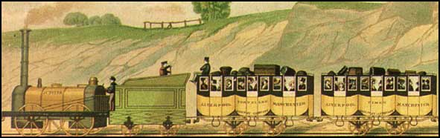

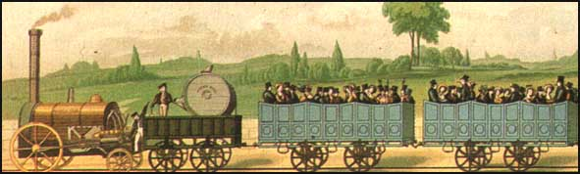

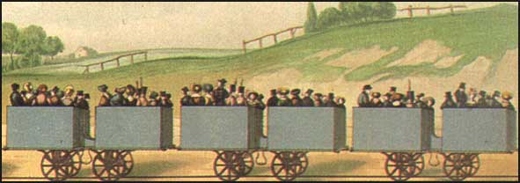

Transformations in technology correspond to transformations in social structure:
Early passenger railways (first, second and third class)

The University of Auckland

Discipline of History, School of Humanities

Semester 2, 2017

History 106 / Europe Transformed: Pre-Modern to the Present

Table of Contents

Course Introduction and Objectives  Learning Outcomes and Information Literacy | page 2
Contact Information; Lecture and Tutorial Times | 3
Lecture and Coursework Schedule | 4-5

Course Resources and Canvas
a. Access to Course Materials | 6
b. Supplemental Textbook Chapters | 6-7
c. Textbook on Short Loan | 7
Tutorial Schedule | 8-9
Coursework Requirements and Assessment
a. Marks Distribution and Due Dates | 10
b. Online Tests | 10-11
c. Essay | 11
d. Exam | 11
e. Tutorial Participation | 11
f. Plussage | 12
Academic Expectations
a. Policy on Late Work | 13
b. Academic Responsibility and Plagiarism Warning Notice | 13
c. DELNA | 13
Essay Topics and Reading Lists | 14-18
Sample Essay Marking Sheet | 19
Tutorial Readings and Reading Questions | After p.19

Copyright Warning: This material is protected by copyright and has been copied by and solely for the educational purposes of the University under licence. You may not sell, alter or further reproduce or distribute any part of this coursepack/material to any other person. Where provided to you in electronic format, you may only print from it for your own private study and research. Failure to comply with the terms of this warning may expose you to legal action for copyright infringement and/or disciplinary action by the University.
Course Introduction and Objectives

Stage I courses are designed to introduce students to basic aspects of the academic study of history. Studying history at the University level is challenging and interesting because it depends on the recognition that ‘history’ is not simply a static list of ‘facts’ to be memorized. In History 106 and other Stage I history courses, you will learn that history is not primarily concerned with finding out what happened but with trying to explain how and why things happened. Such explanations typically involve not only the interpretation of ‘primary sources’ (the name that historians give to documents produced by people at the time being studied), but also the adoption of particular methods of historical interpretation.
History 106 introduces you to these aspects of historical practice by offering a thematic and chronological survey of key issues in European history from the late Middle Ages (c. 1450 CE) to the present. Lectures will provide an overview of important developments, while tutorials will be devoted to the discussion of primary source documents spanning the period since the sixteenth century. In this course, in other words, you will have the opportunity to hear the past ‘speak for itself’, and you will be able to study the way in which historians construct widely different interpretations from the documentary evidence of the past.
Over the semester, you will be introduced to key issues in European history and to varying historical interpretations of movements, events, personalities, and ideas. The semester’s topics include the rise of the modern state, the history of ‘everyday life’ and gender relations, the nature of popular culture(s), the impact of revolutions (religious, political, social and intellectual), the rise and decline of European imperialism, and the effects of global conflict on European culture and society.

Learning Outcomes and Information Literacy

Overall, this course is designed to provide you with a solid foundation for subsequent study in European history as well as an introduction to the nature of historical research and writing. Accordingly, the course objectives include:
- providing a broad survey of European history since the Renaissance, including familiarity with key concepts, events, agents, and ideas
- providing an introduction to the ‘periodization’ of European history and key problems of interpretation within it
- exposing students to a diverse array of ‘primary sources’ and providing hands-on experience with historical interpretation

In addition to the specific objectives listed above, all Stage I courses are also designed to impart general skills needed by history students in line with the aims of the University of Auckland’s ‘Information Literacy’ policy. Such skills are highly transferable to any fields of study that require the assimilation, assessment and presentation of information as well as the construction of independent arguments. History 106 will seek to cultivate the following research-related skills in order to enhance students’ information literacy:
- building your ability to advance coherent oral and written arguments
- taking effective notes from lectures, discussions, and reading materials
- accurately providing references and citations (footnotes or endnotes and bibliographies) to indicate your intellectual obligations
- knowing how to make effective use of a research library, including resources accessed via information technology and online
Contact Information

Lecturers:
Lindsay Diggelmann  email: l.diggelmann@auckland.ac.nz Room 733, 7th floor, Humanities (formerly Arts 1, building 206)  Phone: 923-7099 | Joe Zizek  email: j.zizek@auckland.ac.nz  Room 735, 7th floor, Humanities (formerly Arts 1, building 206)  Phone: 923-8852

Tutor:
Hannah Pym
email: hpym275@aucklanduni.ac.nz
Room details for consultation will be advised at the start of semester

Office hours for teaching staff will be advised at the start of semester

Lecture and Tutorial Times
Each week, students in History 106 are expected to attend two 50-minute lectures and one 50-minute tutorial.
Lectures: Mondays at 12 pm; Wednesdays at 11am
Tutorials will be held on Wednesdays, Thursdays and Fridays. You should by now have enrolled for a tutorial time. The first tutorials will be held in week 2 (2 August - 4 August). Please contact one of the teaching staff if you have any problems with tutorial times or enrolment.

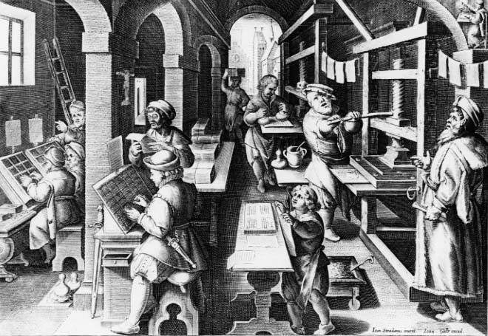

Transformations of media and information during the early modern period:
A sixteenth-century printer’s workshop

Lecture and Coursework Schedule

Week 1: Introduction
Lec 1 – July 24 What is ‘Europe Transformed’?
Lec 2 – July 26 A Tour of Europe c. 1450

Week 2: New Horizons
Lec 3 – July 31 Renaissance(s)
Lec 4 – August 2 New Worlds for Old

Week 3: Reinventing Religion
Lec 5 – August 7 Reformations
Lec 6 – August 9 Religion and the Early Modern State

Online Test 1: 9 August – 16 August

Week 4: The Clash of Old and New Ideas
Lec 7 – August 14 Revolutions in Science
Lec 8 – August 16 Gender and Culture in Early Modern Europe

Week 5: Making Wars, Making States
Lec 9 – August 21 Warfare in Europe and Beyond
Lec 10 – August 23 Absolute Monarchy

Week 6: Eighteenth-Century Transformations
Lec 11 – August 28 Consumerism, Capitalism and Slavery
Lec 12 – August 30 What is Enlightenment?

Online Test 2: 30 August – 6 September

Mid-semester break (2-17 September)
Week 7: Revolution and Reaction
Lec 13 – September 18 French Revolution
Lec 14 – September 20 Political Experiments and Ideologies

Week 8: Remaking Society
Lec 15 – September 25 Industrial Revolution
Lec 16 – September 27 Industrial Society

Essay due: 4 pm, Tuesday 3 October

Week 9: Nations and Empires
Lec 17 – October 2 Nationalism or Socialism?
Lec 18 – October 4 Empire and Colonization to 1914

Online Test 3: 4 October – 11 October

Week 10: Europe in the Age of Global Conflict
Lec 19 – October 9 World War 1 and its Consequences
Lec 20 – October 11 World War 2 and the Holocaust

Week 11: Europe since 1945
Lec 21 – October 16 Post-war Europe and the Cold War
Lec 22 – October 18 Decolonization and Diversity in Modern Europe

Online Test 4: 18 October – 28 October
Week 12: Europe Today
October 23 Labour Day holiday - no lecture
Lec 23 – October 25 Course Review and Exam Preparation

EXAM: held during University Examination Period
(You will be advised of date and location by the University)

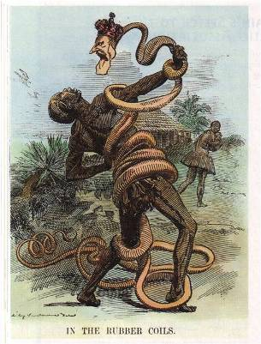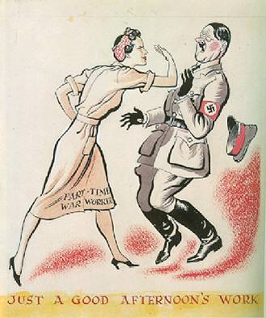

Transforming public opinion: anti-imperial and anti-Nazi images

Course Resources and Canvas

a. Access to Course Materials. Everything distributed, shown, or discussed in lecture—course information, lecture outlines, PowerPoint presentations, and miscellaneous handouts—will be available on the History 106 Canvas site. Please be aware that full lecture notes are not posted to Canvas. Lectures will be recorded and audio files will be posted to Canvas at regular intervals. These materials are intended to assist students who may want to review lecture information; they are not intended as a replacement for physical attendance at lecture. To access materials on Canvas, visit https://canvas.auckland.ac.nz/ and logon with your user name and password. A guide to Canvas for students can be found at: https://community.canvaslms.com/docs/DOC-4121. Assistance is also available at the Information Commons Helpdesk, Kate Edger Information Commons, or by the ‘Help’ icon on Canvas pages.

Course information may be made available via Canvas email announcements. Please check your ‘aucklanduni’ email account regularly to keep up to date with
course information.

b. Supplemental Textbook Chapters. These chapters are meant as background reading for lectures, essays, and exam preparation. Most are available via Canvas Reading Lists. They will not be discussed explicitly in tutorial but will provide helpful context for the assigned tutorial readings.

Weeks 2-3
‘Renaissance and Discovery’ in Donald Kagan et al., The Western Heritage, 3rd edn, Upper Saddle River, NJ, 2002, pp.181-200.
‘The Struggle for Reformation Europe, 1500-1560’ in Lynn Hunt, et al., The Making of the West: Peoples and Cultures, vol. B: 1320-1830, Boston and New York, 2001, pp.524-60.

Weeks 4-6
‘The Experiences of Life in Early Modern Europe, 1500-1650’ in Mark Kishlansky, et al., Civilization in the West, vol. 2, since 1555, 7th edn, New York, 2007, pp.440-69. [Short Loan - ask at the Lending Desk in the General Library]
‘Science and Commerce in Early Modern Europe’ in Mark Kishlansky, et al., Civilization in the West, vol. 2, since 1555, 7th edn, New York, 2007, pp.500-30. [Short Loan - ask at the Lending Desk in the General Library]
‘Absolutism and Constitutionalism’ in John P. McKay et al., A History of Western Society, 10th edn, Boston, 2011, pp.478-517.
‘The Promise of Enlightenment’ in Lynn Hunt, et al., The Making of the West: Peoples and Cultures, vol. B: 1320-1830, 2nd edn, Boston and New York, 2005, pp.707-45.

Weeks 7-9
‘A Revolution in Politics: The Era of the French Revolution and Napoleon’ in Jackson J. Spielvogel, Western Civilization, 6th edn, Belmont, CA, 2006, pp.532-61.
‘The Industrial Revolution’ in John Merriman, A History of Modern Europe: From the Renaissance to the Present, 3rd edn, New York, 2010, pp.513-68.
‘The Concert of Europe: Mass Politics and the Triumph of the State, 1815-1914’ in Margaret L. King, Western Civilization: A Social and Cultural History, 3rd edn, Upper Saddle River, NJ, 2006, pp.664-87.
‘Storm, Stress, and Doubt: European Culture from Classicism to Modernism, 1780-1914’ in Margaret L. King, Western Civilization: A Social and Cultural History, 3rd edn, Upper Saddle River, NJ, 2006, pp.718-42.

Weeks 10-12
‘The Age of European Imperialism’ in John Merriman, A History of Modern Europe: From the Renaissance to the Present, 3rd edn, New York, 2010, pp.819-59.
‘The Beginning of the Twentieth-Century Crisis: War and Revolution’ in Jackson J. Spielvogel, Western Civilization, 6th edn, Belmont, CA, 2006, pp.717-49
‘Dictatorships and the Second World War’ in John P. McKay et al., A History of Western Society, 10th edn, Boston, 2011, pp.886-921.
‘The Cold War Era and the Emergence of the New Europe’ in Donald Kagan et al., The Western Heritage, 3rd edn, Upper Saddle River, NJ, 2002, pp. 593-619.

c. Textbook on Short Loan. If you prefer to follow the narrative of the course by reading a single textbook, we recommend:

Mark Kishlansky, et al., Civilization in the West, vol. 2, since 1555, 7th edn, New York, 2007.

Several copies of this text are available at the Short Loan Collection. Ask at the Lending Desk in the General Library. Please note that the Kishlansky book begins in 1555 so you will still need the scanned chapters by Kagan and Hunt for the early weeks of the course.

Tutorial Schedule

Tutorial 1, week 2 (August 2-4): Renaissance Ideals?
- ‘How to Read a Document’, in Mark Kishlansky, ed., Sources of the West: Readings in Western Civilization, Volume 1, From the Beginning to 1715, 5th edn, New York, 2003, pp.xiii-xxii
- Niccolò Machiavelli, excerpts from The Prince (1513), in David Wootton, ed., Machiavelli: Selected Political Writings, Indianapolis and Cambridge, 1994, pp.47-55, 74-77.

Tutorial 2, week 3 (August 9-11): Whose Reformation?

Martin Luther excerpts from Carter Lindberg, ed., The European Reformations Source-book, Oxford, 2000, pp.36-40, 93-95, 97-99, 274.
- ‘The Twelve Articles of the Upper Swabian Peasants’, from Michael G. Baylor, ed., The Radical Reformation, Cambridge, 1991, pp.231-38.
- Reformation images from Merry Wiesner, Julius Ruff, and William Wheeler, eds, Discovering the Western Past: A Look at the Evidence, vol. 1: To 1789, 4th edn, Boston, 2000, pp.298-301.

Tutorial 3, week 4 (August 16-18): Ideas on Trial
- ‘The Trial of Suzanne Gaudry’, from Alan C. Kors and Edward Peters, eds, Witchcraft in Europe, 400-1700: A Documentary History, 2nd edn, Philadelphia, 2001, pp.359-67.
- Excerpts from ‘The Later Inquisition Proceedings’, in Maurice A. Finocchiaro, ed., The Galileo Affair: A Documentary History, Berkeley, 1989, pp.287-93.

Tutorial 4, week 5 (August 23-25): Absolutism Revealed
- ‘Staging Absolutism’, in Merry Wiesner, Julius Ruff, and William Wheeler, eds, Discovering the Western Past: A Look at the Evidence, vol. 2: Since 1500, 4th edn, Boston, 2000, pp.38-64.

Tutorial 5, week 6 (August 30-September 1): Enlightenment Voices
- Immanuel Kant, ‘What is Enlightenment?’ (1784), in Dennis Sherman, Western Civilization: Sources, Images, and Interpretations from the Renaissance to the Present, 8th edn, New York, 2011, p.98.
- ‘Sophia, a Person of Quality’ (Pseudonym), ‘Woman Not Inferior to Man’ (1739), in Susan Groag Bell and Karen M. Offen, eds, Women, the Family, and Freedom: The Debate in Documents. Volume 1, 1750-1880, Stanford, CA, 1983, pp.24-6.
- Olaudah Equiano, The Interesting Narrative of the Life of Olaudah Equiano, or Gustavus Vassa the African, written by himself (1789), in Sukhdev Sandhu and David Dabydeen, eds, Slavery, Abolition and Emancipation: Writings in the British Romantic Period, vol. 1, Black Writers, Brookfield, VT, 1999, pp.175-82, 201-22.

Mid-semester break

Tutorial 6, week 7 (September 20-22): Revolutionary Freedoms?
- Excerpts from Laura Mason and Tracey Rizzo, eds, The French Revolution: A Document Collection, Boston and New York, 1999, pp.51-54, 102-4, 108-13.

Tutorial 7, week 8 (September 27-29): The Industrial Revolution
- Testimony from Parliamentary Inquiry on Child Labour (1832), in E. Royston Pike, ‘Hard Times’: Human Documents of the Industrial Revolution, New York, 1966, pp.115-24.
- Andrew Ure, The Philosophy of Manufactures; or, An Exposition of the Scientific, Moral, and Commercial Economy of the Factory System of Great Britain, 2nd edn, London, 1835, pp.13-16, 19, 290, 301, 453-54.

Tutorial 8, week 9 (October 4-6): New Ideologies
- Karl Marx and Friedrich Engels, Manifesto of the Communist Party (1848), in Terrell Carver, ed., Marx: Later Political Writings, Cambridge, 1996, pp.1-12, 17-19.
- Ernest Renan, ‘What is a Nation?’ (1882), in Stuart Woolf, ed., Nationalism in Europe, 1815 to the Present: a Reader, London, 1996, pp.48-51, 53, 58-60.

Tutorial 9, week 10 (October 11-13): War and Empire
- ‘Voices from the Battle of the Somme’ (1916), in Mark Kishlansky, ed., Sources of the West: Readings in Western Civilization, Volume 1, From 1600 to the Present, 5th edn, New York, 2003, pp.233-38.
- Wilfred Owen, ‘Anthem for Doomed Youth’ and ‘Dulce Et Decorum Est’, in Collected Poems of Wilfred Owen, New York, 1965, pp.44, 55.

George Orwell, ‘Shooting an Elephant’ (1936), in A Collection of Essays, New York, 1981, pp.148-56.

Tutorial 10, week 11 (October 18-20): Nazism and the Holocaust
- ‘The Nuremberg Laws on Citizenship and Race’, in Louis Snyder, ed., Hitler's Third Reich: a Documentary History, Chicago, 1981, pp.211-14.
- Documents on the Holocaust in Roderick Stackelberg and Sally Winkle, eds, The Nazi Germany Source-book: An Anthology of Texts, London and New York, 2002, pp.339-40, 345-53, 371-78.

Tutorial 11, week 12 (October 25-27): Decolonization; and Exam Preparation
- Frantz Fanon, ‘The Wretched of the Earth’ (1961), in Mitchell Cohen and Nicole Ferman, eds, Princeton Readings in Political Thought: Essential Texts since Plato, Princeton, 1996, pp.616-22.
- ‘Women and the Algerian War’ (1962), in Lisa DiCaprio and Merry Wiesner, eds, Lives and Voices: Sources in European Women’s History, Boston and New York, 2001, pp.553-58.

Coursework Requirements and Assessment

a. Marks Distribution and Due Dates
This course is assessed on the basis of four online tests, one essay, and a two-hour essay-type Exam held during the examination period. Assessment is based 50% on the coursework completed during the semester and 50% on the Exam.

Grades are distributed (as a percentage of total mark in course) as follows:
- 20% - Four (4) online tests, each worth 5% of the final mark
- Test 1 (covers lectures 1-6), available from 9 August to 16 August
- Test 2 (covers lectures 7-12), available from 30 August to 6 September
- Test 3 (covers lectures 13-18), available from 4 October to 11 October
- Test 4 (covers lectures 19-22), available from 18 October to 28 October

- 30% - Essay, 1500 words, due 4:00 pm, Tuesday 3 October

- 50% - Exam (2 hours, 2 essays) held in University Examination period

b. Online Tests (self-administered)
The coursework requirement for History 106 includes four (4) online tests, which are accessible through Canvas (http://canvas.auckland.ac.nz). Access to the course Canvas site requires use of your user name and password – please ensure that you know how to do this in ample time before the test periods. There is more information on Canvas on p. 6 of this courseguide.

Each online test will be available during the period indicated by the dates given in the table above. You may choose to sit a test at any point during its availability. If you are using an off-campus computer, ensure that you have a reliable internet connection. Each test consists of 20 multiple-choice questions with a time limit of 30 minutes. Questions are assigned quasi-randomly from a pool, which gives each week of the course approximately equal weighting. No two students will receive exactly the same mixture of questions, but each test will include some easy questions (designed to reward those who have attended lecture and tutorial), some moderately difficult questions, and no more than 1-2 questions that rate as very difficult.
Students who have computer difficulties: If you have extreme difficulty using or accessing a computer, we are happy to offer you the alternative of sitting printed versions of any or all of the tests. Please contact the teaching staff in advance if you wish to schedule History 106 tests on paper rather than online.

When revising for tests, you should prepare for multiple-choice questions dealing with the following:
- Statements that will test your comprehension and understanding of specific tutorial readings or specific issues covered in lecture and/or tutorial.
- Images shown in lecture or tutorial, whose significance, meaning, or origin you will be asked to identify.
- Statements from which you will be asked to differentiate true, false, or most plausible propositions. These may involve issues raised in lectures or tutorials.
- The chronological sequence of major events covered in lecture and tutorial.
In case of problems: if your online test session is disconnected for any reason, don’t panic. Simply let one of the teaching staff know at the earliest opportunity and we will arrange another attempt for you.

Please note that online tests are meant to assess your own work, and are thus covered under the Student Academic Conduct Statute (see p.13, below). This means that you may prepare for online tests by studying with fellow students, but when you sit the test you must do so by yourself and you must maintain the confidentiality of your test session. You may not receive assistance from anyone during your online session, allow another person to watch as you take your test, or observe or assist another student’s online session.

c. Essay
Students in History 106 are required to submit one 1500 word essay that is assessed for 30% of the total course grade. The assignment description can be found on pp.14-18 of this courseguide. The paper copy of your essay must be handed in at the box marked ‘History essays’ in the foyer of the Arts 1 building. Do not hand or email essays directly to your tutor or lecturer unless there are special circumstances for which you have made advance arrangements. Please attach to your essay a signed and completed cover sheet, which you must generate from Canvas, under the menu heading Cover Sheet. Essays submitted without a cover sheet will be marked, but the grade will be withheld until a signed cover sheet is provided. You must also submit an electronic version of your essay to www.turnitin.com, through Canvas. For information on this, see p.14 below.

A full version of the History Coursework Guide, including information on footnoting and referencing, is available on the History 106 Canvas page.

d. Exam
Students in History 106 must sit a two-hour, essay-type Exam during the official University Examination period. The Exam is closed book, which means that no notes or study materials can be used in the Examination room. The Exam format will provide you with two sets of questions: one set will offer you a choice of questions covering the entire Semester, while the other set will offer you a choice of topics from the second half of the course (topics from the first half are covered by the Essay). We will conduct review sessions for the Exam, including study tips and mock Exam questions, in the final week of tutorials. The best way to prepare yourself for the Exam during the semester is to make a point of regular attendance at lectures and tutorials, keep up with the course reading, and complete all online tests on schedule.

e. Tutorial Participation
Tutorials are held each week, beginning with the second week of the semester. Attendance will be taken at the beginning of each class. Because tutorials are a key component in understanding and assimilating course materials and topics, we strongly emphasize participation and attendance. We encourage students to attend all tutorials, but at a minimum we expect attendance at 8 of the 11 tutorials. Failure to reach this level of attendance will disqualify you from eligibility for Plussage and may result in work not being accepted for marking.

f. Plussage
History 106 offers students who succeed on the Exam the possibility of improving their overall mark in the course under certain conditions. ‘Plussage’ refers to an assessment scheme in which the proportion of the final mark assigned to coursework may be changed (in a fixed way) if this benefits the student. In History 106, where coursework normally counts for 50% and the exam for 50%, students eligible for Plussage may have their Exam count for 100% of the course mark rather than 50% (meaning that coursework would count for 0%). Any students who meet all of the following conditions will be eligible for Plussage:
- achieving the minimum tutorial attendance requirement (8 out of 11)
- completing all coursework (essay and four online tests), with a minimum D+ average
- achieving a higher mark on the Exam than the coursework average mark
If all these conditions are met, a student’s Exam mark will become his or her final grade in the course. Plussage therefore rewards students whose work improves dramatically over the semester.

Examples of Plussage calculations:
- Student 1: attends nine tutorials, completes four online tests (average 65%) and Essay (average 75%) > coursework average is 71% (65% x 0.2 + 75% x 0.3). Exam mark is 69%. No plussage (student qualifies, but exam mark is lower than coursework mark). Final grade = 70% (71% x 0.5 + 69% x 0.5).
- Student 2: attends six tutorials, completes four online tests (average 65%) and the Essay (average 75%) > coursework average is 71% (65% x 0.2 + 75% x 0.3). Exam mark is 85%. No plussage because minimum tutorial attendance not met. Final grade = 78% (71% x 0.5 + 85% x 0.5).
- Student 3: attends nine tutorials, completes three of four online tests (weighted average 55%) and the Essay (average 75%) > coursework average is 67% (55% x 0.2 + 75% x 0.3). Exam mark is 85%. No plussage because minimum coursework requirement not met. Final grade = 76% (67% x 0.5 + 85% x 0.5).
- Student 4: attends nine tutorials, completes four online tests (average 65%) and the Essay (average 75%) > coursework average is 71% (65% x 0.2 + 75% x 0.3). Exam mark is 85%. Qualifies for plussage. Final grade = 85% (69% x 0.0 + 85% x 1.0).

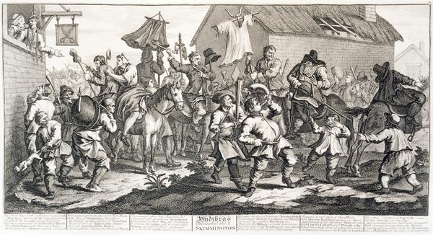

Transformations in popular culture during the eighteenth century:

a ‘skimmington’ or shaming ritual (William Hogarth, 1725)

Academic Expectations

a. Policy on Late Work
In fairness to students who meet course deadlines, all unexcused late submissions will be penalized. Extensions for medical, religious, or compassionate reasons are willingly granted, but require advance approval from your tutor. In certain cases, you may be required to provide supporting documentation, such as a medical certificate. If you need to request an extension, you should see your tutor in person well in advance of the due date (sending your tutor an email hours before an assignment is due does not constitute grounds for an extension!). Extension requests may be denied if the reasons for late submission are not justified. Having other assignments due at the same time is not an acceptable justification for an extension; managing your course workloads is one of the skills we expect you to take seriously as part of your University experience.
If you have not secured an extension and you hand in your work after the due date and time, or if you hand in your work after the due date of your approved extension, you will be penalized 5 percentage points for the first day and 2 percentage points for each subsequent day your work is overdue. Work submitted more than 7 days beyond the original due date will require explicit approval from the course lecturer.

b. Academic Responsibility
Plagiarism—appropriating, as one’s own, the ideas or words of another—is an extremely serious breach of trust, which will be dealt with according to University regulations. The University’s official policy reads as follows:

Plagiarism Warning Notice
The University of Auckland will not tolerate cheating, or assisting others to cheat, and views cheating in coursework and examinations as a serious academic offence. The work that a student submits for grading must be the student’s own work, reflecting his or her learning. Where work from other sources is used, it must be properly acknowledged and referenced. This requirement also applies to sources on the world-wide web. For further information see the ‘Student Academic Conduct Statute’ available at:
http://www.auckland.ac.nz/uoa/home/about/teaching-learning/honesty/tl-uni-regs-statutes-guidelines

Students’ assessed work will be reviewed against electronic source material using computerized detection mechanisms. Students therefore will be required to provide an electronic version of their work for computerized review. The required citation format for History essays is explained in the History Coursework Guide, which is available on Canvas and on the History website.

c. DELNA
All first-year students must undertake DELNA screening at the beginning of their first semester of enrolment irrespective of their linguistic background. This screening (delivered online) only has to be done once. If you are a first-year student and have not yet passed your DELNA screening, please visit the following website and follow directions there to book a test session: http://www.delna.auckland.ac.nz/uoa/

Essay Topics and Reading Lists

Essay, 1500 words, 30% of final grade, due 4:00 pm, Tuesday 3 October

Choose one of the following six essay topics. Read the items listed under your chosen topic and write a 1500 word essay in response to the question posed.
To ensure equal access by all students, all required readings are available in electronic format and can be located via Canvas Reading Lists.

IMPORTANT NOTE: History 106 essays must be submitted in two formats:
1) hard copy handed in to the box marked ‘History essays’ in the Arts Assignment Centre
2) computer file uploaded to Turnitin (through Canvas) within 72 hours of the hard copy submission.
Essay grades are withheld until Turnitin submission is confirmed

Turnitin.com is an electronic plagiarism detection service that is used by many universities world-wide. When a student’s assignment is turned in to the system it is matched against millions of Internet pages, databases and a constantly increasing database of all previously and concurrently submitted assignments. Teaching staff receive a report from Turnitin that can be used as a resource to assist staff in making a judgment as to whether or not a student’s work is plagiarized.

To upload your assignments to Turnitin, go to Canvas > Assignments > Essay. You will see the Turnitin submission box at the bottom of the page.

Helpful hints
You may find it helpful to keep the following issues in mind as you research and write your essays. These suggestions are not meant as a list to be checked off, nor should your essay blindly adopt these suggestions as a structure. Each topic will have its own specific qualities, and your essay’s argument and structure should reflect your response to the question, based on your reading of the listed items.

- This assignment will require you to consider how and why historians have addressed your chosen topic. You may be required to synthesize conflicting viewpoints to arrive at your own response to the question. So please consider how the scholars you are reading have defined the historical issues under investigation. How have they used primary sources to support their arguments, and why have they sometimes chosen different kinds of sources and approaches?

- On what have scholars agreed and disagreed? Why? To what extent have the debates or problems under investigation changed over time? For convenience, the attached bibliographies are in alphabetical order, but whenever possible try to read the works in order of publication (earliest first). This may provide you with some insight on how the historiography has developed over time.

- Apart from consulting the background textbook chapters and lecture notes as needed, there is no need to carry out extra research beyond the given lists. Additional research will not lead to a higher mark if it results in neglect of the assigned items.

- Read the listed works with an eye on the specific task you are seeking to achieve. Don’t fret if you cannot understand all the names or references—you won’t be assessed on the factual content of these articles. Focus instead on the author’s main argument(s), the examples and evidence used in support, and the methods of primary source analysis. What major point is each author trying to make, and how does he/she try to show that his/her view is valid?

- Take notes carefully and quote readings accurately. Direct quotations must be indicated by quotation marks and must be appropriately acknowledged in footnotes. All essays must conform to the guidelines for footnotes and bibliography, detailed in the History Coursework Guide – available on Canvas. There is no need to footnote material drawn from lectures.

Topic 1: Based on your reading of the following, what were the most important features of society and culture during the ‘Renaissance’? Why, in your view, do these scholars offer different explanations?
- Brucker, Gene, ‘Civic Traditions in Premodern Italy’, Journal of Interdisciplinary History, 29, 1999, pp.357-77.
- Burke, Peter, ‘The Renaissance, Individualism and the Portrait’, History of European Ideas, 21, 1995, pp.393-400.
- Findlen, Paula, ‘Possessing the Past: The Material World of the Italian Renaissance’, American Historical Review, 103, 1998, pp.83-114.
- Kelly, Joan, ‘Did Women Have a Renaissance?’, in Women, History, and Theory: The Essays of Joan Kelly, Chicago, 1984, pp.19-50.
- Muir, Edward, ‘The Idea of Community in Renaissance Italy’, Renaissance Quarterly, 55, 2002, pp.1-18.

AND any one of the following:
- Rabb, Theodore, ‘The Civilization of the Renaissance’, in The Last Days of the Renaissance and the March to Modernity, New York, 2006, pp.41-90.
- Rocke, Michael, ‘Gender and Sexual Culture in Renaissance Italy’, in Judith Brown and Robert Davis, eds, Gender and Society in Renaissance Italy, London, 1998, pp.150-70.
- Starn, Randolph, ‘Reinventing Heroes in Renaissance Italy’, Journal of Interdisciplinary History, 17, 1986, pp.67-84.

Topic 2: Based on your reading of the following, to what extent did the Reformation change ordinary people’s lives? Why, in your view, do these scholars offer different explanations?
- Parker, Geoffrey, ‘Success and Failure during the First Century of the Reformation’, Past and Present, 136, 1992, pp.43-82.
- Roper, Lyndal, ‘Going to Church and Street: Weddings in Reformation Augsburg’, Past and Present, 106, 1985, pp.62-101.
- Scribner, Robert, ‘Oral Culture and the Diffusion of Reformation Ideas’, in Popular Culture and Popular Movements in Reformation Germany, London and Ronceverte, 1987, pp.49-69.
- Strauss, Gerald, ‘Success and Failure in the German Reformation’, Past and Present, 67, 1975, pp.30-63.
- Wiesner, Merry E., ‘Beyond Women and the Family: Towards a Gender Analysis of the Reformation’, Sixteenth Century Journal, 18, 1987, pp.311-21.

AND any one of the following:
- Scribner, Robert, ‘Incombustible Luther: The Image of the Reformer in Early Modern Germany’, Past and Present, 110, 1986, pp.38-68.
- Sreenivasan, Govind P., ‘The Social Origins of the Peasants’ War of 1525 in Upper Swabia’, Past and Present, 171, 2001, pp.30-65.
- Strauss, Gerald, ‘The Social Function of Schools in the Lutheran Reformation in Germany’, History of Education Quarterly, 28, 1988, pp.191-206.

Topic 3: Based on your reading of the following, how did ideas about gender influence the experience of European people during the Early Modern period? Why, in your view, do these scholars offer different explanations?
- Amussen, Susan Dwyer, ‘The Gendering of Popular Culture in Early Modern England’, in Tim Harris, ed., Popular Culture in England, c. 1500-1850, London, 1995, pp.48-68.
- Evangelisti, Silvia, ‘Wives, Widows, and Brides of Christ: Marriage and the Convent in the Historiography of Early Modern Italy’, The Historical Journal, 43, 2000, pp.233-47.
- Hardwick, Julie, ‘Seeking Separations: Gender, Marriages, and Household Economies in Early Modern France’, French Historical Studies, 21, 1998, pp.157-80.
- Ingram, Martin, ‘Ridings, Rough Music and the Reform of “Popular Culture” in Early Modern England’, Past and Present, 105, 1984, pp.79-113.
- Purkiss, Diane, ‘Women’s Stories of Witchcraft in Early Modern England: The House, the Body, the Child’, Gender and History, 7, 1995, pp.408-32.

AND any one of the following:
- Davis, Natalie Z., ‘Women on Top’, in Society and Culture in Early Modern France: Eight Essays, Stanford, 1975, pp.124-51.
- Fissell, Mary, ‘Gender and Generation: Representing Reproduction in Early Modern England’, Gender and History, 7, 1995, pp.433-56.
- Rowlands, Alison, ‘Witchcraft and Old Women in Early Modern Germany’, Past and Present, 173, 2001, pp.50-89.
Topic 4: Based on your reading of the following, what were the most important factors shaping social relationships under the ‘absolute’ monarchy? Why, in your view, do these scholars offer different explanations?
- Burke, Peter, ‘The Fabrication of Louis XIV’, History Today, 42, 1992, pp.24-30.
- Farr, James R., ‘The Death of a Judge: Performance, Honor, and Legitimacy in Seventeenth-Century France’, Journal of Modern History, 75, 2003, pp.1-22.
- Koslofsky, Craig, ‘Princes of Darkness: The Night at Court, 1650-1750’, Journal of Modern History, 79, 2007, pp.235-73.
- Le Roy Ladurie, Emmanuel, ‘Versailles Observed: The Court of Louis XIV in 1709’, in The Mind and Method of the Historian, trans. Sian and Ben Reynolds, Chicago, 1981, pp.149-73.
- Mukerji, Chandra, ‘The Political Mobilization of Nature in Seventeenth-Century French Formal Gardens’, Theory and Society, 23, 1994, pp.651-77.

AND any one of the following:
- Hanley, Sarah, ‘Engendering the State: Family Formation and State Building in Early Modern France’, French Historical Studies, 16, 1989, pp.1-27.
- Ranum, Orest, ‘Courtesy, Absolutism, and the Rise of the French State, 1630-1660’, Journal of Modern History, 52, 1980, pp.426-51.
- Smith, Jay M., ‘“Our Sovereign’s Gaze”: Kings, Nobles, and State Formation in Seventeenth-Century France’, French Historical Studies, 18, 1993, pp.396-415.

Topic 5: Based on your reading of the following, what effect(s) did consumer goods have upon the peoples of Europe and the Atlantic world? Why, in your view, do these scholars offer different explanations?
- Crowley, John E., ‘The Sensibility of Comfort’, American Historical Review, 104, 1999, pp.749-82.
- Fairchilds, Cissie, ‘The Production and Marketing of Populuxe Goods in Eighteenth-Century Paris’, in John Brewer and Roy Porter, eds, Consumption and the World of Goods, London, 1993, pp.228-48.
- Finn, Margot, ‘Men’s Things: Masculine Possession in the Consumer Revolution’, Social History, 25, 2000, pp.133-55.
- Sussman, Charlotte, ‘Women and the Politics of Sugar, 1792’, Representations, 48, 1994, pp.48-69.
- Weatherill, Lorna, ‘A Possession of One’s Own: Women and Consumer Behaviour in England, 1660-1740’, Journal of British Studies, 25, 1986, pp.131-56.

AND any one of the following:
- Breen, T.H., ‘“Baubles of Britain”: The American and Consumer Revolutions of the Eighteenth Century’, Past and Present, 119, 1988, pp.73-104.
- McKendrick, Neil, ‘The Consumer Revolution of Eighteenth-Century England’, in N. McKendrick et al., eds., The Birth of a Consumer Society, New York, 1982, pp.9-33.
- Smith, Woodruff D., ‘Complications of the Commonplace: Tea, Sugar, and Imperialism’, Journal of Interdisciplinary History, 23, 1992, pp.259-78.

Topic 6: Based on your reading of the following, what do you see as the main cause(s) behind the outbreak of the French Revolution? Why, in your view, do these scholars offer different explanations?
- Darnton, Robert, ‘The High Enlightenment and the Low-Life of Literature’, in The Literary Underground of the Old Regime, Cambridge, MA, 1982, pp.1-40.
- Jones, Colin, ‘The Great Chain of Buying: Medical Advertisement, the Bourgeois Public Sphere, and the Origins of the French Revolution’, American Historical Review, 101, 1996, pp.13-40.
- Kwass, Michael, ‘A Kingdom of Taxpayers: State Formation, Privilege, and Political Culture in Eighteenth-Century France’, Journal of Modern History, 70, 1998, pp.295-339.
- Markoff, John, ‘Peasants and their Grievances’, in Peter R. Campbell, ed., The Origins of the French Revolution, New York, 2006, pp.239-67.
- Taylor, George V., ‘Non-Capitalist Wealth and the Origins of the French Revolution’, American Historical Review, 72, 1967, pp.469-96.

AND any one of the following:
- Hunt, Lynn, ‘The Global Financial Origins of 1789’, in Lynn Hunt, Suzanne Desan, and William Max Nelson, eds, The French Revolution in Global Perspective, Ithaca, NY, 2013, pp.32-43.
- Maza, Sarah, ‘Domestic Melodrama as Political Ideology: The Case of the Comte de Sanois’, American Historical Review, 94, 1989, pp.1249-64.
- Smith, Jay M., ‘Social Categories, the Language of Patriotism, and the Origins of the French Revolution: The Debate over noblesse commerçante’, Journal of Modern History, 72, 2000, pp.339-74.

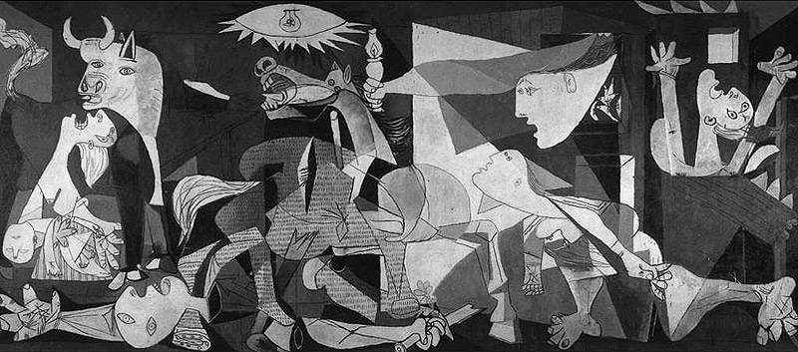

Transformations in art reflect transformations in war:
Pablo Picasso, ‘Guernica’, 1937
Sample Essay Marking Sheet

In order to demystify the assessment process, this is an example of the type of comment sheet that will be used when marking your essays. It’s provided here for your reference (there’s no need to copy or hand in this sheet). Please review the categories of assessment before submitting your essays. Note that structure, content, and style are evaluated across the entire essay; checkmarks will be placed in the corresponding boxes to provide diagnostic help for improvement. The comments on your essay are more important than the boxes ticked.

Student Name:_______________________________________________

 | Excellent |  | Competent |  | Needs Attention
Reading/Research
evidence of compulsory reading
Perception and Comprehension
understanding of essay question/topic
defining key terms and concepts
engagement with reading
Argument
answering the question
appropriate ideas and interpretations
all claims backed with evidence
Structure and Organisation
introduction and conclusion
properly constructed paragraphs
logical development of ideas
Style
clarity of expression
formal language, spelling, grammar
Referencing
appropriate use of footnotes/endnotes
accurate notes and bibliography
COMMENTS

MARK: GRADE:

