WORKSHOPS: CLASS CONTENT:LEC/TUT/READINGS, ESSAY 101, SOURCES/BIBLIOGRAPHY/REFERENCING…
WANANGA: WHOLE DAY STUDY SESSIONS FOR LARGE ESSAYS AND EXAMS: TUTOR AND LECTURERS…
STUDY SESSION: BOOK OUT SPACES FOR STUDY, BOTH DISCUSSION BASED IN ASC AND SILENT SPACES.

ANCHIST 110 SPECIFIC
11-12 Tuesday, Room 308 Arts 1
CLASSICS 110 SPECIFIC
12-1 Wednesday, Room 308 Arts 1
ANCHIST & CLASSICS DROP IN
11- 12 Wednesday, Room 308 Arts 1
HUMANITIES DROP IN
10-2 Every Week Day, Room 308 Arts 1

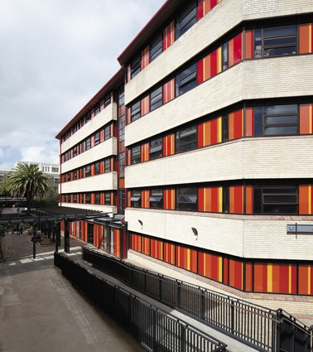

Contact Details: mste856@aucklanduni.ac.nz

Facebook Page: Tuākana: Ancient History and Classics 2018

