Goal:
In this lab you will familiarise yourself with the elements of an adult human skeleton. You will apply the anatomical definitions and should also be able to use that information to identify elements. A second goal is that you understand both the morphology and biology of bone from micro- to macro-structure so that you have a sense of bone as a living tissue and are able to work from first principles when examining bone.

Preparation:
Read http://bme.sunysb.edu/people/faculty/docs/crubin/2001-ESJ-bone-biology.pdf
Chapter 3 of Brickley, M The bioarchaeology of metabolic bone disease. New York: Wiley-Liss
Available via the library.
And these are two very helpful websites:
http://www.youtube.com/watch?v=inqWoakkiTc (AMGEN websites on bone biology)
http://depts.washington.edu/bonebio/ASBMRed/ASBMRed.html

Task:
Part 1:
You will each be asked to lay out a partial human skeleton in anatomical layout from cranium to feet. This involves you identifying and handling the elements. You can refer to the articulated skeletons for reference. You are then asked to write in your lab book the following observations:
- What the task was.
- What elements you identified and their side (i.e. an inventory including degree of completeness recorded as <25% complete, 25-50% complete, 50-75% complete, 75-99% complete, complete).
- Notes for yourself on the identification of elements:
- Cervical vs thoracic vs lumbar vertebrae
- Humerus vs radius vs ulna
- Positioning of the innominate – i.e. sketch it and indicate superior inferior, ventral dorsal.
- Femur vs tibia vs fibula
- Metacarpals/metatarsals and phalanges.
Part 2:
From your skeleton remove one long bone other than the tibia. In your lab book draw the bone and label the following structures: (You can refer to the anatomy atlases etc in the lab but make sure you identify these structures on your bone).
- Diaphysis (shaft)
- Epiphysis (proximal and diatal)
- Edge of articular capsule
- Line of epiphysiseal fusion
- Nutrient foramen
- Sharpey’s fibres
- Location of periosteal and endosteal surface (so will need to draw the bone in cross section as well)
- Lines of insertion (of muscles and tendons)
- Extent of trabecular bone (estimated)
- Any anatomical landmarks (e.g. greater trochanter etc – guide to these in anatomy atlases)
Having done that – then draw a horizontal cross section of your long bone (you can refer to diagrams and slides that are out) and identify:
- Lamellar bone
- Trabecular bone
- Haversian system (Osteon – primary, secondary, cement line, interstitial lamellae)
- Haversian canal
- Medullary cavity
Make sure that you are clear about the process of ossification and bone remodelling, as well as terminology.

PREVIEW: ANATOMICAL DIRECTIONS

Identifying human bone surfaces is done in reference to three planes dissecting the body:

The traverse plane lies across the body (see figure below) and that is the plane that defines superior (cranial) and inferior (caudal). Superior and inferior normally refer to irregular elements (e.g. the vertebrae) while long bones are referred to as proximal (closest to the head), distal (furtherest away from) e.g. the distal femur articulates with the proximal tibia.

The sagittal plane divides the body along the midline so bone surfaces are defined as to whether they are close to midline (medial) or the surface away from the midline (lateral).

The coronal plane divides the body from front (anterior or ventral) to back (posterior or dorsal).

The anatomical stance in adult humans can be considered to be a position in which the body is standing upright with both feet together, arms by the side, and both palms and face directed forward. Therefore, in this stance, the face-side of the body is the anterior side, while the other side is posterior. The head-end can still be referred to as cephalic or cranial, but is more commonly referred to as the superior end of the body. Opposingly, the feet are referred to as being inferior.

The palm side of the hand is called the volar or palmar surface, the other the dorsal. The sole of the foot is the plantar surface while the other side is the dorsal surface.

Note the terms superior/posterior, inferior superior refer to different directions in a quadruped (hence the drawing of the pig).
The head region of a quadruped or the front side of an
.
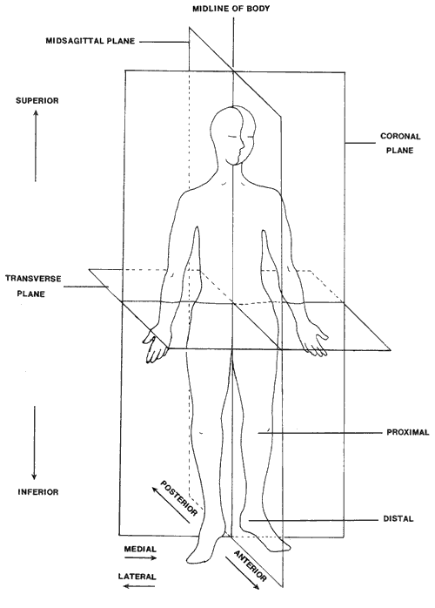
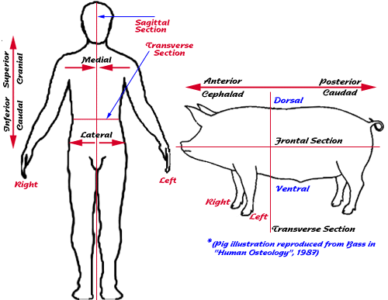
Dental Terminology

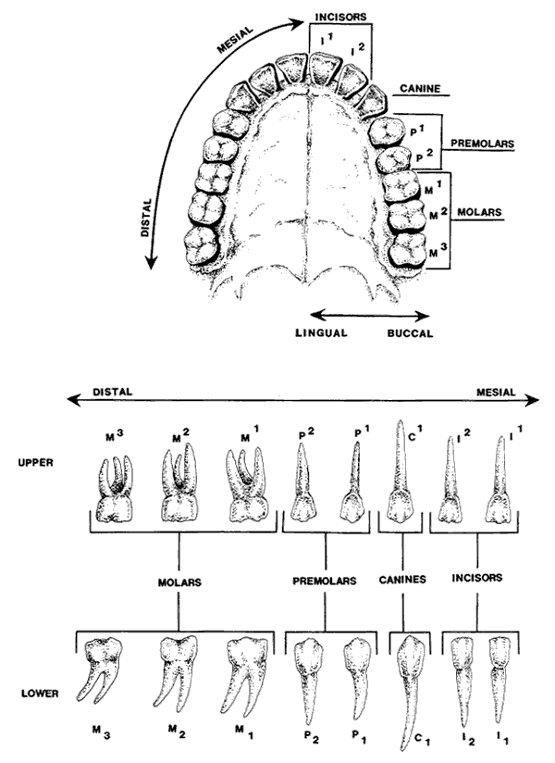

Surfaces on teeth are defined as lingual (closest to the tongue) and buccal (closest to the cheek) or labial (closest to the lip (relevant for the incisors), the other surfaces are defined as mesial (towards the midline) and distal (away from the midline)

The skeleton

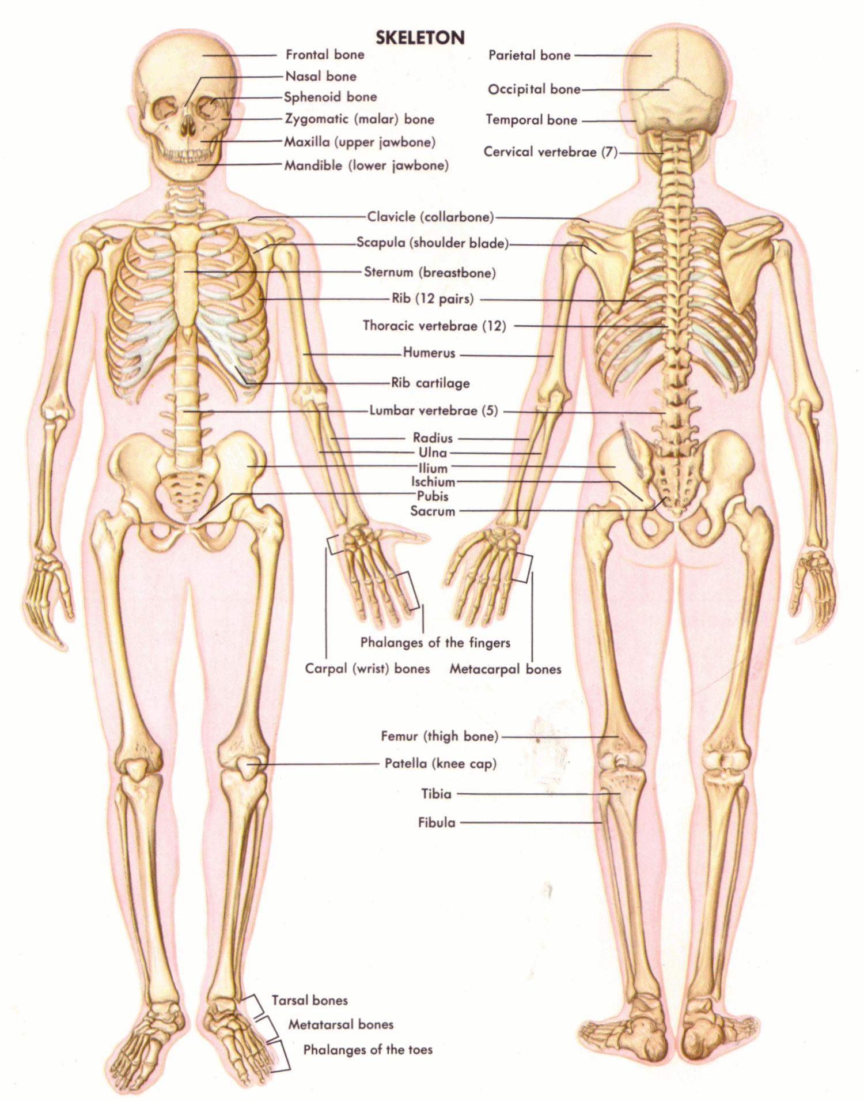
http://www.aokainc.com/wp-content/uploads/2013/10/Body-Skeleton.gif

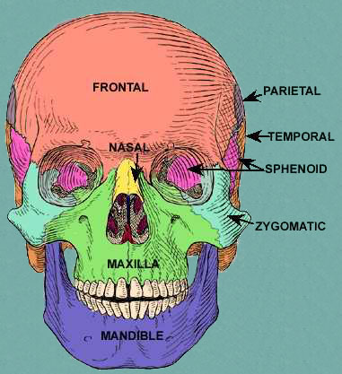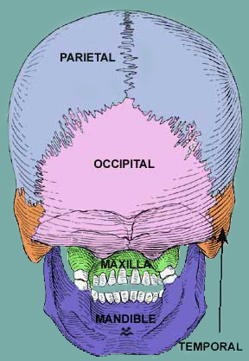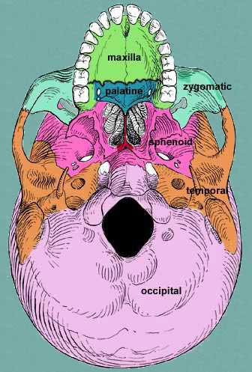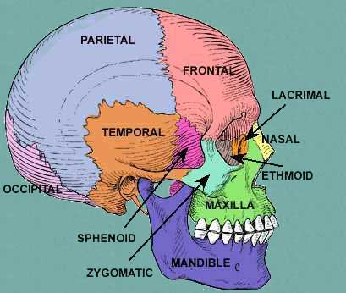

BONES OF THE CRANIUM

http://mmaarriiaa0.tripod.com/id3.html

