University of Auckland
Anthropology, School of Social Sciences,
Te Pokapū Pūtaiao Pāpori

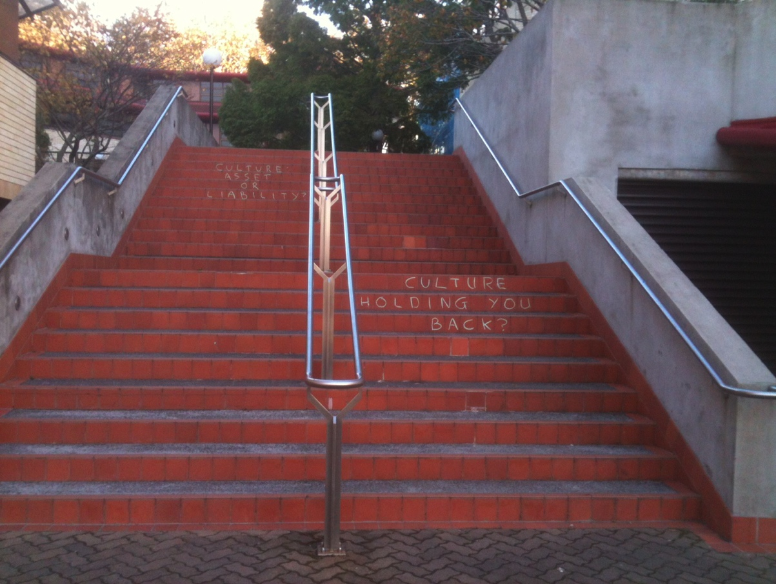
Photo Credit: Thegn Ladefoged (2014)

ANTHRO 753
Practicing Research Methods
Course Outline & Reading List
Semester 1 2018

University of Auckland ANTHRO 753 2018 Semester One Practicing Research Methods

Course Outline & Reading List

Course Co-ordinator:
Phyllis Herda

p.herda@auckland.ac.nz

HSB 810; ph 373-7599 ext. 87111

Office hours: Tuesdays 11:00-12:00

Please feel free to discuss with me any course-related matters or other academic issues.

Seminar Time and Place:
Wednesdays 3:00 – 5:00 in HSB 807.

Plus two Fieldwork Workshops of at a day/time/place to be arranged.

As a result of the time devoted to the workshop we will not have class in weeks 9 - 11, but I will keep additional office hours for individuals or groups in class time to assist with your final assignments.

I hope that you benefit from your work in this course and that you enjoy the experience of creating your own ‘data’ (which of course is never ‘given’), working with it and working collegially with your classmates and me.

The 2018 course is organised around a real-life class research-learning project on the topic of first year students’ experience of University. You will explore how first year anthropology students found their way to anthropology and try to understand their ‘life world’ at university. To do this you will learn to use a range of different approaches: interviews, participant observation, group discussion, walkabout (multisensory) and visual approaches, and how to apply relevant analyses. You will be encouraged to use a reflexive approach. Finally you will get the opportunity to ‘write up’ a short ethnographic essay on an aspect of your research, practice writing a research proposal on your (completed) project, and reflect on what you have learned.

Remember: this is a class learning exercise during which you can have hands-on practice using various techniques and learn what is involved. You will learn as much from reflections on what goes not so well as from what goes well.

The key is to KEEP IT SIMPLE, CLEAR, AND MANAGEABLE! Budget your time to organise and index your material, and start writing early.

Course Prerequisites and Restrictions: course prerequisites = BA in Anthropology; course restrictions = Anthro 711, 734

Course and learning objectives:
1. To study the place of field, library, and archive research in social anthropology
2. To become familiar with a range of ethnographic field methods and techniques, applicable in diverse research situations
3. To gain closely supervised research practice including research design, proposal writing and ethnographic writing, while working on a research learning project
4. To develop an understanding of the theoretical, epistemological and ethical implications of various approaches to research
5. To be able to argue for your disciplinary perspective on research
Course Readings are available on-line through the Anthro 753 page on Canvas. In addition two ethnographies of US university student life and an article about Auckland University which you may find useful are:
Nathan, Rebekah, My Freshman Year: What a Professor Learned by Becoming a Student, Cornell University Press, Ithaca, NY, 2003 (Author name is a pseudonym for anthropologist Cathy Small)
Moffatt, Michael, Coming of Age in New Jersey: College and American Culture, Rutgers University Press, New Brunswick, N.J., 1989
Shore, Cris & Mira Taitz, ‘Who “Owns” the University? Institutional Autonomy and Academic Freedom in an Age of Knowledge Capitalism’, Globalisation, Societies and Education, vol. 10, no. 2, 2012, pp. 201-219
What is expected from students:
1. Satisfactory preparation and completion of set tasks, including readings, exercises, presentations and oral discussions in class. Note that you are expected to spend 10 hours a week on this 15 point course.
2. Each exercise and written assignment should have your name and ID number and ANTHRO 753 on the front page, plus the title of the assignment. Be sure to keep a back-up copy of all your notes as well as your work for handing in. Email to yourself or use a pen drive or similar. All written work must be done on a computer and conform to departmental policy. I do not accept late work without penalty except under exceptional circumstances which may require documentation.
3. Be familiar with the Auckland University ethics guidelines for research with people (human participants). Ethics approval for research conducted within the guidelines of this paper has been obtained from UAHPEC, and oversight of this research has been delegated to your lecturer. Please make sure you are thoroughly familiar with the grounds for this permission and use the approved Participant Information sheet and consent forms. See http://www.auckland.ac.nz/uoa/re-uahpec for the University Ethics principles.
4. If you are unavoidably prevented from attending class, please email me before class. Any student who misses a class must turn in legible notes on the reading/s as soon as possible and discuss other catch up work as necessary to qualify for participation grades.

5. My expectation is that in this class we will each think, discuss and debate as anthropologists. That is, we use concepts that are scholarly, are conscious of the language we use, as well as the way that our personal values and experiences are reflected in our views. Please be careful and sensitive when you talk about race, gender, sexuality, class, faith, etc. Avoid inflammatory or exclusionary language. I reserve the right to ask you to reframe or refrain if, in our opinion, your contribution does not meet these criteria. Please be considerate of others.

Assessment:

3 Major Components (1: Preparation, Presence & Participation; 2: Practicing Research Methods; 3: Writing Up Your Research & Writing A Research Proposal)

1: Preparation, Presence and Participation (10% of total course marks)

- Read all required readings before class and prepare concise notes in preparation for discussion or exercises.
- Hand in notes for 3 seminars at end of that class.
- Participate intelligently in discussions and in-class exercises. Lead the discussion in at least one class seminar.

10% of your grade will be based on a composite of these three criteria representing class involvement: preparation, presence and participation. Hard copies of your reading notes -- your brief responses to the required readings -- for three seminars must be turned in at the end of that class. Remember, it is not how much you say, but what you say that demonstrates that you have read assignments, thought about them, and are paying attention to what others are saying that counts. In addition, you will lead the discussion in at least one seminar.

2: Practicing Research Methods (combined = 40% of total course marks)

- Take part in a walking tour of the university with your participant, which includes some of its significant features according to him or her. Note sensory phenomena and how your participant feels about it and its importance in their life. (Description should be around 750 words, excluding maps, diagrams, captions and quotes. Also hand in your fieldnotes, which should include reflections on how it went.) Worth 15% of total course marks; due noon, Friday 23 March.

- Undertake a semi-structured interview of about 30-50 mins, transcribe a minimum of 15 minutes of this, make a summary of main themes and important structural features of the whole interview with relevant quotes, and make notes about things you might have done differently. About 500 words, excluding transcription and quotes. Worth 15% of total course marks; due noon, Thursday 29 March.

- Complete a third method of your choice and write a description. You might join with your fellow students to do a focus group with your participants, or at your participant’s invitation, join in a relevant activity with him or her, or do a semi-structured interview or questionnaire on a specific topic perhaps using different media (eg phone or email), use photography as a research method or another approved technique. Describe the method that you used, summarise the results in about 500 words and turn in your fieldnotes which should include some reflections on how it went. Worth 10% of total course marks; due noon, Friday 20 April.

3. Writing Up Your Research & Writing A Research Proposal (combined = 50% of total course marks):

A. Thematic research report: Chose a theme from your research materials and write a brief, focussed ethnographic piece, integrating it with relevant academic literature. This will read like a section of an ethnography. Include an introduction to the theme, your ethnographic analysis with relevant literature, a conclusion, a list of references used and an abstract. Approximately 2,750 words (report = 2500; abstract = 250 words). 30% Due noon, Friday 11 May

B. Research proposal: The topic of your research proposal will be a question about the experiences of first year university students (it might be on the theme you wrote about in the thematic research report). This will follow the headings of a ‘real’ research proposal: Title; Aim; Significance including literature review, Research Design and Methods, Ethical considerations. It should also include an annotated bibliography of at least 10 items, demonstrating that you have mastered the use of at least three different academic databases. Approximately 1,250 words. 20% Due noon, Friday 1 June

Academic resources
The University provides many Academic resources for graduate students which you can access through SLC and the Library.
If you want to improve your writing, please seek help as early as possible from Student Learning http://www.library.auckland.ac.nz/student-learning. These services also include
English Language support.
Use web-based sources with care, checking their academic credentials, before citing them.
The Anthropology Department essay guide and other useful forms and information are available on http://www.arts.auckland.ac.nz/en/about/schools-in-the-faculty-of-arts/school-of-social-sciences/forms-for-students.html
Please consult the ‘Survival Guide’ which is provided by the Graduate Advisor in Anthropology.

Department Seminars
You are strongly encouraged to attend the Thursday 4pm seminars. Seminars are an opportunity for you to see and hear other graduate students, visitors and staff present their research and to take part in discussions. They are an important part of staff and graduate student academic and social life.

Complaints
Should some difficulty arise, please see Phyllis in the first instance (if that is appropriate). Alternatively contact the Social Anthropology graduate student representative. Your Graduate Advisor (Mark Busse) and Head of Discipline (Christine Dureau) can also help. The Department and the University has well established processes for dealing with difficulties or complaints, see
https://cdn.auckland.ac.nz/assets/central/for/current-students/postgraduate-students/documents/policies-guidelines-forms/resolution-of-student-academic-complaints-and-disputes-statute.pdf

Personal resources
The University provides many academic, personal and technical resources and support. Take the time to look under “Current Students” on the university website for an introduction to these, or CONTROL click here (if you are using this on line) http://www.auckland.ac.nz/uoa/for/currentstudents/currentstudents.cfm

Academic Honesty and Integrity
http://www.auckland.ac.nz/uoa/home/about/teaching-learning/honesty
Please take the time to study the university’s guidelines on academic honesty.

The University of Auckland will not tolerate cheating, or assisting others to cheat, and views cheating in coursework as a serious academic offence. The work that a student submits for grading must be the student's own work, reflecting his or her learning. Where work from other sources is used, it must be properly acknowledged and referenced. This requirement also applies to sources on the world-wide web. A student's assessed work may be reviewed against electronic source material using computerised detection mechanisms. Upon reasonable request, students may be required to provide an electronic version of their work for computerised review.

Turnitin: In order to ensure you submit work that reflects your learning, coursework must be submitted to Turnitin. In order to upload your work to Turnitin go to www.turnitin.com and follow the prompts.

Our class # for Turnitin is: 12132608

Our class password for Turnitin is: Research (case sensitive)

Seminar Schedule
Don’t forget to make notes on questions and topics from the readings for class discussion. You will lead discussions of the readings in at least one seminar and we will work this out in Week 1.

Week One:

28 February Introductions of people and to the course

Required Reading: ANTHRO 753 Course Outline & Reading List – carefully READ THE ENTIRE OUTLINE so you will be familiar with my expectations of you for the course

Malinowski, B., ‘Introduction: The Subject, Method and Scope of This Enquiry’, Argonauts of the Western Pacific, E.P. Dutton and Co., New York, 1961 [1922], pp.1-25 [no ISBN]

Dyck, N., Home Field Advantage? in V. Amit (ed), Constructing the Field: Ethnographic Fieldwork in the Contemporary World, Routledge, London and New York, 2000, pp. 32-53 [ISBN 0-415-19830-5]

Week Two:

7 March Getting Started: participating, observing & asking questions

Required Reading: Thomas, D. H., ‘What are Anthropological Data?’, in Figuring Anthropology, Holt Rinehart and Winston, New York, 1976, pp.19-29 [ISBN 0030028566]

O’Reilly K, ‘Participating and Observing’, in Ethnographic Methods, Routledge, London, 2005, pp. 84-111 [ISBN 0415321557]

Spradley, J., ‘Interviewing an Informant, Asking Descriptive Questions’, in The Ethnographic Interview, Holt, Rinehart and Winston, New York, 1986, pp. 55-69, 79-91 [ISBN 0030444969]

Week Three:

14 March Understanding Ethics: designing & practising
ethical research; sensory research methods

Required Reading: Jackson, M., Lifeworlds: Essays in Existential Anthropology, University of Chicago Press, Chicago, 2012, pp 3-9. ( A Google eBook, and this excerpt is available free) [ISBN 10: 0-226-92366-5]

Blommaert, J. and Jie, D., Ethnographic Fieldwork: A Beginner’s Guide, Multilingual Matters, Bristol, 2010, pp. 4-15 [ISBN 978-1-84769-294-8]

Ethical Guidelines from Association of Social Anthropologists of Aotearoa/New Zealand and the Association of Social Anthropologists of the UK and the Commonwealth, 1999

Workshop #1: Practising data collection methods with classmates: life-story and other semi-structured interviews, walkabout learning, sensory research methods, the walking tour, visual methods, sounds, smells, spatiality, as part of understanding the life-world, socio-scapes

Week Four:

21 March Recording & Keeping Fieldnotes

Required Reading: Spradley, J. ‘Doing Participant Observation, Making an Ethnographic Record and Making Descriptive Observations’, in Participant Observation. New York, Holt, Rinehard and Winston, New York, 1979, pp.53-81 [ISBN 0030445019]

LeCompte, Margaret D. and Jean J. Schensul, ‘Tidying Up, Cataloguing, and Creating Data Inventories’, in Analysis and Interpretation of Ethnographic Data: A Mixed Methods Approach, Altamira Press, Plymouth, 2013, pp. 51-64 [ISBN 978-0-7591-2207-9]

Walking Tour due noon, Friday 23 March

Week Five:

28 March Photography & the Field

Required Reading: Collier, John Jr. & Malcolm Collier, ‘Principles of Visual Research’, in Visual Anthropology: Photography as a Research Method, University of New Mexico, Albuquerque, 1986 [1967], pp. 161-173 [ISBN 0 8263-0899-6]

Scherer, Joanna C., ‘The Photographic Document: Photographs as Primary Data in Anthropological Enquiry’, in Edwards, Elizabeth (ed), Anthropology and Photography, 1860-1920, Yale University Press, New Haven and London, 1992, pp. 32-41 [ISBN 0300051689]

Hirsch, Julia, ‘Place and Time’, in Family Photographs: Content, Meaning and Effect, Oxford University Press, New York and Oxford, 1981, pp. 47-79 [ISBN 0195028899]

Workshop #2 Libraries and Archives: Finding relevant and useful material and using bibliographical software

Required Reading: Zeitlyn, D., ‘Anthropology in and of the Archives: Possible Futures and Contingent Pasts; Archives as Anthropological Surrogates’, Annual Review of Anthropology vol. 4, 2012, pp. 461-480. doi: 10.1146/annurev-anthro-092611-145721 [electronic resource]

Galloway, Patricia, ‘The Unexamined Habitus: Direct Historic Analogy and the Archaeology of the Text’, in Practicing Ethnohistory: Mining Archives, Hearing Testimony, Constructing Narrativeˆ, University of Nebraska Press, Lincoln, 2006, pp. 55-77 [ISBN 0803271158]

Semi-structured interview due noon, Thursday 29 March

30 MARCH – 14 APRIL: easter/MID-SEMESTER Break

no SEMINARS

Week Six:

18 April Reflecting on ‘The Field’

Required Reading: Gupta, A., & Ferguson, J., ‘Discipline and Practice: “The Field” as Site, Method, and Location in Anthropology’, Anthropological Locations: Boundaries and Grounds of a Field Science, 1997, pp.1-46 [ISBN 05200-20680-0]

Marcus, George, ‘Ethnography In/Of the World System’, Annual Review of Anthropology, vol. 24, 1995, pp.95-117 [ISSN 0084-6570]

Third Method due noon, Friday 20 April

Week Seven: 25 April: Anzac Day

no SEMINAR

Week Eight:

2 May Preparing Research Proposals, Writing Ethnographies and the Dissemination of Research

Required Reading:
Silverman, S., ‘Writing Grant Proposals for Anthropological Research’, Current Anthropology, vol. 32, no. 4, 1991, pp.485-489 [ISSN 00113204]

Emerson, Robert, Rachel I. Fretz and Linda L. Shaw, ‘Writing an Ethnography’, in Writing Ethnographic Fieldnotes, The University of Chicago Press, Chicago and London, pp. 169-210 [ISBN 0-226-20681-5]

Boellstorff, T. 2008 and 2010. How to Get an Article Accepted at American Anthropologist (or Anywhere). American Anthropologist, (electronic resource in 2 parts):
Part 1:Vol. 110, Issue 3, pp. 281–283 [ISSN 0002-7294 online ISSN 1548-1433. DOI: 10.1111/j.1548-1433.2008.00034.x] ; .
Part 2: 112, Issue 3, pp. 353–356 [ISSN 0002-7294 online ISSN 1548-1433. DOI: 10.1111/j.1548-1433.2010.01244.x]

Week Nine - Eleven: As a result of the time devoted to the workshops we do not have class in weeks 9 - 11, but I will keep additional office hours for individuals or groups in class time to assist with your final assignments.

Thematic Report due noon, Friday 11 May
Week Twelve:

30 May Reflecting on Where We Have Been

Required Reading: Davies, C.A., Reflexive Ethnography: A Guide to Researching Selves and Others, Routledge, London, 2008, pp.10-27 [ISBN 978-0-415-40901-8]

Brettell, C., Introduction’, in C. Brettell (ed), When They Read What We Write, Westport, CT. Bergin and Garvey, Westport, 1993, pp. 1-23 [ISBN 0897893255]

Research Proposal due noon, Friday 1 June

Suggestions for further reading:

In addition to the required readings on Canvas, there are many texts about all phases of doing research from planning, through data collection and analysis, to writing, which could be of help to you. Use your library searches to find them. I have selected some which are particularly useful.

V. Amit (ed), Constructing the Field: Ethnographic Fieldwork in the Contemporary World, Routledge, London and New York, 2000

Antonius, C., G. M. Robben, and Jeffrey A. Sluka (eds), Ethnographic Fieldwork: An Anthropological Reader, Blackwell Publishing, Oxford and Melbourne, 2007

Blommaert, J. and Jie, D., Ethnographic Fieldwork: A Beginner’s Guide, Multilingual Matters, Bristol, 2010

Boellstorff, T.,Nardi, B., Pearce, C., and Taylor, T.L., Ethnography and Virtual Worlds: A Handbook of Method, Princeton, Princeton University Press, Princeton, 2012

Brettell, C. (ed), When They Read What We Write, Westport, CT. Bergin and Garvey, Westport, 1993

Collier, John Jr. & Malcolm Collier, Visual Anthropology: Photography as a Research Method, University of New Mexico, Albuquerque, 1986 [1967]

Davies, Charlotte Aull, Reflexive Ethnography: A Guide to Researching Selves and Others, Routledge, London, 2008

Emerson RM, Fretz R.I., and L.L. Shaw, Writing Ethnographic Fieldnotes The University of Chicago Press, Chicago, 1995 and 2011

Faubion, J., G. Marcus, and M. Fischer (eds), Fieldwork is Not What it Used to Be: Learning Anthropology’s Method in a Time of Transition, Cornell University Press, Ithaca,

Gay y Blasco, Paloma and Huon Wardle, How to Read Ethnography, Routledge, London, 2007

Jackson, Michael, Lifeworlds: Essays in Existential Anthropology, University of Chicago Press, Chicago, 2012

Leach, Helen, in Cultivating Myths: Fiction, Fact, and Fashion in Garden History, Godwit Press, Auckland, 2000

Leedy, P and Ormrod, J., Practical Research, Merrill, Prentice Hall, Columbus, 2991

Madden, Raymond, Being Ethnographic: A Guide to the Theory and Practice of Ethnography, Sage, Los Angeles, 2010

Norman K. Denzin, and Yvonna S. Lincoln, The SAGE Handbook of Qualitative Research, Sage, Thousand Oaks, 2011 (all editions are useful and contain different articles)

O’Reilly, Karen, Key Concepts in Ethnography, Sage, London, 2009

Pink, S., Doing Sensory Ethnography, Sage, London, 2009

Rountree K. and P. Laing, Writing by Degrees, Longman, Auckland, 1996

Scherer, Joanna C., ‘The Photographic Document: Photographs as Primary Data in Anthropological Enquiry’, in Edwards, Elizabeth (ed), Anthropology and Photography, Yale University Press, New Haven and London, 1992

Spradley, J., Participant Observation, Holt, Rinehard and Winston, New York, 1979

Spradley, J., The Ethnographic Interview, Holt, Rinehart and Winston, New York, 1986

