Location of TV Studio, Kenneth Meyers Centre, Shortland Street
The Television studio is located in the Kenneth Meyer’s Centre (KMC) Shortland Street. This is at the Princes Street end of Shortland Street and the historic, stylised brick exterior with the antique aerial on the roof is easy to identify, cramped between the modern high rise buildings. It will take you approximately 10 minutes to walk to the studio at KMC from the main campus.

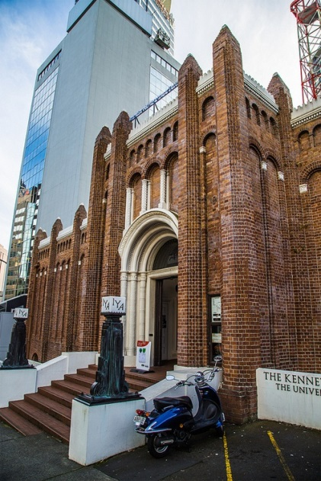

The Television Studio is at street level, accessed through the Art Gallery foyer and left at the top of the stairs (the doorway to the left in the photo below).

