COMMS 203: Television Journalism

Semester 2, 2018
COMMS 203 is a practical course introducing students to the production of television current affairs journalism. The course is split between working in the University's High Definition multi-camera television studio and working in the field learning single camera production skills and post production editing. Students learn to write, video, present and edit short current events style news items in the field and integrate these into a multi-camera production recorded 'as live' in the television studio at the end of the semester. Studio skills include directing, production management, multi-cam scripting, vision switching, presenting and interviewing within a framework of current industry practice.

Time: Thursday 9-12am (alternating between TV studio/edit suites)

Course Convenor: Dr Margaret Henley
HSB, Room 537
m.henley@auckland.ac.nz
373 7599 x 87571

Field Production & Peter Simpson
TV Studio Tutor: HSB, Room 532, x 86657
pj.simpson@auckland.ac.nz

TV Studio Technical
Assistant: Tim Signal
HSB, Room 527, x 86224
t.signal@auckland.ac.nz

Editing Tutor: Martin Hansen: Arts 1, Room 132, x 84596
m.hansen@auckland.ac.nz

Locations: 1) TV Studio
TV Studio, Level 4 (street level) KMC,
Kenneth Meyers Centre,74 Shortland Street (see photo pg. 5)
2) FTVMS Mac Lab

HSB Room 160, level 1 (access off Wynyard Street)
3) Television Gear Store, Arts 1, level 1, Room 131
4) Demonstration Room (intro to cameras and sound equipment)
HSB level 1, Room 143.

Set Readings:
Reading and viewing resources will be supplied on Canvas.
There is no set text for the course but a recommended practical text is:
‘Producing Videos: A Complete Guide’, 3rd Edition, 2001, Martha Mollinson, Allen & Unwin,
Relevant readings and youtube links will be supplied on Canvas.

Viewing:
You are required to regularly view a range of interview and magazine format programmes.
You are also expected to watch previous FTVMS 201 (renamed COMMS 203 in 2018) programmes available at the front desk in the main library. This should be done as a group before mid-semester break to help you with ideas for the topic, content and presentation of your own programme.

AV Material
There are a large number of studio interview programmes available for viewing our Media, Film & Television AV Library collections (available from the Front Desk in the main Library). A range of local and overseas interview programmes/magazine style programmes should be watched for interviewing techniques as well as magazine style format for content and technical production. These should range from entertainment/celebrity chat shows through to political magazine and current affairs programmes.

You should comment on Piazza or the Canvas class discussion page about your viewing and discuss the different content, structure and interview techniques with your classmates. I will be putting suggestions on Canvas each week for interview and magazine format programmes to watch for general class debate which will act as an online tutorial discussion.

Canvas Communication:
All major announcements, course outline, assessment information and course notes will be on Canvas. You must ensure that your email address is correct and that you are receiving emails via Canvas and check Canvas daily.

ASSESSMENT
Course assessment:
There is no final exam as this course is 100% internal assessment. The final marks will be made up of a mix of individual and group marks. Therefore attendance is a vital part of your overall assessment. There can be no course clashes or unexplained absences for this production paper, even absences with a medical certificate will jeopardise your assessment and that of your group.
All absences must be notified before class.

Assignments:
1) Assignment No 1: Practical exercises 20% (Individual & Group)
Due dates:
- Editing Exercise: (individual) Monday 27 August (end of week 6)
- Interview: (group shoot, individual edit) Thursday 13 September (end of week 7)
- Vox Pop: (group shoot, group edit) Friday 5th October

All editing assignments will be placed into the 203 dropbox. Martin will take you through the process.

2) Assignment No2: VT items
Due: Thursday 18 October (no extension possible) 30% (indiv & group work)
Single camera production/editing assignment to be used as inserts in the final studio programme.
2 x 1.5-2 mins inserts (to be used in studio assessment)
These inserts must be ready to use for the last rehearsal day on Friday 27 October. You need to have these VT items edited by Thursday at the latest to be able to integrate them into your final programme during the last rehearsal.

3) Assignment No 3: Recorded Programme 50% (indiv.& group)
Tuesday 23 October

‘Live’ Studio Interview Programme with two ‘outside’ guests. Duration: 23mins maximum.
All group documentation to be collated in hard copy file or in ONE google doc. By Monday 6 November. DAs responsible for making sure that each group member provides their folder of documents to be included in the group file box or grouped under each production role on the memory stick.

Handing in assessments:
Assignment No 1: Submission of edit to course file
Assignment No 2: VT inserts x 2. Hand in your written work and clearly labeled memory stick to Margaret by the date due – see assessment sheet for details.
Because of the production nature of the course no extensions are possible for assessments
2 & 3 – this is not negotiable. If you fail to meet these deadlines your whole group fails.
(This is the world of live television!).

Attendance: important
You may not have any absences throughout the semester unless there are exceptional circumstances. If you are going to be absent please let Margaret know in advance or on the day by email so we can accommodate your absence. This is particularly important for crewing the television studio.

BE WARNED
Unexplained absence or the lack of a legitimate reason to be absent or late to class will result in 5 marks per absence being deducted from your final assessment.
As the work in the latter part of the course is group work then it is imperative that you have 100% attendance or you will jeopardise both your individual assessment and that of your group.
If you have a legitimate medical reason for an absence, it is vitally important that you keep in contact with Margaret and your group regarding all work after mid-term break in particular.

Access to Equipment
1) TV Studio
The TV studio is only available for use within set class times no other rehearsal times are available (assessment is based on experience gained during a set number of hours in the facility, which must be the same for every group). The only concession to this is the 30 minute rehearsal for each group on the last Friday of the semester.

2) Edit Suites – Mac Lab HSB level 1, Room 160
The Mac Lab is block booked for class time and from then on will be available on a booking basis at other times as well as after hours.

All bookings must be made through email with Martin Hansen (copy in both addresses on your email bookings). NO BOOKING will be accepted unless applied and confirmed through email with Martin.

If you are 15 minutes late for your booked editing time, your booking will become available for other class members.

After Hours Access to HSB Mac Lab
The producer of each production team will take responsibility for the swipe card which will be issued in the first week of term. That person will have the responsibility for collecting, administering and returning your group’s swipe card. University Security will have a list of the class should there be any problems. The Mac Lab is open until 11pm every week night and until 5pm weekends.

3) Video Cameras and production gear
These will need to be booked via email with Martin Hansen in the same way as the edit facilities.
Check the end of this handout for the gear booking sheet.

4) Raw footage
All raw footage is recorded onto the camera memory cards. At the end of each shoot you should transfer your footage onto the editing hard drives before you return the camera. Martin will go over this in class with you in your intro to the camera. If one of your group has an external hard drive you can also use this as additional protection of your footage but it must be available in the edit suite for all members in each group to access. It is highly recommended to back up all your footage to an external hard drive.

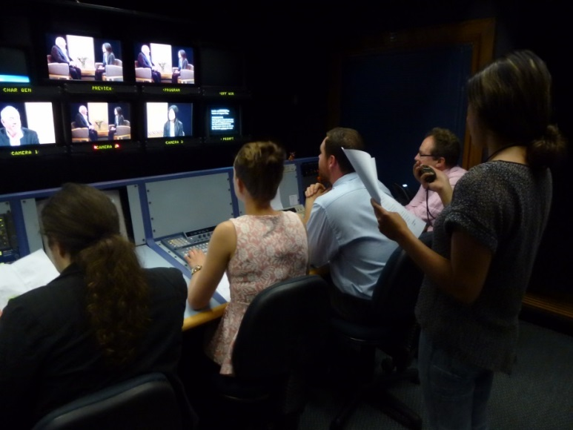

COMMS 203: Course Schedule: 2018
INTRODUCTION (2 Weeks)
Wk 1: 19 July 9am: All meet HSB level 1, Room 143. (The Black Box Studio)
Introduction to the course, assessment and attendance requirements.
Split into two production groups;
GELHORNS and the FISKS

1) GELHORNS in TV studio – 1x1 interviews
- FISKS – HSB level 1, Room 143. (Black Box)
Introduction to Camera and sound, gather shot coverage for 1x1 interview. To be finished out of class time and ready for editing by Week 4 (your second week in the edit suites).

Wk 2: 26 July 1) FISKS: TV Studio – 1x1 interviews.
2) GELHORNS: Intro to camera/sound: Shoot 1x1 field interview.
Introduction to Camera and sound, gather shot coverage for 1x1 interview. To be finished out of class time and ready for editing by Week 6 (your second week in the edit suites).

PRACTISING PRODUCTION SKILLS – Studio/edit suite/camera (4 weeks)
Wk 3: 2 August 1) GELHORNS: TV Studio –– completion of every group member directing. 2) FISKS: Intro to Adobe Premiere Edit Suites:
Editing exercise with footage supplied by Martin. Each student must complete the edit exercise and have it checked off by Martin.
Wk 4: 9 August Groups stay in same location as last week (2 week cycle)
- GELHORNS: TV Studio: Groups consolidate production roles and select topic for final assessment. Production exercises/VT items set up for Mid term break
- FISKS: Edit Suites: View own interview footage from first camera production exercise. Assess footage, log, digitise and edit.

Wk 5 16 August 1) FISKS: TV Studio
- GELHORNS: Edit suites
(Same as week 3 but groups reversed).

Wk 6: 23 August Assignment No2 and all details for Studio Assessment Day finalised
1) FISKS: TV Studio
2) GELHORNS: Edit Suite
(Same as week 4 but groups reversed)

MID TERM BREAK

27 August –9 September

Wk 7: 13 September 1) GELHORNS: TV Studio

2) FISKS: Vox Pop - planning and shooting

Wk 8: 20 September 1) FISKS: TV Studio
Working in production teams of 4 for final studio assessment
2) GELHORNS: Shooting Vox pop

PRE-PRODUCTION PLANNING (2 WEEKS)

Wk 9: 27 September 1) GELHORNS: TV Studio:
2) FISKS: Production Meetings with Margaret – Venue: TV Studio
2.30 – FISKS Gp 4
3.00 - FISKS Gp 5
3.30 - FISKS Gp 6

Wk 10: 4 October 1) FISKS TV Studio:
- GELHORNS: Production meetings with Margaret - Venue: TV Studio
2.30 – GELHORNS Gp 1
3.00 – GELHORNS Gp 2
3.30 – GELHORNS Gp 3

PRE-ASSESSMENT REHEARSAL PERIOD (2 weeks)

Wk 11: 11 October 1) GELHORNS: TV studio
Trial run of studio assessment programme with draft continuity script and VT inserts.
- FISKS - Time to complete VT items for programme.

Martin and Tim to complete technical check of the final edits for each group and load to server.

Wk 12: 18 October

1) FISKS: TV Studio
Trial run of studio assessment with draft continuity script and VT inserts.
Runners contacted and working with production teams.

2) GELHORNS – Time to complete Assignment No 2 for studio assessment.
Martin and Tim to check final edit and load to server during the week to be ready for the Friday 27th rehearsal.

Wk 12: 19 October: Friday 1-4pm FINAL REHEARSAL ALL GROUPS
Extra rehearsal time in studio. 30 minute run through for each group in assessment order. All components of each programme need to be finished by this date to ensure each group is able to have full rehearsal using at VT inserts.

As this is not scheduled class time, some of you may not be able to make it down to the studio for your rehearsal. DAs will organize with each other to make sure there are enough crew per session to rehearse each programme. Your timetabled classes take precedent over 203 but it is important to use this final rehearsal time efficiently and productively – it is your last chance before recording your programme on Tuesday.

Runners scheduled to work with each production team if they are available.

STUDIO ASSESSMENT DAY: Tuesday 23 OCTOBER

SCHEDULE (half day each production team of three groups)

  - Studio open for set dressing

  - GELHORNS Gp 1
  - GELHORNS Gp 2
  - GELHORNS Gp 3

12.30 – 1.30 LUNCH

12.30 Studio available for set dressing

  - FISKS Gp 4
  - FISKS Gp 5
  - FISKS Gp 6

Students are required to be there for the entire morning or the afternoon of your group programme and to crew for the other two groups as you have done all semester.

The studio will run ‘as-live’ all day, according to the above schedule. Any stand-down periods will be for technical error only, not human!

All students MUST be there for their half day and crew for each other. Absolutely no exceptions.

Studio etiquette will be observed by all participants at all times, any breaches in studio dress code or behaviour will incur a mark penalty.

