Spanish 206 / Spanish 306
Semester 2, 2018

Spanish Myths and Global Icons

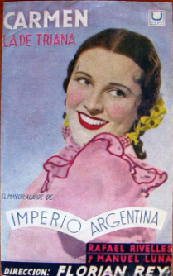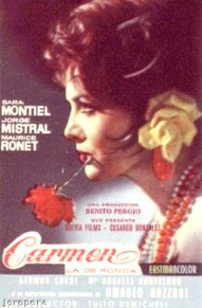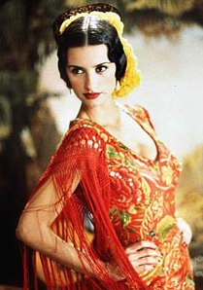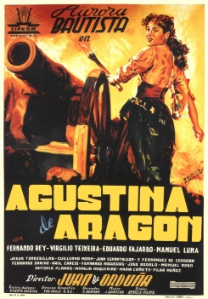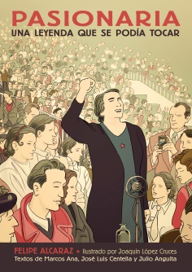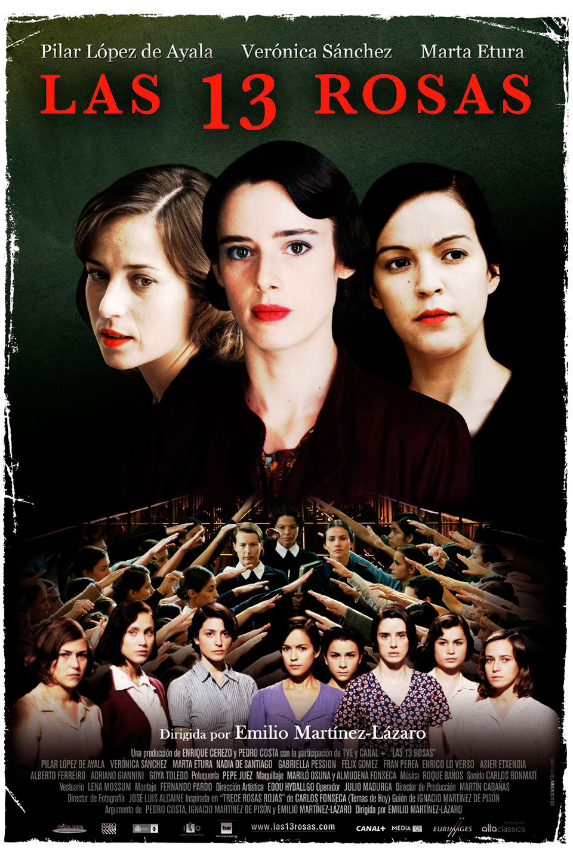

Lecturers:
Weeks 1-6: Prof. José Colmeiro (convenor) | Arts 2, Room 507| j.colmeiro@auckland.ac.nz
Office Hour: Thur 2-3pm
Weeks 7-12: Prof. Christine Arkinstall | Arts 2-404 | c.arkinstall@auckland.ac.nz
Office Hour: Wednesdays 1-2pm (Weeks 7-12)

Lecture, Tuesday 2-4pm: Arts 1, Room 209
206 Tutorial, Thursday 3-4pm: 201, Room 304
306 Tutorial, Thursday 4-5pm: 201, Room 304

Description: This course explores cultural representations of universal Spanish motifs in literature and the arts from the modern era to our global age. It examines both classical Spanish cultural myths (such as Carmen and Agustina de Aragón), as well as icons associated with Spain in modern culture. These cultural representations have created a series of powerful and universal images of Spain, which have been revisited and redefined in different periods and through artistic platforms. The course traces the formation, adaptation/appropriation and contestation of these images throughout different historical periods, and their intermedial circulation (literature, art, music, cinema, television). Through the analysis of the social and historical contexts, the course will foster the critical understanding of the cultural forces that determined these myths.

Assessment:
Spanish 206:
2 in-class 1 hour tests (20 % each)
2 essays (30% each, 1750 words each)

Spanish 306:
2 in-class 1 hour tests (20 % each)
2 essays (30% each, 2000-2200 words each)

Prueba #1: 16 de Agosto:
Prueba #2: 4 de octubre
Ensayo #1: 10 de Septiembre, 4pm
Ensayo #2: 31 de octubre

Texts: Electronic reading packets are posted on Cecil.
Programa del curso:

Semanas 1-6: José Colmeiro

Literatura, música y cine de la españolada: De Carmen a Penélope Cruz
Semana 1
Introducción: Imagología. Orígenes de la Españolada. La España romántica de Carmen.
Leer:
-Joep Leersseen, “Imagology: On using ethnicity to make sense of the world” Revue Iberic@l, Revue d’études ibériques et ibéro-américaines 10 (2016).
-Colmeiro, J. “El Oriente comienza en los Pirineos (La construcción orientalista de Carmen).” Revista de Occidente 264 (2003): 57-83.

Semana 2
Leer:
-Carmen (1845), novela de Prosper Mérimée, capítulos 1 y 2
-Robinson, Peter. “Mérimée´s Carmen.” In Susan McClary ed., Bizet’s Carmen. Cambridge UP, 1992. 1-14.

Semana 3
Leer:
-Carmen, capítulos 3 y 4
-Mickelsen, David. “Travel, Transgression, and Possession in Mérimée's Carmen.” The Romanic Review 87.3 (1996): 329+

Semana 4
Ópera Carmen (1875) de Georges Bizet
Leer:
-Libreto de Carmen de Henri Meilhac/Ludovic Halévy
-Susan McClary “The genesis of Bizet's Carmen” and “Images of race, class and gender in nineteenth-century French culture”. In Bizet’s Carmen.
Ver: Película Carmen de Francesco Rossi (1983)

Semana 5
Película Carmen (1983) de Carlos Saura
Canciones “Carmen de España”, “La nieta de Carmen”
Leer:
-Benet, Vicente and Sánchez Biosca, Vicente, “La españolada en el cine”, in Ser españoles. Imaginarios nacionalistas en el siglo XX, Javier Moreno y Xosé M. Núñez Seixas (eds.), Barcelona, RBA, 2013. 560-591.
-Susan McClary, “Carmen on film”. In Bizet’s Carmen.
-D'Lugo, Marvin. “Historical reflexivity: Saura's anti-Carmen” Wide Angle 9:3 (1987): 52-61.
-Fiddian, Robin W. “The Europeanization of Carmen.” In Challenges to Authority: Fiction and Film in Contemporary Spain. Eds. Peter Evans and Robin W. Fiddian. London: Tamesis, 1988.

16 de Agosto: Prueba #1

Semana 6
Película La niña de mis ojos (1998) de Fernando Trueba
Fragmentos de Carmen la de Triana (1938) y Carmen, la de Ronda (1959)
Leer:
-Hardcastle, Anne. “Representing Spanish Identity through españolada in Fernando Trueba´s The Girl of Your Dreams (La niña de tus ojos).” Film Criticism 31.3 (2007): 15-37.
-Colmeiro, J. “Nationalising Carmen: Spanish Cinema and the Specter of Francoism” Journal of Iberian and Latin American Research 15.1 (2009): 1-26.

Entregar el Ensayo #1: 10 de Septiembre, 4pm

Bibliografía:
Andreu, Xavier. El descubrimiento de España. Madrid, Taurus, 2016.
Benet, Vicente. “Spanish archetypes in transnational cinema: a comparative study of iconography” Journal of Spanish Cultural Studies 16.1 (2015): 1-19.
Benet, Vicente and Sánchez Biosca, Vicente, “La españolada en el cine”, in Ser españoles. Imaginarios nacionalistas en el siglo XX, Javier Moreno y Xosé M. Núñez Seixas (eds.), Barcelona, RBA, 2013. 560-591.
Davies, Ann and Phil Powrie. Carmen on Screen: An Annotated Filmography and Bibliography. Woodbridge: Tamesis, 2006.
Gabilondo, Joseba. “On the Inception of Western Sex as Orientalist Theme Park: Tourism and Desire in Nineteenth-Century Spain (on Carmen and Don Juan as Femme Fatale and Latin Lover)”, in Spain is (Still) Different: Tourism and Discourse in Spanish Identity. Eugenia Afinoguénova and Jaume Martí-Olivella, eds. Lanham, MD : Lexington Books, 2008.
García Carrión, Marta. “Españoladas y estereotipos cinematográficos: algunas consideraciones sobre su recepción en la España de los años veinte”. Les stéréotypes dans la construction des identités nationales depuis une perspective transnationale. Ed. Géraldine Galéote. Revue Iberic@l, Revue d’études ibériques et ibéro-américaines 10 (2016).
McClary, Susan. Bizet’s Carmen. Cambridge: Cambridge UP, 1992.
Perriam, Chris and Ann Davies, eds. Carmen: From Silent Film to MTV. Amsterdam: Rodopi, 2005.
Utrera, Rafael and Virginia Guarinos (eds.), Carmen global. El mito en las artes y los medios audiovisuales, Sevilla, Universidad de Sevilla, 2010.

__________________________________________________________________________

Semanas 7-12: Christine Arkinstall

“No Pasarán”: De Agustina de Aragón a La Pasionaria y Las Trece Rosas

Semanas 7-8
Agustina de Aragón en el drama de Rosario de Acuña, Amor a la patria (1877)

Semanas 9-10
Dolores de Ibárruri y la guerra civil española: They Shall Not Pass

4 de octubre: Prueba #2

Semanas 11-12
Las trece rosas: Representaciones de heroínas de la guerra civil

Entregar el Ensayo #2: 31 de octubre, 4pm

Bibliografía: TBC

