GOAL:
The goal of this lab is to start you on the road towards answering the most common question asked in the field “is it human or animal”? While you can learn each bone independently really the only way to fully be able to address this is to sort out in your head a series of first principles. So we are running two labs dealing with this issue. The first is introducing you to size and to joint shapes. The second is getting you to try your skills at identification.

READING AND PREPARATION:

Available online at the library:
Human and nonhuman bone identification a color atlas Chapter 1 Introduction

Diane L France Boca Raton, Fla. : CRC Press 2009
https://www-taylorfrancis-com.ezproxy.auckland.ac.nz/books/9781420062878

A useful website on joints:
http://cnx.org/content/m44786/latest/

TASK:

In this lab we will get you to undertake three different tasks: joint identification. element identification, Identification using complete element.

Background:

Joints are areas where the bones come into contact with one another. There are three joint types you should be familiar with: fixed joints, movable or synovial joints, and partly movable joints (see Appendix 1)

- Cranial sutures are an example of fixed joints. These are the margins where individual cranial bones meet and they are often very sinuous or jagged. In young individuals, the sutures may be unfused or incompletely fused. As the individual ages, the sutures fuse and in time they may disappear altogether.
- Movable or synovial joints are those where bones move freely. They are represented here by the smooth articular ends of long bones. Movable joints include ball-and-socket joints (femur-innominate), hinge joints (ulna-humerus), and pivot joints (first two cervical vertebrae and skull).
- An example of partly movable joints is the area where the pubic bones of the innominate meet. This is area is called the pubic symphysis marked on the articulated skeleton.

We have also placed out an articulated dog, baboon, bonobo and human skeleton as well as femora of a sheep, cow, pig, bird, dog. So you can think about relative size.

Appendix 1: Joint Types (Synovial joints)
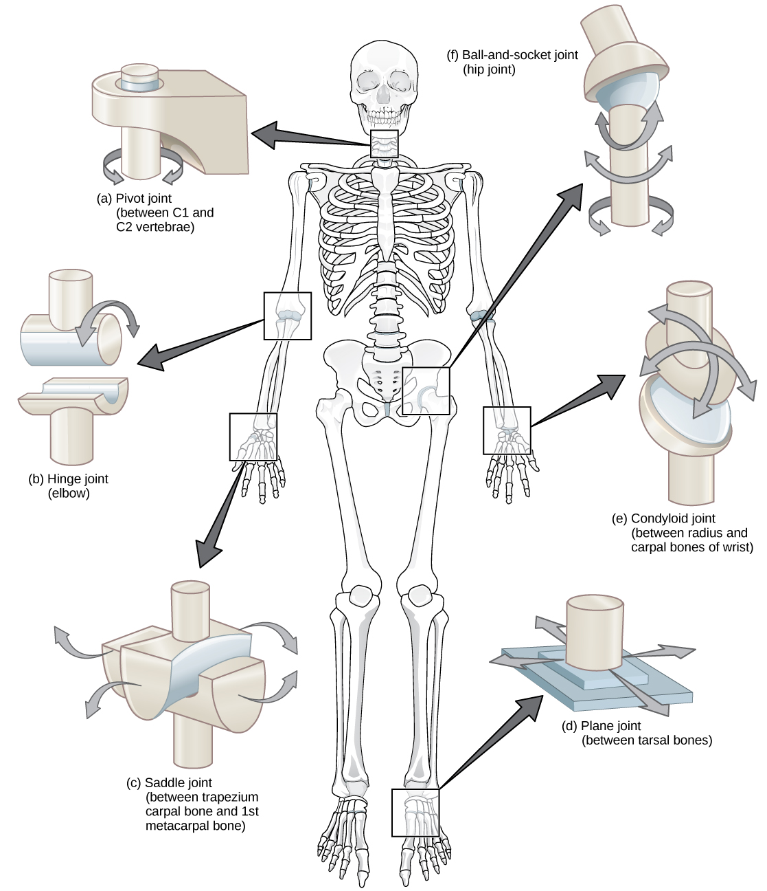

http://cnx.org/content/m44786/latest/
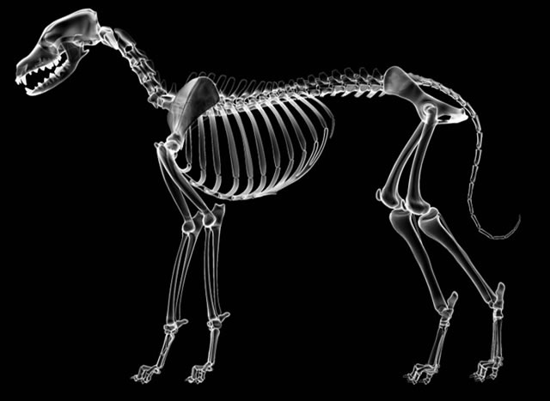
Dog skeleton
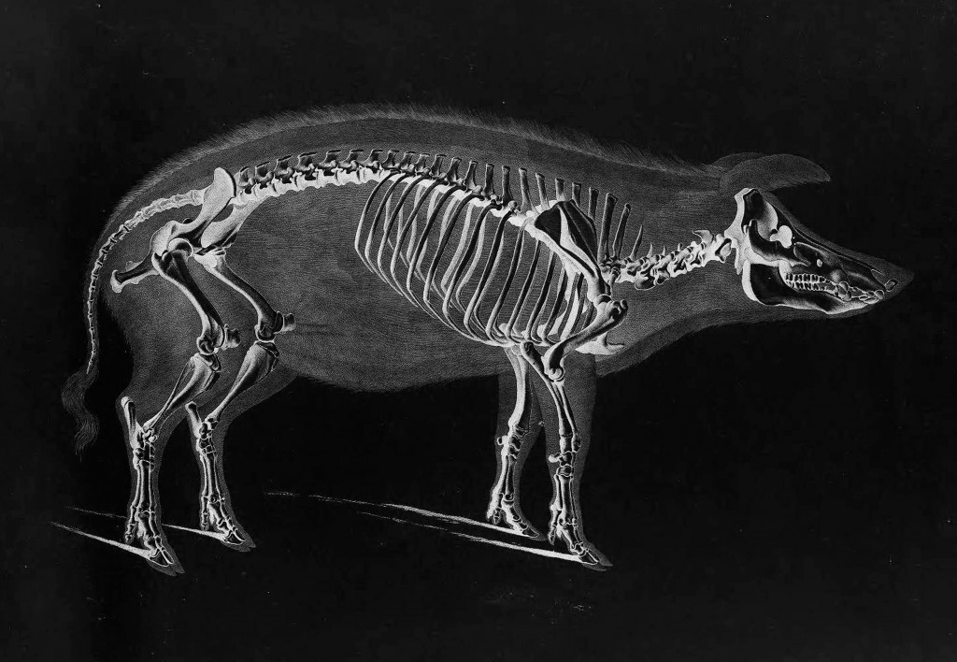Pig skeleton
NAME:___________________________________

EXERCISE 1.

Station 1. A OR B (circle which one you are examing)

Identify the following elements: they come from a range of animals but all we need you to do is to think about what element it is and whether it is human or nonhuman

a.
b.
c.
d.
e.
f.
g.
h.
i.
j.

EXERCISE 2.
Station 1. A OR B (circle which one you are examing)

Identify the type of joint and the range of movement involved:
 | Joint | Range of movement
a.
b.
c.
d.
e.

Take one of the animal joints (particularly forelimb or hindlimb) and compare the joint surfaces of a quadruped with the human biped – think about how to interpret movement from the joint surface.
EXERCISE 3:
Station 1. A OR B (circle which one you are examining)

Mystery element.

Identify this element and hypothesise what animal it comes from. Make sure you consider element, size, function.
Answer:
Element:_________________________________
Species _____________________________

