# Task:

Following on from last week, this week we move you onto more fragmentary remains. We have laid out bone fragments – both replicas and real and your task is to attempt an identification. You can discuss this and debate it with your fellow students, feel free to move around to the articulated skeletons. But before that you need to understand about identifying juvenile from adult material which you have studied before this class (see attached images). This class is also a chance for you to gain greater familiarity with the human skeleton so you should also lay out and think about the complicated identifications of:

The different types of vertebrae

Carpals versus tarsals

Metacarpals versus metatarsals

Proximal to distal phalanages

The different types of teeth

We have included a series of photographs taken in the field (yes these are photos that have been sent in for identification). Think about what works in the photo, how could these photographs be made more useful, what are the principles of a good photograph for identification.

# Preparation:

Read (as per last week) -

## Available online at the library: [Human and nonhuman bone identification a color atlas](http://librarysearch.auckland.ac.nz/primo_library/libweb/action/display.do?tabs=detailsTab&ct=display&fn=search&doc=uoa_alma51220904120002091&indx=2&recIds=uoa_alma51220904120002091&recIdxs=1&elementId=1&renderMode=poppedOut&displayMode=full&frbrVersion=&frbrSourceidDisplay=uoa_alma&frbrIssnDisplay=&dscnt=0&frbrRecordsSource=Primo+Local&vid=UOA2_A&institution=UOA&lastPag=&highlight=true&rfnGrp=frbr&tab=search_library&frbrJtitleDisplay=&vl(78265423UI0)=any&lang=eng&fromLogin=true&dstmp=1468798702181&group=GUEST&frbg=626917137&?dscnt=1&lastPagIndx=1&frbrSrt=date&query=any%2Ccontains%2Chuman+and+nonhuman+bone+identification&frbrEissnDisplay=&search_scope=Combined_Local&scp.scps=scope%3A%28Standard_record%29%2Cscope%3A%28Combined_record%29&cs=frb&fctV=626917137&bulkSize=10&fctN=facet_frbrgroupid&displayField=title&displayField=creator&dym=true&vl(freeText0)=human%20and%20nonhuman%20bone%20identification) Chapter 1 introduction.

### **Diane L France Boca Raton, Fla. : CRC Press 2009**

<https://www-taylorfrancis-com.ezproxy.auckland.ac.nz/books/9781420062878>

[.](http://dx.doi.org.ezproxy.auckland.ac.nz/10.1201/9781420062878)

 **Juvenile remains in varying degrees of fusion.**

[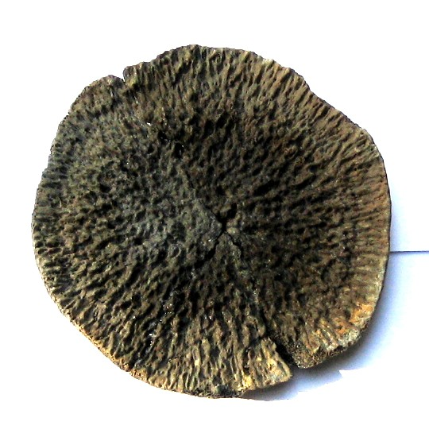](http://www.google.co.nz/url?sa=i&rct=j&q=&esrc=s&frm=1&source=images&cd=&cad=rja&docid=8usAYlgSq7cALM&tbnid=ELZz5lgdCHgyNM:&ved=&url=http://www.thefossilforum.com/index.php?/topic/3395-need-help-reassembling-a-whale-vertebra/page-2&ei=pJkOU5jLOsqxlAWDrIC4DA&bvm=bv.62178728,d.dGI&psig=AFQjCNE17hYB25tt6i6zN7AZk-Gl-e0Htg&ust=1393551349009187)

Surface of unfused epiphysis (whale vertebrae).

[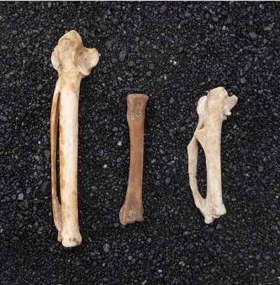](http://s893.photobucket.com/albums/ac137/ossamentaDW/?action=view&current=juvfagelcmc.jpg)

Two adult bird bones (carpometacarpus) and the unfused bone in the centre.

|  |  |  |  |
| --- | --- | --- | --- |
| Number | Adult/juvenile | Element | Species |
| 1 |  |  |  |
| 2 |  |  |  |
| 3 |  |  |  |
| 4 |  |  |  |
| 5 |  |  |  |
| 6 |  |  |  |
| 7 |  |  |  |
| 8 |  |  |  |
| 9 |  |  |  |
| 10 |  |  |  |
| 11 |  |  |  |
| 12 |  |  |  |
| 13 |  |  |  |
| 14 |  |  |  |
| 15 |  |  |  |
| 16 |  |  |  |
| 17 |  |  |  |
| 18 |  |  |  |
| 19 |  |  |  |
| 20 |  |  |  |
| 21 |  |  |  |
| 22 |  |  |  |
| 23 |  |  |  |
| 24 |  |  |  |
| 25 |  |  |  |
|  |  |  |  |

## PHOTOGRAPHY

Use your mobile phone to take photographs of one of these elements. How can you maximise the chance for identification? Think about a set of principles for photography in the field. We will discuss these at the end of the lab session.

Principles:

1

2

3

4

5

6

7

8

9

10