Week 9: Anthro748

Dental Analysis Lab

Identifying and recording dental pathology is a critical part of any skeletal analysis – especially as teeth can offer important insight into the health and nutrition of individuals. But also identification of different teeth is important so this is your chance to bone up one tooth morphology. So I have included an additional table of tooth identification (in lab readings on dropbox)

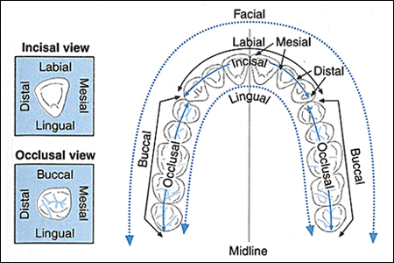In this lab you will learn to identify and record some common dental pathologies using recording forms at the end of this document. But first read the following information on recording criteria for the various pathologies.

..

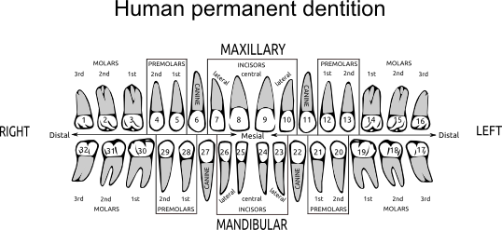

With reference to the chapter “Dentition” included in your lab readings have a close look at these different teeth and use your time to work on identifying:

1. First the tooth type: incisor, canine, premolar, molar
2. Second: deciduous or permanent
3. Third: upper or lower
4. Fourth: left or right
5. Fifth: tooth position.

This is where drawing is really useful and while this is just a taster and it will take much more work than one lab session to ensure you can identify teeth you really should be adept at at least questions 1-3 and hopefully 4 by the end of this course.

Recording Information

**Inventory**

Each tooth is identified as being present or absent. If the tooth is absent you need to note whether it was lost ante or post-mortem, based on the state of the tooth socket in the jaw. If the socket shows signs of remodelling then the tooth must have been lost while the individual was still living; if there is no sign of remodelling then it was probably lost post mortem. If the socket is damaged and it is not possible to tell, then this needs to be noted

**P**=present (or just tick); **AM** =ante mortem loss; **PM** = post mortem loss; **D**=damaged (unobservable); **C**=congenital absence (usually only the 3rd molars)

**Caries**

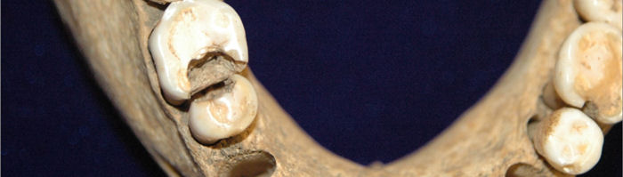Caries is an infectious disease that results from bacterial fermentation of dietary sugars, specifically fermentable carbohydrates such as sucrose. Because of their association with dietary sugars, they can inform us about the types of food people may have been eating in the past. For example, in the Americas a significant increase of caries was associated with the adoption of agriculture due to the increased consumption of maize.

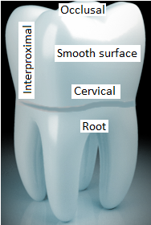Caries is also a progressive disease, which starts as areas of demineralised enamel –usually white or brown spots of chalky enamel. As it progresses the demineralised enamel erodes away creating a cavity. Only caries that have reached this stage are recorded and a common criteria is that cavity is large enough to admit the head of a dental probe. A carious cavity can usually be recognised by brownish staining in or around the lesion, due to bacteria infiltration. The walls of the lesion will be irregular and have sharp edges, which differentiates them from pit type hypoplasia that have smooth rounded edges. Due to the progressive nature of caries, the size of the lesion is not normally recorded but the site or area of the tooth affected is noted as follows:

**Location codes**

0= no lesion present

1= occlusal surface, including the buccal and lingual grooves of molars

2= interproximal surface, mesial and distal

3= Smooth surface, labial and buccal

4= Cervical margin, originates at the cement-enamel junction – except interproximal regions

5= Root surfaces

6= Large caries – large area of destruction so origin cannot be determined

**If there is more than one carious lesion per tooth, separate their codes using a /.**

**Enamel hypoplasia**

Enamel hypoplasia are enamel defects that present, most commonly, as horizontal linear grooves and small pits. Line or groove type defects, also known as LEH (linear enamel hypoplasia), occur in the lateral enamel below the occlusal or cuspal enamel. Pits can appear as single pits, a scattering of pits, or a line of pits. Occasionally gross defects may be found where large amounts of enamel is missing, these are known as plane type defects (because the plane of the striae of Retzius is exposed) . In bioarchaeology, enamel hypoplasia are used as non-specific stress indicators as they have been shown to result from episodes of physiological stress e.g. disease and/or under-nutrition, experienced during infancy and childhood when the enamel is being formed and indicate a systemic growth interruption.

When recording hypoplastic defects, they are most easily detected with the use of an oblique light source – such as a torch held at an angle to the tooth surface. A magnifying glass is also helpful to find any defects in the cervical areas, as the defects will be less apparent here due closer perikymata spacing. It is important to record the location of the defects as their position on the crown provides an estimate of the person’s age when the defect formed. This can be done by recording the crown third i.e. occlusal, mid, or cervical, the defects are located in. On your recording form you just need to note the number of LEH for each crown third. Pits are recorded separately as follows:

0= no pits

1= single pit

2= line of pits

3= scatter of pits

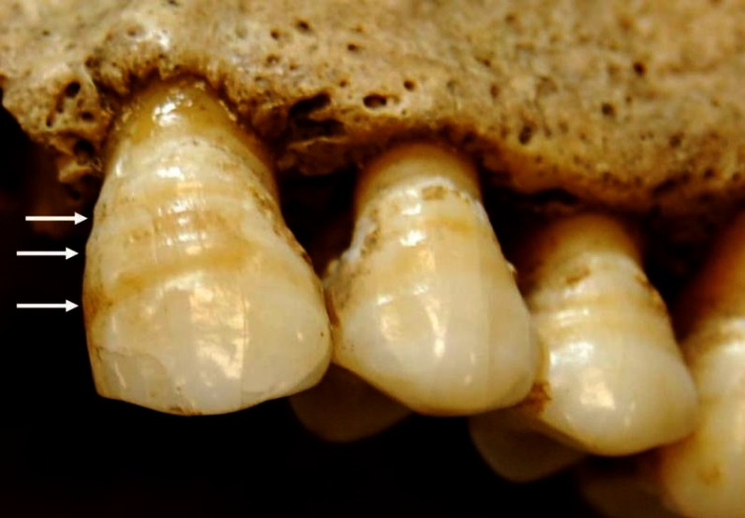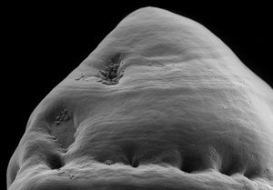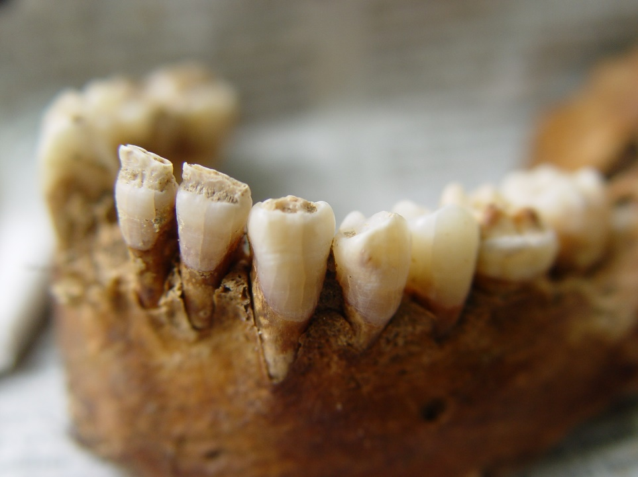

Figure 2 Pit type hypoplasia in a row and plane type above them.

Figure 1 Plane type hypoplasia

Figure 3 Linear enamel hypoplasia

**Calculus**

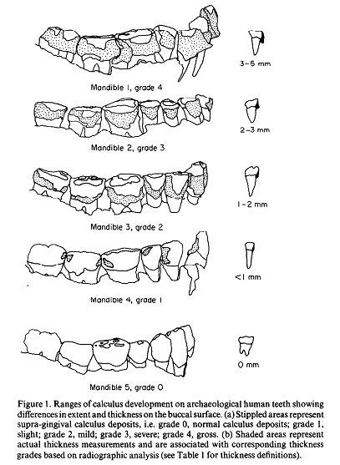Plaque is a biofilm, comprised largely of bacteria and other cells, that coats the surface of teeth and tends to build up around the gum line or between teeth. Over time, if conditions are right, plaque can become mineralised due to minerals present in saliva and gingival fluid, thus forming calculus. One of the conditions required for calculus to form is an alkaline oral environment, as acid will tend to have a demineralising effect. Calculus therefore tends to accumulate faster in individuals who consume a high protein and/or carbohydrate diet that favour alkaline oral environments. Because food remains, including starches, phytoliths and DNA, can become entrapped in calculus, it is often a rich source of dietary information. Calculus thickness (approximate) is recorded as follows (Dobney and Brothwell 1987):

0= none

1= <1 mm

2= 1-2 mm

Figure 4 Calculus scores

3= 2-3 mm

4 = >3 mm

**Dental wear**

Over time teeth become worn but the rate of wear is largely determined diet. Harder or coarser food stuffs result in faster wear, which means we can gain insight into peoples diet from how worn their teeth are. For example, some Hunter-gather populations may have lost most of the enamel on their 1st molar when still young to middle aged adults. Teeth may also become worn due to cultural activities such as using teeth as tools. Dental wear is recorded by scoring each tooth by the amount of dentine that is exposed on the occlusal surface. For molars, each quadrant is scored individually, so wear slopes can be detected.

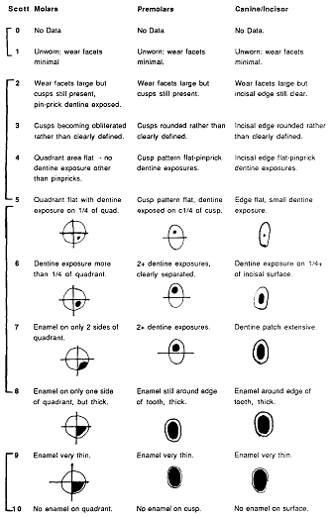

MAXILLA DENTAL RECORDING

|  |  |  |  |  |  |  |  |  |  |  |  |  |  |  |  |  |  |  |  |  |  |  |
| --- | --- | --- | --- | --- | --- | --- | --- | --- | --- | --- | --- | --- | --- | --- | --- | --- | --- | --- | --- | --- | --- | --- |
|  | 1 | | 2 | | 3 | | 4 | 5 | 6 | 7 | 8 | 9 | 10 | 11 | 12 | 13 | 14 | | 15 | | 16 | |
| M3 | | M2 | | M1 | | P2 | P1 | C | I2 | I1 | I1 | I2 | C | P1 | P2 | M1 | | M2 | | M3 | |
| Present/absent |  | |  | |  | |  |  |  |  |  |  |  |  |  |  |  | |  | |  | |
| Caries: Number |  | |  | |  | |  |  |  |  |  |  |  |  |  |  |  | |  | |  | |
| Locus |  | |  | |  | |  |  |  |  |  |  |  |  |  |  |  | |  | |  | |
| Hypoplasia - Linear  Cuspal 1/3 |  | |  | |  | |  |  |  |  |  |  |  |  |  |  |  | |  | |  | |
| Mid 1/3 |  | |  | |  | |  |  |  |  |  |  |  |  |  |  |  | |  | |  | |
| Cervical 1/3 |  | |  | |  | |  |  |  |  |  |  |  |  |  |  |  | |  | |  | |
| Pits |  | |  | |  | |  |  |  |  |  |  |  |  |  |  |  | |  | |  | |
| Plane type |  | |  | |  | |  |  |  |  |  |  |  |  |  |  |  | |  | |  | |
| Calculus |  | |  | |  | |  |  |  |  |  |  |  |  |  |  |  | |  | |  | |
| Attrition |  |  |  |  |  |  |  |  |  |  |  |  |  |  |  |  |  |  |  |  |  |  |
|  |  |  |  |  |  |  |  |  |  |  |  |

Skeletal ID: Observer: Date:

|  |  |  |  |  |  |  |  |  |  |  |  |  |  |  |  |  |  |  |  |  |  |  |
| --- | --- | --- | --- | --- | --- | --- | --- | --- | --- | --- | --- | --- | --- | --- | --- | --- | --- | --- | --- | --- | --- | --- |
|  | 32 | | 31 | | 30 | | 29 | 28 | 27 | 26 | 25 | 24 | 23 | 22 | 21 | 20 | 19 | | 18 | | 17 | |
| M3 | | M2 | | M1 | | P2 | P1 | C | I2 | I1 | I1 | I2 | C | P1 | P2 | M1 | | M2 | | M3 | |
| Present/absent |  | |  | |  | |  |  |  |  |  |  |  |  |  |  |  | |  | |  | |
| Caries: Number |  | |  | |  | |  |  |  |  |  |  |  |  |  |  |  | |  | |  | |
| Locus |  | |  | |  | |  |  |  |  |  |  |  |  |  |  |  | |  | |  | |
| Hypoplasia - Linear  Cuspal 1/3 |  | |  | |  | |  |  |  |  |  |  |  |  |  |  |  | |  | |  | |
| Mid 1/3 |  | |  | |  | |  |  |  |  |  |  |  |  |  |  |  | |  | |  | |
| Cervical 1/3 |  | |  | |  | |  |  |  |  |  |  |  |  |  |  |  | |  | |  | |
| Pits |  | |  | |  | |  |  |  |  |  |  |  |  |  |  |  | |  | |  | |
| Plane type |  | |  | |  | |  |  |  |  |  |  |  |  |  |  |  | |  | |  | |
| Calculus |  | |  | |  | |  |  |  |  |  |  |  |  |  |  |  | |  | |  | |
| Attrition |  |  |  |  |  |  |  |  |  |  |  |  |  |  |  |  |  |  |  |  |  |  |
|  |  |  |  |  |  |  |  |  |  |  |  |

Mandible: Dental Inventory and pathology recording form

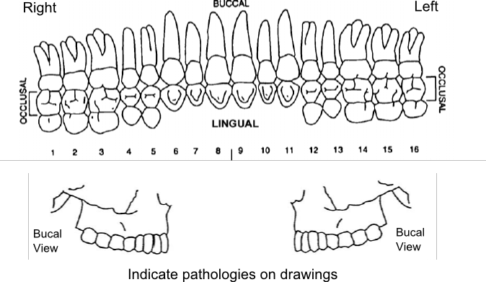

Indicate pathologies on diagram

**Additional comments:** (i.e. cysts or abscesses? If so – which tooth?)

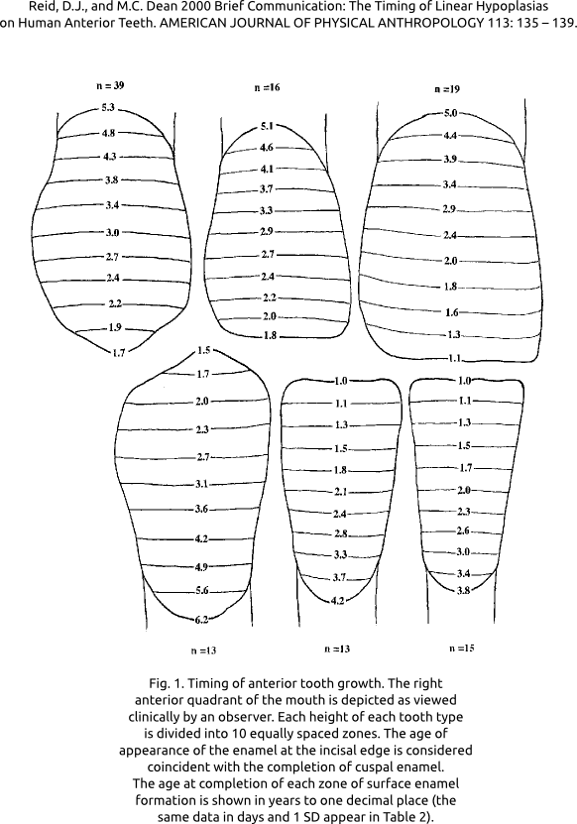

Musculoskeletal Stress Markers (MSM)

Rather than doing a systematic survey of MSMs this is merely an introduction to demonstrate how studying or evaluating such markers relies upon detailed assessment of anatomic location and then of the associated movement. While entheseal changes have been recorded on both fibrous and fibrocartilaginous entheses, it is only the latter that seem to correlate with activity in a consistent fashion. Fibrocartilaginous entheses occur close to joints and involve the enthesis transitioning from tendon with parallel collagen fibres to a zone of change to fibrocartilage and abrupt zone of shift to ossified fibrocartilage and then bone. In contrast fibrous entheses insert directly into the periosteum or the bone.   
There is a very simple blog introduction at <https://bonesdontlie.wordpress.com/2013/04/09/can-you-determine-activity-from-human-remains/> and I have included in lab readings a paper which just gives good illustrations of normal and entheseal change.

