## Goal:

The aim of this lab is introduce to a range of pathological conditions as well as making sure you can identify the difference between psuedopathology – often caused by post-mortem burial conditions – and pathology.

## Essential Background Reading:

Roberts, Charlotte Guidance on recording pathology. In Brickley, M and J. McKinley eds. Guide to Recording Human Remains Institute of Field Archaeology 7. Chapter 12 Available at<http://www.babao.org.uk/assets/Uploads-to-Web/HumanremainsFINAL2.pdf>

Boylston, Andrea Guidance on recording weapon trauma. In Brickley, M and J. McKinley eds. Guide to Recording Human Remains Institute of Field Archaeology 7. Chapter 12 Available at <http://www.babao.org.uk/HumanremainsFINAL.pdf>

I have included information from Roberts on what terms to use, information on the types of blunt trauma, information on arthritis, and criteria on the distinction between antemortem, perimortem and post-mortem trauma.

## Task:

Work in pairs. I have laid out a series of pathological examples. Choose one example at a time to work on but try to analyse as many as you during the lab period. In your lab book, describe each type of pathology – refer to the work sheets at the end of this document regarding the type of information you need to note. Remember: observe first, then describe the lesions before attempting to diagnose a pathology.

## SKELETAL PATHOLOGIES

The following is suggested as a step by step procedure in description. It should be noted that comparison of abnormal with normal elements is a pre-requisite to recognising the abnormal, and access to a comparative skeleton is considered essential for this work (and a good knowledge of the normal appearance of the bone or tooth). Only definite abnormalities should be recorded so as not to over-inflate prevalence rates for disease (ie avoid recording normal variation as disease):

1. Which bone/tooth is affected (including side).
2. What part of the bone/tooth (eg proximal shaft),and aspect (eg medial) is involved, using anatomical terms (also see Lovell 2000, table 8.2 for terms).
3. What is the nature of the lesion itself (see Lovell 2000, table 8.1 for terms)? Is it a forming, destroying or mixed lesion?
4. If bone has been formed, is it woven (porous, disorganised and indicating active disease at the time of death) or lamellar (smooth and organised), indicating a healed and chronic lesion, or is it in the process of healing? See Figures 12 and 13.
5. If bone has been destroyed, is there any sign of healing eg rounding of the edges of the lesion (see Figure 14).
6. What is the distribution pattern of the lesions if more than one bone/tooth is involved? Different disease processes have different patterning (for example, leprosy affects the facial, hand and foot bones).
7. Can the abnormality be measured and compared with the normal opposite side?
8. Consider all potential diagnoses for the abnormalities recorded (differential diagnosis).

It is absolutely essential that any description thus given should allow for independent review by another observer who can, based on an objective description, agree or disagree with the preferred diagnosis. This should also help ensure comparability across samples and between populations.

Photographs of abnormal or rare lesions are recommended, especially if they are unusual and a diagnosis made is rather tenuous; this will help other researchers when the abnormalities are being reconsidered.

Photographs should also be taken if the severities of lesions are being described. Scales should be used and preferably a normal bone or tooth as a comparison (opposite if appropriate and present). Black backgrounds are often an effective contrast for displaying bones and their lesions. Filling most of the frame with the bone

often provides a more informative illustration (Cover, upper left Figure). When X-radiography is used, descriptions should include the relationship of the lesion to the underlying cortex, any endosteal changes and/or changes in the medullary cavity

## TYPES OF PATHOLOGIES

Skeletal **pathologies** are diseases that affect the growth of bone due to microbial infection, metabolic or nutrient deficiencies, hematological disorders, repetitive activity, injuries, or congenital conditions.

Pathologies resulting from infections include **periostitis** (periosteal reaction), **osteomyletis** (osteitis), **treponemal diseases** like syphilis, tuberculosis, and leprosy. Scurvy, rickets, and gout are metabolic or nutrient deficiencies that affect bone. **Hematological diseases** that affect bone include iron deficiency anemia and sickle cell anemia. **Osteoarthritis** (degenerative joint disease), **vertebral osteophytosis**, and **rheumatoid arthritis** are forms of arthritic diseases that affect bone. **Dental pathologies** include **caries** (cavities), **abscesses** and **hypoplasias** (Sciulli 1991, White 1991). In today's lab we'll examine periostitis, arthritis and dental pathologies.

**Periostitis** is an infection of the periosteum caused by mircoorganisms such as staff (Scuilli 1991).  In the early stages the outer surface of the bone is resorbed in a wormy or dendritic pattern (see the figure below).  As the disease progresses, the periosteum separates from the bone, immature bone is deposited to fill the gap, and the bone begins to bulge (Scuilli 1991).

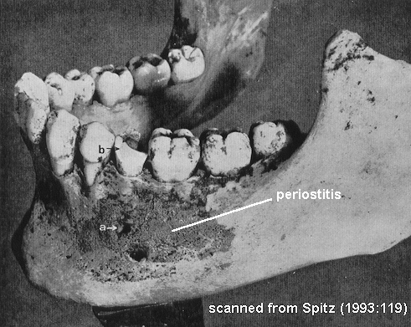



**Osteoarthritis or degenerative joint disease** is caused by traumas or wear-and-tear on synovial joints like knees, wrists, and fingers. As cartilage wears down at these joints and the lubricating synovial fluid is lost, bones rub together and cause a smoothing and polishing of the articular surfaces of the bones at the joint. Epiphyseal lipping is another effect of osteoarthritis. Traumatic osteoarthritis is randomly distributed through an individual's body, whereas wear-and-tear osteoarthritis is patterned, based on the repetitive activity in which the individual engaged (Sciulli 1991). The three images below illustrate the effects of osteoarthritis.

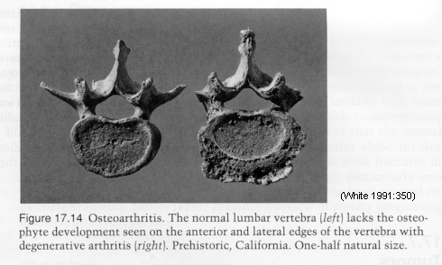

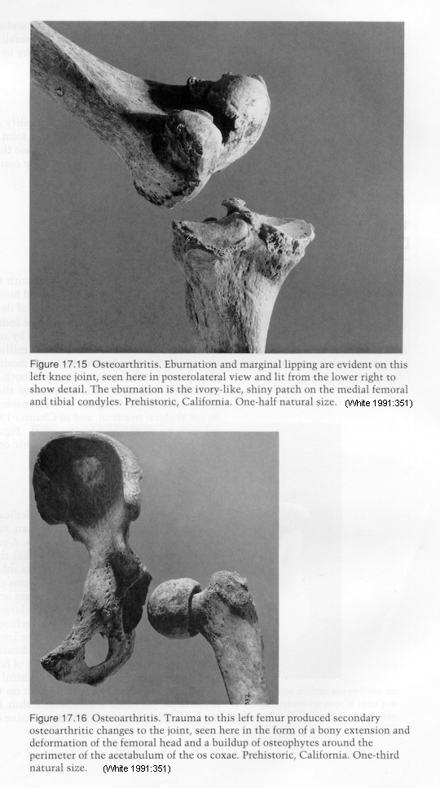

**Rheumatoid arthritis** is an inherited disease or may a side effect of Lyme disease. It affects more joints than osteoarthritis and affects the body symmetrically, causing epiphyseal lipping. It can also result in ankylosing spondylitis, or fusion of the vertebral column into one structure (Sciulli 1991).

**Dental caries** or cavities are "the progressive decalcification of enamel or dentine" or lesions left in teeth due to dental deterioration from bacteria (White 1991:353). If caries become infected, **abscesses** may form in the alveolar bone of the maxilla and/or mandible. An abscess is a "localized collection of pus in a cavity formed by tissue disintegration" (White 1991:354). Dental caries and abcesses are illustated in the image below.  **Dental hypoplasias** are irregularities in the tooth enamel.  These take the form of horizontal lines in the enamel and/or pits that do not completely penetrate the enamel.  Dental hypoplasias are the result of interruptions in enamel formation and may develop due to nutritional stress during growth and development (White 1991).

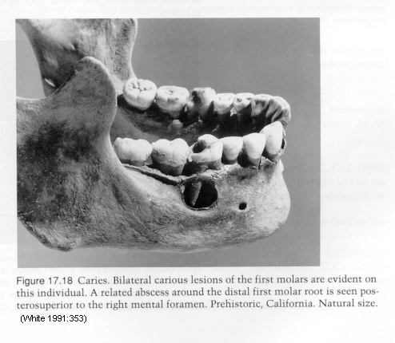

Name: _______________________________________

STATION ONE

Specimen: __________________________________________

1. Is the lesion pseudopathology (due to post-mortem damage) or an actual pathological lesion? On what criteria have you based your decision?
2. Where is the lesion located (remember bone, side, aspect)?
3. Type of lesion: is it lytic (or resorptive), proliferative, deformative?

**lytic** lesions (loss of **bone**); proliferative lesions (excess **bone**); **deformative** lesions (malshaped **bones)**

1. Describe the lesion using the terminology from Lovell. Remember to include size and extent of the lesion.
2. Does the lesion show any signs of healing (lamellar versus woven bone, rounded edges of the margins). Is healing complete or incomplete or hasn’t even started? (This may be difficult to determine on cast material but have a go).

Name: _______________________________________

STATION TWO

Specimen: __________________________________________

1. Is the lesion pseudopathology (due to post-mortem damage) or an actual pathological lesion? On what criteria have you based your decision?
2. Where is the lesion located (remember bone, side, aspect)?
3. Type of lesion: is it lytic (or resorptive), proliferative, deformative?

**lytic** lesions (loss of **bone**); proliferative lesions (excess **bone**); **deformative** lesions (malshaped **bones)**

1. Describe the lesion using the terminology from Lovell. Remember to include size and extent of the lesion.
2. Does the lesion show any signs of healing (lamellar versus woven bone, rounded edges of the margins). Is healing complete or incomplete or hasn’t even started? (This may be difficult to determine on cast material but have a go).

STATION 3 – TRAUMA

1. Where is the lesion located (remember bone, side, aspect)?
2. Is the injury antemortem, perimortem or post-mortem? (describe the degree of healing and its location, the nature of any fragmentation or breakage (sharped edges, bevelling jagged edges, radiating fractures) and colouration of the margins?
3. What type of injury (fracture, cutting or sharp force or gunshot)? (if a fracture is in simple or comminuted (many pieces), compression (crished bone), depressed, impacted (one end of the break is forced into the other), a spiral break or a greenstick fracture? Think about direction of the force. For cutting think about the shape of the black and the kerf (saw marks etc). Gunshot think about entrance and exit, low power or higher power (radiating cracks).
4. Any sequelae from the injury? (joint displacement, secondary arthritis, infection), State of healing?

STATION 4: Degennerative joint disease

Specimen number: ______________________________________

1. Is osteophytosis present? Yes No

Describe: size, extent and on what surfaces.

1. Is there any indication of porosity? Yes No

Describe: size, extent, on what surfaces.

1. Is there any indication of eburnation Yes No

Describe: size, on what surfaces.

1. Is there any associated deformation (e.g. vertebral collapse, narrowing of foramina, depression or abnormality in bone shape?)

STATION 5: Degennerative joint disease

Specimen number: ______________________________________

1. Is osteophytosis present? Yes No

Describe: size, extent and on what surfaces.

1. Is there any indication of porosity? Yes No

Describe: size, extent, on what surfaces.

1. Is there any indication of eburnation Yes No

Describe: size, on what surfaces.

1. Is there any associated deformation (e.g. vertebral collapse, narrowing of foramina, depression or abnormality in bone shape?)