## Goal:

The aim of this lab is to explore further what characteristics are used to identify and assess population ancestry. This is not a simple rule book approach so one of the things to find out in doing this lab is how population variation works and how levels of certainty apply or do not apply. It is also to point out that at times you need to make some assessment of ancestry (i.e. Maori-non-Maori for heritage management purposes) but that increasingly assessments of population affinity (i.e. what someone looks like) is not particularly indicative of where they or their family origins lay or more importantly how they might identify.

## Background Reading:

Littleton, J and Kinaston, R 2009 Human identification in a diverse space. In Oxenham, M ed. Forensic Approaches to Death Disaster and Abuse. Bowen Hills: Australian Academic Press. (available in dropbox).

O’Connell, Linda 2004 Guidance on recording ancestry. In Brickley, M and J. McKinley eds. Guide to Recording Human Remains Institute of Field Archaeology 7. Pp27 Available at <http://www.babao.org.uk/HumanremainsFINAL.pdf>

Johnston, C and Littleton, J 2009 A guide to the recording of human remains in archaeological sites, New Zealand. Prepared for the NZAA. (available in dropbox)

## Task:

We have laid out the series of skulls which are the ‘type’ or teaching skulls of different ancestries. We have also identified male versus female. What we want you to do is to observe these confirming the characteristics that are used to identify population affinity. In addition we have laid out some other non-teaching material so that you can get a feel for some postcranial characteristics. We have also then laid out a series of skulls of unknown ancestry – choose three and record their cranial characteristics ending with a tentative suggestion of population ancestry. You can ignore the possibility of African American or Aboriginal in your assessments. I have included extra copies of the table so that you can use them and stick them in your lab book. The thing to think about is what characteristics most heavily influence your choice, what things do you need to look for (what confounders) and if you were to give a sense of certainty (% sure) to your assessment what would it be for each cranium.

Since ancestry is necessary before many of the regression formulae for stature estimation can be used I have included these tables and suggest that you use this opportunity to calculate stature. Remember stature estimates which are very important in identification rely upon population specific body proportions and come in the form of a regression formula where by leg segment length for instance is correlated to total height. That means there is an error measurement in the final assessment, plus given loss of height with age there is also an age correction factor. It should be noted given these two factors plus the unknown variability in a population in terms of body proportion comparisons of skeletal material need to involve the direct bone length. Stature estimates are indicative (a way of picturing size) but not a secure metric to be used for further analyses.

**Ancestry (Based on Gill 1998:300)**

|  |  |  |  |  |  |  |
| --- | --- | --- | --- | --- | --- | --- |
| **. Characteristics** | **East Asian** | **American Indian** | **European** | **Aboriginal** | **Polynesian** | **African/ African American** |
| **Cranial form** | **Long and broad , robust** | **medium-broad , flat cranial base but rounded (not pentagonal)** | **Medium length and breadth**  **Globular, rounded, maximum breadth high** | **Dolicocephalic (long narrow)**  **Maximum breadth low, marked occipital torus.** | **highly variable (broad and shorter compared to European) ; pentagonal shape from back view, straight palates, flat cranial base** | **long** |
| **Sagittal line** | **Arched** | **Arched** | **arched** | **Peaked** | **arched** | **flat** |
| **Sagittal outline** | **high, globular** | **medium-low; sloping frontal** | **high, rounded** | **Sloping frontal** | **medium** | **highly variable; post-bregmatic depression** |
| **Cranial sutures** | **complex** | **complex** | **simple** | **-** | **complex** | **simple** |
| **Nose form** | **medium** | **medium** | **narrow** | **wide** | **medium** | **broad** |
| **Nasal bone size** | **small** | **medium/large** | **large** | **large** | **medium** | **medium/small** |
| **Nasal bridge form** | **flat** | **medium/tented** | **high/steeple-like** | **Sometimes depressed, flat** | **medium** | **low/quonset hut** |
| **Nasal profile** | **concave** | **concavo-convex** | **straight** |  | **concave/concavo-convex** | **straight/concave** |
| **Interorbital projection** | **very low** | **low** | **high, prominent** | **Low** | **low** | **low** |
| **Nasal spine** | **medium** | **medium, tilted** | **prominent, straight** |  | **Downturned at times** | **reduced** |
| **Nasal sill** | **medium** | **medium** | **sharp** | **blunt** | **dull/absent at times** | **dull/absent** |
| **Incisor form** | **shovelled >90%** | **shovelled** | **blade** | **Blade** | **blade/shovelled c75%** | **blade** |
| **Facial prognathism** | **moderate** | **moderate** | **reduced** | **projecting** | **Flat-moderate** | **extreme** |
| **Alveolar prognathism** | **moderate** | **moderate** | **reduced** | **marked** | **moderate** | **extreme** |
| **Malar form** | **projecting** | **projecting** | **reduced** | **Projecting, rugged,** | **Projecting, turns back at 90degrees ,** | **reduced** |
| **Zygomaticomaxillary suture** | **angled** | **angled** | **curved , arch not visible from superior view** | **Arch visible from superior view** | **curved/angled , arch visible from superior view** | **curved/angled** |
| **Palatal form** | **parabolic/elliptic** | **elliptic/parabolic** | **Parabolic – v shaped** | **Wide u shaped** | **parabolic** | **hyperbolic/parabolic** |
| **Palatine suture** | **straight/jagged** | **straight** | **jagged** |  | **highly variable** | **arched/jagged** |
| **Orbital form** | **round** | **rhomboid** | **rhomboid** | **rectangular** | **rhomboid** | **round** |
| **Mastoid form** | **wide** | **wide** | **narrow, pointed** |  | **wide , supramastoid crest** | **oblique, posterior tubercle** |
| **Mandible** | **robust** | **robust** | **medium, cupped below incisors** | **Robust, squared, broad** | **robust; rocker form, submental curve, ascending ramus straight** | **gracile; oblique gonial angle** |
| **Chin projection** | **moderate** | **moderate** | **prominent** | **Prominent** | **moderate** | **reduced** |
| **Chin form** | **median** | **median** | **bilateral** | **Bilateral** | **median** | **median** |

### F. Population Affinity or Geographic Ancestry

Geographic variation of the skeleton is used to suggest ancestry of an individual. Most information is available on differentiating between Asian, African and European groups but in this part of the world it is also necessary to be aware of the distinguishing features of Pacific peoples and Australian Aborigines. Unfortunately information for these two groups is not so readily available. I have included diagrams where available but as you go through see how many features you can identify reliably on the casts we have.

Compared to sex, age, and stature estimation, geographic ancestry determination is "more difficult, less precise, and less reliable" because "no human skeletal markers ... correspond perfectly to geographic origin" (White 1991:328-329). In addition, many skeletal indicators used to estimate ancestry are nonmetric traits, whose documentation can be somewhat subjective, varying for researcher to researcher. However, ancestry estimation is a critical endeavor in forensic identification as sex, age, and stature estimation are greatly influenced the ancestry of the individual.

Skeletal indicators of ancestry focus primarily on skull and dental traits, as summarized in the table below. Ancestry indicators on the skull are both nonmetric and metric traits and include robusticity, lengths and widths of skull features, shapes of skull features, and unique population-specific dental features.

Note the following instructions for **assessing the zygomatic arches**:  "Hold the skull with the occipital region in your hand and the facial area up. Place a pencil across the nasal aperture [nasal cavity or opening]. Now try to insert your index finger between the cheek (zygomatic) bones and the pencil. Caucasoids have a face that comes to a point along the midline and cheek bones that do not extend forward. This will allow you to insert your finger between the cheek bones and the pencil without knocking the pencil off. Mongoloids have a much flatter face (the cheek bones extending much further forward), and it is difficult to insert your finger between the pencil and the cheek bones on a Mongoloid skull without knocking the pencil off" (Bass 1986:83).

Note the following instructions for **assessing prognathism**:  "Place one end of your pencil on or near the anterior nasal spine (on the midline of the skull) at the base of the nasal aperture [nasal cavity or opening]. Lower the pencil toward the face so that the pencil will touch the chin. Caucasoids have a 'flat' (orthognathous) face in the dental area along the midline. This is the opposite of the Negroid face, which exhibits protrusion of the mouth region, known as prognathism. ... Negroids are noted for alveolar prognathism, or an anterior protrusion, of the mouth region. A pencil or ballpoint pen placed with one end on the nasal spine (midline at base of nasal aperture) will not touch the chin (the teeth protrude too far forward)" (Bass 1986:87).

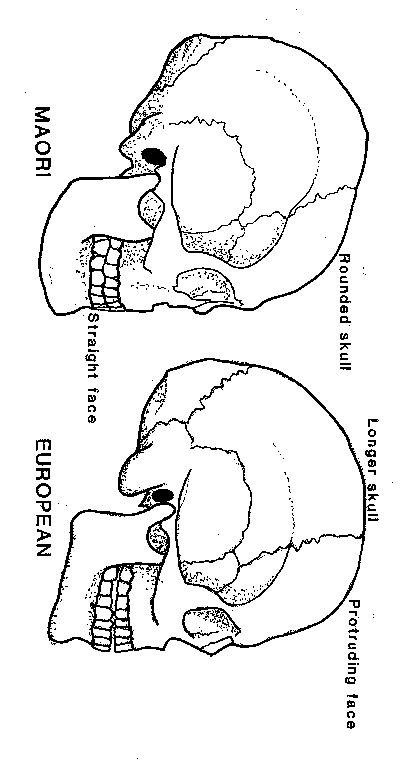

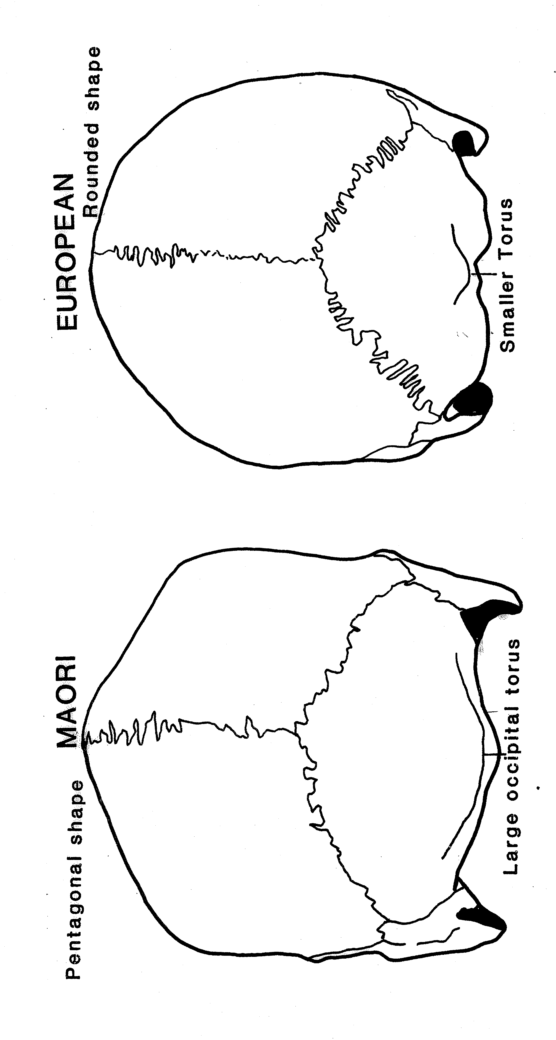

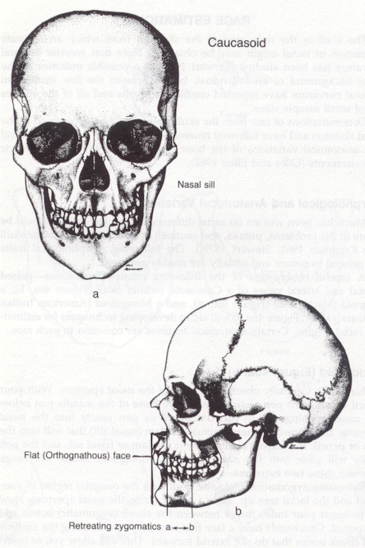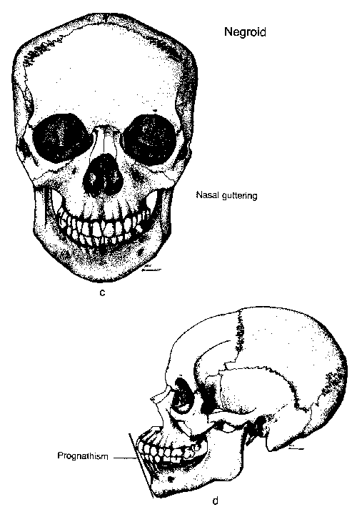

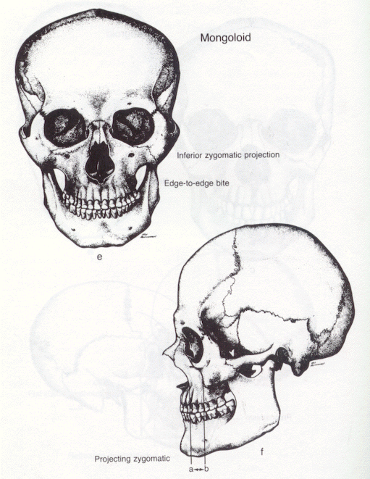

**Human Number : ________________________**

**Using the criteria given to you identify the possibly ancestry of this individual.**

**First you need to have a thought about the sex of the individual:**

**Then circle the appropriate characteristics in order to derive your assessment of population affinity.**

|  |  |  |  |  |  |  |
| --- | --- | --- | --- | --- | --- | --- |
| **. Characteristics** | **East Asian** | **Native American** | **European** | **Aboriginal** | **Polynesian** | **African/ African American** |
| **Cranial form** | **Long and broad , robust** | **medium-broad , flat cranial base but rounded (not pentagonal)** | **Medium length and breadth**  **Globular, rounded, maximum breadth high** | **Dolicocephalic (long narrow)**  **Maximum breadth low, marked occipital torus.** | **highly variable (broad and shorter compared to European) ; pentagonal shape from back view, straight palates, flat cranial base** | **long** |
| **Sagittal line (posterior view)** | **Arched** | **Arched** | **arched** | **Peaked** | **arched** | **flat** |
| **Sagittal outline (medial view)** | **high, globular** | **medium-low; sloping frontal** | **high, rounded** | **Sloping frontal** | **medium** | **highly variable; post-bregmatic depression** |
| **Cranial sutures** | **complex** | **complex** | **simple** | **-** | **complex** | **simple** |
| **Nose breadth** | **medium** | **medium** | **narrow** | **wide** | **medium** | **broad** |
| **Nasal bone size** | **small** | **medium/large** | **large** | **large** | **medium** | **medium/small** |
| **Nasal bridge form** | **flat** | **medium/tented** | **high/steeple-like** | **Sometimes depressed, flat** | **medium** | **low/quonset hut** |
| **Nasal profile (medial view)** | **concave** | **concavo-convex** | **straight** |  | **concave/concavo-convex** | **straight/concave** |
| **Interorbital projection** | **very low** | **low** | **high, prominent** | **Low** | **low** | **low** |
| **Nasal spine** | **medium** | **medium, tilted** | **prominent, straight** |  | **Downturned at times** | **reduced** |
| **Nasal sill** | **medium** | **medium** | **sharp** | **blunt** | **dull/absent at times** | **dull/absent** |
| **Incisor form** | **shovelled >90%** | **shovelled** | **blade** | **Blade** | **blade/shovelled c75%** | **blade** |
| **Facial prognathism** | **moderate** | **moderate** | **reduced** | **projecting** | **Flat-moderate** | **extreme** |
| **Alveolar prognathism** | **moderate** | **moderate** | **reduced** | **marked** | **moderate** | **extreme** |
| **Malar form** | **projecting** | **projecting** | **reduced** | **Projecting, rugged,** | **Projecting, turns back at 90degrees ,** | **reduced** |
| **Zygomaticomaxillary suture** | **angled** | **angled** | **curved , arch not visible from superior view** | **Arch visible from superior view** | **curved/angled , arch visible from superior view** | **curved/angled** |
| **Palatal shape** | **parabolic/elliptic** | **elliptic/parabolic** | **Parabolic – v shaped** | **Wide u shaped** | **parabolic** | **hyperbolic/parabolic** |
| **Palatine suture** | **straight/jagged** | **straight** | **jagged** |  | **highly variable** | **arched/jagged** |
| **Orbital shape** | **round** | **rhomboid** | **rhomboid** | **rectangular** | **rhomboid** | **round** |
| **Mastoid shape** | **wide** | **wide** | **narrow, pointed** |  | **wide , supramastoid crest** | **oblique, posterior tubercle** |
| **Mandible** | **robust** | **robust** | **medium, cupped below incisors** | **Robust, squared, broad** | **robust; rocker form, submental curve, ascending ramus straight** | **gracile; oblique gonial angle** |
| **Chin projection** | **moderate** | **moderate** | **prominent** | **Prominent** | **moderate** | **reduced** |
| **Chin shape** | **median** | **median** | **bilateral** | **Bilateral** | **median** | **median** |

**Suggested population affinity: _____________________________________________**

**Human Number : ________________________**

**Using the criteria given to you identify the possibly ancestry of this individual.**

**First you need to have a thought about the sex of the individual:**

**Then circle the appropriate characteristics in order to derive your assessment of population affinity.**

|  |  |  |  |  |  |  |
| --- | --- | --- | --- | --- | --- | --- |
| **. Characteristics** | **East Asian** | **Native American** | **European** | **Aboriginal** | **Polynesian** | **African/ African American** |
| **Cranial form** | **Long and broad , robust** | **medium-broad , flat cranial base but rounded (not pentagonal)** | **Medium length and breadth**  **Globular, rounded, maximum breadth high** | **Dolicocephalic (long narrow)**  **Maximum breadth low, marked occipital torus.** | **highly variable (broad and shorter compared to European) ; pentagonal shape from back view, straight palates, flat cranial base** | **long** |
| **Sagittal line (posterior view)** | **Arched** | **Arched** | **arched** | **Peaked** | **arched** | **flat** |
| **Sagittal outline (medial view)** | **high, globular** | **medium-low; sloping frontal** | **high, rounded** | **Sloping frontal** | **medium** | **highly variable; post-bregmatic depression** |
| **Cranial sutures** | **complex** | **complex** | **simple** | **-** | **complex** | **simple** |
| **Nose breadth** | **medium** | **medium** | **narrow** | **wide** | **medium** | **broad** |
| **Nasal bone size** | **small** | **medium/large** | **large** | **large** | **medium** | **medium/small** |
| **Nasal bridge form** | **flat** | **medium/tented** | **high/steeple-like** | **Sometimes depressed, flat** | **medium** | **low/quonset hut** |
| **Nasal profile (medial view)** | **concave** | **concavo-convex** | **straight** |  | **concave/concavo-convex** | **straight/concave** |
| **Interorbital projection** | **very low** | **low** | **high, prominent** | **Low** | **low** | **low** |
| **Nasal spine** | **medium** | **medium, tilted** | **prominent, straight** |  | **Downturned at times** | **reduced** |
| **Nasal sill** | **medium** | **medium** | **sharp** | **blunt** | **dull/absent at times** | **dull/absent** |
| **Incisor form** | **shovelled >90%** | **shovelled** | **blade** | **Blade** | **blade/shovelled c75%** | **blade** |
| **Facial prognathism** | **moderate** | **moderate** | **reduced** | **projecting** | **Flat-moderate** | **extreme** |
| **Alveolar prognathism** | **moderate** | **moderate** | **reduced** | **marked** | **moderate** | **extreme** |
| **Malar form** | **projecting** | **projecting** | **reduced** | **Projecting, rugged,** | **Projecting, turns back at 90degrees ,** | **reduced** |
| **Zygomaticomaxillary suture** | **angled** | **angled** | **curved , arch not visible from superior view** | **Arch visible from superior view** | **curved/angled , arch visible from superior view** | **curved/angled** |
| **Palatal shape** | **parabolic/elliptic** | **elliptic/parabolic** | **Parabolic – v shaped** | **Wide u shaped** | **parabolic** | **hyperbolic/parabolic** |
| **Palatine suture** | **straight/jagged** | **straight** | **jagged** |  | **highly variable** | **arched/jagged** |
| **Orbital shape** | **round** | **rhomboid** | **rhomboid** | **rectangular** | **rhomboid** | **round** |
| **Mastoid shape** | **wide** | **wide** | **narrow, pointed** |  | **wide , supramastoid crest** | **oblique, posterior tubercle** |
| **Mandible** | **robust** | **robust** | **medium, cupped below incisors** | **Robust, squared, broad** | **robust; rocker form, submental curve, ascending ramus straight** | **gracile; oblique gonial angle** |
| **Chin projection** | **moderate** | **moderate** | **prominent** | **Prominent** | **moderate** | **reduced** |
| **Chin shape** | **median** | **median** | **bilateral** | **Bilateral** | **median** | **median** |

**Suggested population affinity: _____________________________________________**

**Specimen Number : ________________________**

**Using the criteria given to you identify the possibly ancestry of this individual.**

**First you need to have a thought about the sex of the individual:**

**Human Number : ________________________**

**Using the criteria given to you identify the possibly ancestry of this individual.**

**First you need to have a thought about the sex of the individual:**

**Then circle the appropriate characteristics in order to derive your assessment of population affinity.**

|  |  |  |  |  |  |  |
| --- | --- | --- | --- | --- | --- | --- |
| **. Characteristics** | **East Asian** | **Native American** | **European** | **Aboriginal** | **Polynesian** | **African/ African American** |
| **Cranial form** | **Long and broad , robust** | **medium-broad , flat cranial base but rounded (not pentagonal)** | **Medium length and breadth**  **Globular, rounded, maximum breadth high** | **Dolicocephalic (long narrow)**  **Maximum breadth low, marked occipital torus.** | **highly variable (broad and shorter compared to European) ; pentagonal shape from back view, straight palates, flat cranial base** | **long** |
| **Sagittal line (posterior view)** | **Arched** | **Arched** | **arched** | **Peaked** | **arched** | **flat** |
| **Sagittal outline (medial view)** | **high, globular** | **medium-low; sloping frontal** | **high, rounded** | **Sloping frontal** | **medium** | **highly variable; post-bregmatic depression** |
| **Cranial sutures** | **complex** | **complex** | **simple** | **-** | **complex** | **simple** |
| **Nose breadth** | **medium** | **medium** | **narrow** | **wide** | **medium** | **broad** |
| **Nasal bone size** | **small** | **medium/large** | **large** | **large** | **medium** | **medium/small** |
| **Nasal bridge form** | **flat** | **medium/tented** | **high/steeple-like** | **Sometimes depressed, flat** | **medium** | **low/quonset hut** |
| **Nasal profile (medial view)** | **concave** | **concavo-convex** | **straight** |  | **concave/concavo-convex** | **straight/concave** |
| **Interorbital projection** | **very low** | **low** | **high, prominent** | **Low** | **low** | **low** |
| **Nasal spine** | **medium** | **medium, tilted** | **prominent, straight** |  | **Downturned at times** | **reduced** |
| **Nasal sill** | **medium** | **medium** | **sharp** | **blunt** | **dull/absent at times** | **dull/absent** |
| **Incisor form** | **shovelled >90%** | **shovelled** | **blade** | **Blade** | **blade/shovelled c75%** | **blade** |
| **Facial prognathism** | **moderate** | **moderate** | **reduced** | **projecting** | **Flat-moderate** | **extreme** |
| **Alveolar prognathism** | **moderate** | **moderate** | **reduced** | **marked** | **moderate** | **extreme** |
| **Malar form** | **projecting** | **projecting** | **reduced** | **Projecting, rugged,** | **Projecting, turns back at 90degrees ,** | **reduced** |
| **Zygomaticomaxillary suture** | **angled** | **angled** | **curved , arch not visible from superior view** | **Arch visible from superior view** | **curved/angled , arch visible from superior view** | **curved/angled** |
| **Palatal shape** | **parabolic/elliptic** | **elliptic/parabolic** | **Parabolic – v shaped** | **Wide u shaped** | **parabolic** | **hyperbolic/parabolic** |
| **Palatine suture** | **straight/jagged** | **straight** | **jagged** |  | **highly variable** | **arched/jagged** |
| **Orbital shape** | **round** | **rhomboid** | **rhomboid** | **rectangular** | **rhomboid** | **round** |
| **Mastoid shape** | **wide** | **wide** | **narrow, pointed** |  | **wide , supramastoid crest** | **oblique, posterior tubercle** |
| **Mandible** | **robust** | **robust** | **medium, cupped below incisors** | **Robust, squared, broad** | **robust; rocker form, submental curve, ascending ramus straight** | **gracile; oblique gonial angle** |
| **Chin projection** | **moderate** | **moderate** | **prominent** | **Prominent** | **moderate** | **reduced** |
| **Chin shape** | **median** | **median** | **bilateral** | **Bilateral** | **median** | **median** |

**Suggested population affinity: _____________________________________________**

**Stature Estimate:**

The **stature** or **height** of an individual is useful information for making forensic identifications.  Before estimating stature, one must determine the ancestry, sex, and age of the individual as stature varies with the variables.

Stature estimates are just that, estimates.  They are not exact and should always be expressed with a range of error. Stature estimates are usually reported in centimeters. For incomplete skeletons or isolated bones, stature is estimated by comparing the lengths of certain bones to tables of published data or by plugging lengths into published **regression formulas**.  The most commonly used bones for stature estimation of incomplete remains are the long bones (femur, tibia, fibula, humerus, ulna, radius), but short bones of the hands and feet may also be used. The use of two or more bones to estimate the stature of an individual improves the accuracy.

Bone length and stature tables for a number of human populations have been published.  For this lab we'll be using published regression formulas for stature estimation (Bass 1986:156-157, 163-164, 221-222, 238, 244).   
 

|  |  |  |  |
| --- | --- | --- | --- |
| **BONE** | **Ancestry** | **MALE EQUATION** | **FEMALE EQUATION** |
|  |  |  |  |
| Femur | Europea | 2.32 * femur + 65.53 ± 3.94 cm | 2.47 * femur + 54.10 ± 3.72 cm |
| Femur | African | 2.10 * femur + 72.22 ± 3.91 cm | 2.28 * femur + 59.76 ± 3.41 cm |
| Femur | Asian | 2.15 * femur + 72.57 ± 3.80 cm | not available |
|  |  |  |  |
| Tibia | Europea | 2.42 * tibia + 81.93 ± 4.00 cm | 2.90 * tibia + 61.53 ± 3.66 cm |
| Tibia | African | 2.19 * tibia + 85.36 ± 3.96 cm | 2.45 * tibia + 72.56 ± 3.70 cm |
| Tibia | Asian | 2.39 * tibia + 81.45 ± 3.24 cm | not available |
|  |  |  |  |
| Fibula | Europea | 2.60 * fibula + 75.50 ± 3.86 cm | 2.93 * fibula + 59.61 ± 3.57 cm |
| Fibual | African | 2.34 * fibula + 80.07 ± 4.02 cm | 2.49 * fibula + 70.90 ± 3.80 cm |
| Fibual | Asian | 2.40 * fibula + 80.56 ± 3.24 cm | not available |
|  |  |  |  |
| Humerus | Europea | 2.89 * humerus + 78.10 ± 4.57 cm | 3.36 * humerus + 57.97 ± 4.45 cm |
| Humerus | African | 2.88 * humerus + 75.48 ± 4.23 cm | 3.08 * humerus + 64.67 ± 4.25 cm |
| Humerus | Asian | 2.68 * humerus + 83.19 ± 4.16 cm | not available |
|  |  |  |  |
| Ulna | Europea | 3.76 * ulna + 75.55 ± 4.72 cm | 4.27 * ulna + 57.76 ± 4.30 cm |
| Ulna | African | 3.20 * ulna + 82.77 ± 4.74 cm | 3.31 * ulna + 75.38 ± 4.83 cm |
| Ulna | Asian | 3.48 * ulna + 77.45 ± 4.66 cm | not available |
|  |  |  |  |
| Radius | Europea | 3.79 * radius + 79.42 ± 4.66 cm | 4.74 * radius + 54.93 ± 4.24 cm |
| Radius | African | 3.32 * radius + 85.43 ± 4.57 cm | 3.67 * radius + 71.79 ± 4.59 cm |
| Radius | Asian | 3.54 * radius + 82.00 ± 4.60 cm | not available |
|  |  |  |  |

**Potential stature** refers to the stature of an individual who has not undergone skeletal changes associated with the aging process.  Most people who are less than 30 years old at the time of death have not undergone these changes.

**Living stature** refers to the stature of an individual who has undergone skeletal changes associated with the aging process that result in a decrease in stature.  Most people who are 30 years old or older at the time of death have undergone these changes.  Therefore, to account for the loss of height associated with aging, we must subtract from the stature estimates of older individuals.  To do this, we must know the age of the individual.  That age is plugged into the following equation, the answer of which is subtracted from the stature estimate:   0.06 * (age - 30) cm.  So, an individual who is 50 years old will likely have lost 1.2 cm of height (0.06 * 50-30 cm) due to the aging process.