Global Art Histories

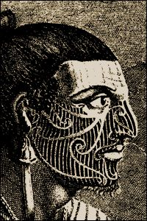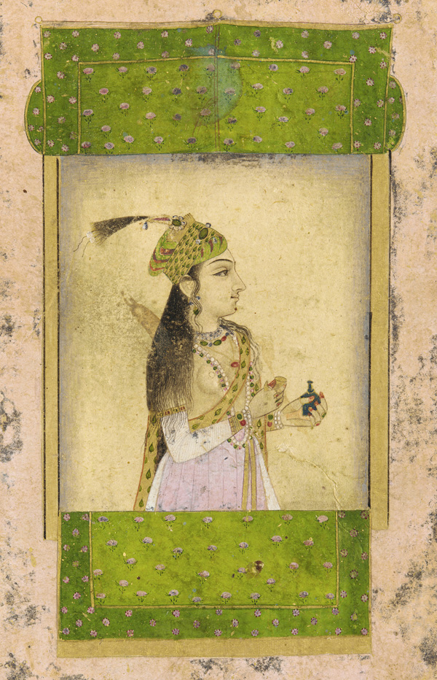

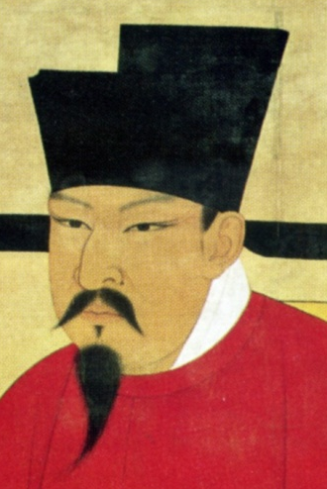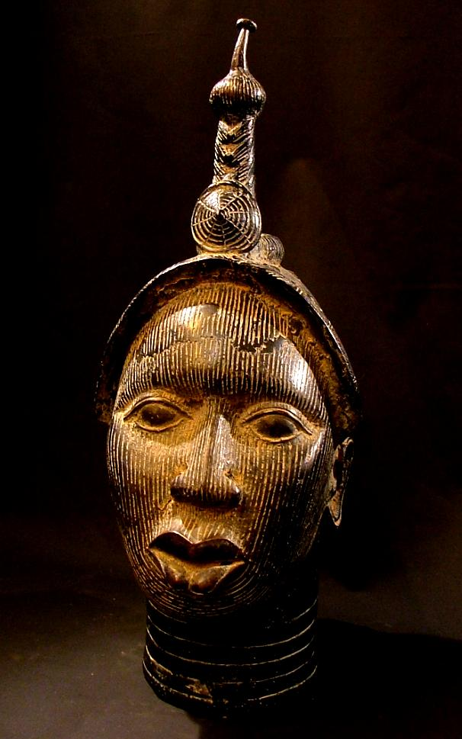

Kia ora koutou, malo e lelei, talofa lava, ni sa bula, kia orana, fakaalofa lahi atu, welcome.

This course will provide a global survey of the visual arts spanning the early modern period to the contemporary. You will be introduced to a range of art practices situated within a global context and will consider art works produced in Maori and Pacific cultures alongside Indian, African, Asian, Middle Eastern, European and American traditions. Taking a comparative approach to different cultures in a global context, the course aims to develop your awareness of how art has shaped a number of cultural identities and experiences of cultural exchange. It will allow you to gain an invaluable comparative, global overview of artistic practice.
No reira, nau mai, haere mai.
Tena koutou, tena koutou, tena koutou katoa.

Learning Outcomes
By the end of the course students will have learned the following skills and competencies:
1. To be able to visually analyse artworks, images and examples of visual culture using appropriate methods and terminology
2. Competence in comparing and contrasting artworks and examples of visual culture across cultures
3. Will be able to situate artworks in their social, historical, cultural and economic contexts
4. Will have the skills to sustain an argument and logically compose a narrative in essay writing
5. Will have learned how to find and research quality resources and information in the library and online
Recommended Reading:
Nigel Borell, Te Atinga – 25 Years of Contemporary Maori Art. Wellington: Toi Maori Aotearoa - Maori Art New Zealand and Te Atinga - Contemporary Visual Arts Committee. 2013.
Brunt, Peter, Nicholas Thomas, et al. Art in Oceania: A New History. London: Thames and Hudson, 2012.
Whitney Chadwick, Women, Art, and Society. London: Thames & Hudson, 2007
Craig Clunas, Art in China. Oxford: Oxford University Press, 2009
James Elkin, Is Art History Global? London: Routledge, 2006
Jonathan Fenby, The Penguin History of Modern China. London; New York: Allen Lane, 2008
David Joselit, American Art Since 1945. London: Thames & Hudson, 2003
Adrienne Kaeppler, The Pacific Arts of Polynesia and Micronesia. Oxford: Oxford University Press, 2008
Gregory Minissale and Celina Jeffery, eds., Global and Local Art Histories. Newcastle: Cambridge Scholars Press, 2007
Gregory Minissale, Images of Thought: Painting in Islamic India. Newcastle: Cambridge Scholars Press, 2009
Partha Mitter, Indian Art. Oxford: Oxford University Press, 2001
Partha Mitter, The Triumph of Modernism: India's Artists and the Avant-garde, 1922-47. Cambridge & New York: Cambridge University Press, 1994
Richard J. Powell, Black Art. London: Thames and Hudson, 2002
John F. Richards, The Mughal Empire. Cambridge; New York, NY: Cambridge University Press, 1993.
Michael Rogers, Mughal Miniatures. London: British Museum Press, 1993 Vercoe, Caroline. ‘Art,’ in Moshe Rapaport, ed., Environment and Society. Honolulu: University of Hawai’i Press, 2013.
SEMESTER 1, 2019 15 points
ALL LECTURES WILL BE RECORDED
4-5 pm Mondays and Thursdays, Engineering 1401/401-401.
2 x 1-hour lectures and 1 hour tutorial
Associate Professor Greg Minissale, Room 206-749, ph: 9236033 g.minissale@auckland.ac.nz Office hours:Thurs 3-4
Dr Caroline Vercoe, Room 206-747, ph: (09) 932 7501 Email: c.vercoe@auckland.ac.nz Office hours: Tuesday 1-2 pm
Dr Ngarino Ellis, Room 206-745, ph. (09) 9236992 Email: ngarino.ellis@auckland.ac.nz Of TBA
Associate Professor Linda Tyler 206-741, ph. (09) 9235189 Email: l.tyler@auckland.ac.nz Office hours: Thurs 1-2pm
Your tutors for this course are:
Anisha Verghese Email: aver069@aucklanduni.ac.nz
Office Hours: Monday 3:00 - 4:00pm, Room 206-303
Talei Si’ilata Email: esii482@aucklanduni.ac.nz
Office Hours: Monday 2:00 - 3:00pm, Room 206-305
Tuakana Mentor, Eden Tongia Contact Eden through the Canvas link.
Office Hours: Fridays 12-2, Room 206-308
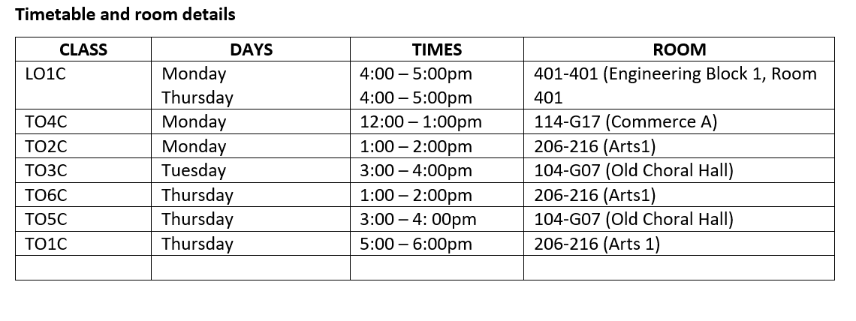
Summary of Course Description:
This course is the best way to become familiar with the world's knowledge and cultural and historical diversity. It will provide a broad survey of art and visual culture spanning the early modern world leading up to an examination of the contemporary world we live in today. This course is an important meeting of history, politics and art. In history and in different cultures images, materials and art practices are used to express and extend power and authority. Yet such images have also been used for revolution and change. In this unique course, students will be introduced to art, history and politics in a global context including Māori, Pacific, European and American, African and Asian traditions. Taking this comparative approach, the course provides students with the knowledge of the world's most important cultural traditions. It trains students to recognize how power manipulates vision, concepts and materials, and how artists have challenged this power.
The classes are structured within thematic topics which include the expression and representation of authority and power; the emergence of different perspectives on modernity and different cultural and political explorations of feminism and identity, migrations and diasporas.
Course outcomes:
By the end of the course students will have acquired the following skills and competencies:
- To be able to visually analyse artworks, images and examples of visual culture using reliable methods and terms
- Confidence in comparing and contrasting artworks and examples of visual culture across cultures
- The ability to situate artworks in their social, historical, cultural and economic contexts
- The skills to sustain an argument and logically compose a narrative in essay writing
- Techniques to find and research quality resources and information in the library and online.
The course aims to be exciting and exploratory featuring digital media, online learning, discussion groups, multimedia bibliographies and tutorials to encourage fresh and innovative ways of learning, understanding and engaging with artworks.

LECTURE PROGRAMME
NE = Ngarino Ellis CV = Caroline Vercoe
LT=Linda Tyler GM = Greg Minissale
WEEK ONE
MARCH 4:
1 INTRODUCTION
In this class we offer an overview of the course, introducing its central aims and concerns.
For general introduction: Oxford Art Online
https://www.library.auckland.ac.nz/search/Grove%20art#uoa-lib-ms-databases
MARCH 7:
2 POWER + AUTHORITY: Moko/tatau (NE)
This class will focus on the ways that signs and symbols of rank and authority are represented in Maori and Pacific cultures. There will be a particular focus on moko and tatau, both historically but also as practiced today. Our starting point is Epeli Hau’ofa’s concept of a sea of islands.

WEEK TWO
MARCH 11:
3 POWER + AUTHORITY: Personal adornment (NE)
This class will examine the ways in which Maori and Pacific peoples express ideas of power and authority through the making and wearing of different forms of body adornment.
MARCH, 14:
4 POWER + AUTHORITY: Māori and Pacific architecture (NE)
Architecture can embody and extend ideas about power and authority, both individual and also communal. In today’s class we will consider the architecture, design and symbolism, and relationships with the Pacific.

WEEK THREE
MARCH, 18:
5 POWER AND AUTHORITY: Maori and Pacific Carving and Sculpture (CV)
With a particular emphasis on carving and sculptural practice, this lecture will focus on the ways that art forms functioned in relation to indigenous pre-Christian religious practice. It will also deal with the impact and influence of colonial settlement in the Pacific.
MARCH, 21:
6 POWER + AUTHORITY: Textiles (CV)
In today’s class we’ll explore the importance and function of indigenous Pacific textile arts focusing on tapa (decorated bark cloth) and weaving in a range of Maori and Pacific contexts.
WEEK FOUR
MARCH, 25:
7 POWER + AUTHORITY: Court Art and the Manchu emperors in China (LT)
This lecture looks at how the production of court art under three High Qing emperors, Kangxi (r. 1663–1722), Yongzheng (r. 1723–35), and Qianlong (r. 1736–95), with a focus on artistic parallels between the art of the Chinese and European courts. Later in the 18th and 19th centuries, great commercial cities such as Yangzhou and Shanghai became art centres where wealthy merchant-patrons encouraged artists to produce bold new works.

MARCH, 28:
8 POWER + AUTHORITY: Ukiyo-e and the art of the Meiji Restoration in Japan (LT)
This lecture begins with the art produced when Edo (modern Tokyo) became the capital of samurai government in the seventeenth century and explores how images of “the floating world” came into ascendancy in the nineteenth century.
WEEK FIVE
APRIL 1:
9 Power and Authority: African Art –1500-1700 (CV)
This lecture looks at art produced on the West Coast of Africa, with a particular emphasis on figurative art from Benin.
APRIL 4:
10 POWER + AUTHORITY 5: The Mughals in India 1550-1700 (GM)
This lecture explains how the Mughals were influenced by Central Asian, Persian and Indian cultural traditions in order to create an art form that effectively conveys power and authority through geometrical structures.

WEEK SIX
APRIL, 8:
11 POWER + AUTHORITY 6: Mughal Art, Social and material practices (GM)
A study of how Mughal Indian artists worked together in the studios, materials used and painting styles and genres as well as relationships of the artists to patrons.
April 11:
12 TEST IN CLASS
……………………………………………………………………………………….
MID-SEMESTER BREAK 15-28 APRIL 2019
WEEK SEVEN
APRIL, 29:
13 MODERNISMS: British Imperialism in India (SP)
This lecture is looks at how the aims of British colonialism were supported by photography
MAY, 02:
14 MODERNISMS: Modern Art in India (AV)
This lecture looks at how Indian artists negotiated the legacy of modernism and cultural identity in a variety of ways in the early twentieth century.
WEEK EIGHT
MAY 6:
15 MODERNISMS: European and American Art (GM)
This lecture looks at how European and American artists dealt with the trauma of two World Wars
MAY 09:
16 FEMINISMS: Gender – Part 1 (NE )
This lecture looks at the ways in which feminist art history in the US and UK emerged in the 1970s, and focuses on key questions: what is the identity of women artists and their practices over time, how did the field of art history set to exclude them, and how do we practice feminist art history?
WEEK NINE
MAY 13:
17 FEMINISMS: Gender – Part 2 (NE)
The waves of feminism were criticised by many indigenous and African-American writers, thinkers and artists as excluding them by virtue of their culture, race or ethnicity. In this class we look at this history through the work of artists such as Lorna Smith, Kara Walker, Shona Rapira-Davies and Robyn Kahukiwa.
MAY 16:
18 MIGRATIONS + DIASPORAS: Art and Diaspora (GM )
This lecture is devoted to an examination of how artists have explored notions of cultural identity experimenting with hybridity.
WEEK TEN
MAY 20:
19 MIGRATIONS + DIASPORAS: Contemporary Asian Art (LT )
From Political Pop in China to Takashi Murakami’s highly commercialised practice and Yayoi Kusama’s dot paintings and pumpkins, this lecture will analyse the phenomenon of contemporary Asian art. Direct political practices and performance art have emerged in recent decades, as exemplified by Chinese artists Ai Weiwei whose work has been highly critical of state policy and also drawn attention to the current refugee crisis.
MAY 23
20 CONTEMPORARY ART: Contemporary Maori Art (CV)
This lecture considers the idea of contemporary Maori art, which emerged for many in the 1960s led by Maori who migrated from their rural turangawaewae/home to the cities. Themes in many of their works will be addressed including land, protest, and identity. Artists will include Ralph Hotere, Emare Karaka, Robyn Kahukiwa, Michael Parekowhai, Lisa Reihana and Shannon Te Ao.
WEEK ELEVEN
MAY 27:
21 CONTEMPORARY ART: Contemporary Pacific Art (CV)
Today’s class focuses on contemporary Pacific art with a particular focus on Pacific artists in Aotearoa New Zealand. Connections are made between gallery and non-gallery based art practices.
Artists include Fatu Feu’u, Michel Tuffery, Ani O’Neill, Niki Hastings-McFall, Kalisolaite Uhila and FAFSWAG.
MAY 30:
22 CONTEMPORARY ART: Aboriginal Art (CV)
This lecture focuses on a range of works by Aboriginal artists. It highlights the diversity of art practice produced by Aboriginal artists in response to social, cultural and political issues.
WEEK TWELVE
23 JUNE 3: QUEEN’S BIRTHDAY NO CLASS
JUNE 6:
24 Main concepts in Global Art Histories, exam skills and essay writing/best practice

ASSESSMENT REQUIREMENTS

One test (20%), one essay (30%), one exam (50%)
ASSESSMENT REQUIREMENTS

One test (20%), one essay (30%), one exam (50%)
All coursework is compulsory. Plussage does not apply.

COURSEWORK DUE DATES AND WORD LENGTHS:

TEST: Thursday April 11 AT 4pm (IN CLASS)
ESSAY: Friday May 3 - 1500 words (1650 max).

Please submit a hard copy of your essay by the due date, to the Arts Students Centre (ASC), as well as a copy electronically via Turnitin.

Please attach an Art History Department assignment cover sheet to the front of your assignment so it can be marked. The cover sheet is generated in Canvas.

Please attach your Turnitin receipt to your essay when you submit it to the ASC.

For any questions or queries please contact any of the lecturers or tutors.

Extensions for assignments:
Extensions will be granted in exceptional circumstances. They will require appropriate documentation (e.g. a medical certificate) and must be sought in advance of the date the assignment is due.

Late Assignments:
Assignments handed in late will have the mark reduced by 2% for each day they are late. Assignments handed in more than 1 week after the due date will not be marked, unless an extension has been applied for and granted beforehand.

Guidelines for Written Assignments:
Assignments should be typed, using 12 pt font (Arial or similar) and 1.5 line spacing.

Citations must be in footnotes (not in-text). Please use the Chicago 17th style of referencing. See this link for more information: http://www.cite.auckland.ac.nz/index.html

In addition to the citations, you also need to include an alphabetised Bibliography listing all the sources consulted in writing your assignment.

Please refer to the Art History Guide to Essay Writing, which is available on Canvas.

Referencing:
You are expected to use the Chicago ‘Notes and Bibliography’ system of referencing in your written assignments, i.e. citations in footnotes, with an alphabetised Bibliography at the end.

Bibliography

A general introduction to Art History

Adams, Laurie Schneider, The Methodologies of Art. An Introduction. Boulder, CA.: Westview Press, 1996.
D’Alleva, Anne, How to Write Art History. London: Laurence King Publishing, 2010, especially chapter 4 ‘Writing Art History essays and papers’. 2nd ed.
D’Alleva, Anne, Look Again! Art History and Critical Theory. Upper Saddle River, NJ: Prentice Hall, 2005.
D’Alleva, Anne, Look! The Fundamentals of Art History. Upper Saddle River, NJ: Pearson Prentice Hall, 2010. 3rd ed.
D’Alleva, Anne, Methods and Theories of Art History. London: Laurence King, 2005.

Diaspora, Hybridity, Globalism, Postcolonial Responses

Ahmed, Sara Uprootings / Regroundings : Questions of Home and Migration. Oxford: Berg, 2003
Alloula, Malek. The Colonial Harem. Minneapolis: University of Minnesota Press, 1986
Anderson, Benedict. Imagined Communities. 2nd ed. London: Verso, 1991
Antoni, Janine. ‘Mona Hatoum’ (interview). Bomb 63 (Spring 1998). Available: http://bombsite.com/issues/63/articles/2130
Ashcroft, Bill et al, eds. The post-colonial studies reader (2nd ed). Abingdon, Oxford; New York: Routledge, 2006
Beatson, Diane, Peter Beatson & Robert Leonard. Headlands: Thinking through New Zealand Art, Museum of Contemporary Art, Sydney, ed. Mary Barr, 1992
Clifford, James and George E. Marcus, eds. Writing Culture: The Poetics and Politics of Ethnography. Berkeley: University of California Press, 1986
Clifford, James. The Predicament of Culture: Twentieth-Century Ethnography, Literature and Art. Cambridge, Mass: Harvard University Press, 1988
Collier, John Jr., and Collier, Malcolm. Visual Anthropology. Photography as a Research Method. Albuquerque: University of New Mexico Press, 1986
Doris, David T. 'Destiny World: Textile Casualties in Southern Nigeria.' African Arts, 2006 Summer, Vol.39 (2), pp.36-47, 86-87
Edwards, Elizabeth, (ed). Anthropology and Photography. New Haven: Yale University Press, 1992
Enloe, Cynthia. Bananas, Beaches and Bases. Making Feminist Sense of International Politics, Los Angeles: The University of California Press, 1990
Fanon, F. Black Skin, White Masks. New York: Grove Press Inc., 1967
Ferguson, Russell et al, eds. Discourses: Conversations in Postmodern Art and Culture. New York: The Museum of Contemporary Art, 1993
Ferguson, Russell et al. Out There: Marginalization and Contemporary Cultures, Cambridge, Mass.: MIT Press, 1990
Foster, Hal, ed. Dia Foundation Discussions in Contemporary Culture: Number One. Seattle: Bay Press, 1987
Foster, Hal, ed. Vision and Visuality. Dia Foundation Discussions in Contemporary Culture. Number 2. Seattle: Bay Press, 1988
Foster, Hal. Return of the Real. Cambridge, Mass.: MIT Press, 1996
Foucault, Michel. Power/Knowledge: Selected Interviews & Other Writings 1972-1977. New York: Pantheon Books, 1980.
Fusco, Coco. English is Broken Here. Notes on Cultural Fusion in the Americas, New York: New Press, 1995
Fusco, Coco. The bodies that were not ours: and other writings. New York; London: Routledge, 2001
Gilbert Helen and Joanne Tompkins. Post-Colonial Drama: Theory, Practice, Politics. London: Routledge, 1996
Gidley, Mick, ed. Representing Others: White View of Indigenous Peoples. Exeter Studies in American and Commonwealth Arts, Number 4. Exeter: The University of Exeter Press, 1992
Giroux, Henry A. Disturbing Pleasures: Learning Popular Culture. New York: Routledge, 1994
Gomez-Pena, Guillermo. Warrior for Gringostroika. Canada: Graywolf Press, 1993
Harasym, Sarah, ed. The Post-Colonial Critic: Interviews, Strategies, Dialogues, Gayatri Chakravorty Spivak, New York: Routledge, 1990
Hiller, Susan, ed. The Myth of Primitivism, London: Routledge, 1991
hooks, bell. Black Looks: Race and Representation Boston, South End Press, 1992
hooks, bell. Outlaw Culture: Resisting Representations. New York: Routledge, 1994
hooks, bell. Art On My Mind: Visual Politics. New York: New Press, 1995
Jeffery, Celina, Gregory Minissale eds., Global and Local Art Histories. Newcastle:
Cambridge Scholars Press, 2007
Karp, Ivan and Steven D. Lavine, eds. Exhibiting Cultures: The Poetics and Politics of Museum Display. Washington, DC: Smithsonian Institution Press, 1991
Kleinert, Sylvia, ed. Crossing cultures: art, politics and identity. Darwin, NT: Charles Darwin University Press, 2006.
Lippard, Lucy, ed. Partial Recall, New York: New Press, 1992
Mercer, Kobena. Welcome to the Jungle: New Positions in Black Cultural Studies. New York: Routledge, 1994
Mack, John. The museum of the mind: art and memory in world cultures. London: British Museum, 2003.
Minh-ha, Trinh T. Woman Native Other. Bloomington, IN: Indiana University Press, 1989
Minh-ha, Trinh T. When the Moon Waxes Red: Representation, Gender and Cultural Politics. New York: Routledge, 1991
Minh-ha, Trinh T. Framer Framed. New York: Routledge, 1992
Moore-Gilbert. B.J. Postcolonial Theory: Contexts, Practices, Politics. London: Verso, 1997
Morely, David and Kuan-Hsing Chen, eds. Stuart Hall: Critical Dialogues in Culture Studies. London: Routledge, 1996
Ngugi Wa Thiong'o. Decolonising the Mind, London: Currey; Portsmouth, NH: Heinemann, 1986
Peffer, John. 'The Diaspora as Object'. In Farrell and Byvanck, eds. Looking both ways: art of the contemporary African disapora, Museum for African Art. New York: Gent Snoeck, 2003, pp. 22-36. Available: http://www.artafrica.info/novos-pdfs/artigo_1-en.pdf
Root, Deborah. Cannibal Culture: Art Appropriation and the Commodification of Difference. Boulder: Westview Press, 1996
Rushdie, Salman. Imaginary Homelands: Essays and Criticism 1981-1991. London: Granta Books, 1990
Said, Edward W. Orientalism. Western Conceptions of the Orient, London: Penguin Books, 1978
Said, Edward W. The World, The Text and The Critic London: Vintage, 1983
Said, Edward W. Culture and Imperialism. London: Vintage, 1993
Scott, James C. Domination and the Arts of Resistance. New Haven: Yale University Press, 1990
Shohat, Ella and Robert Stam. Unthinking Eurocentrism: Multi-culturalism and the Media. London: Routledge, 1994
Slemon, Stephen. 'The Scramble for Post-Colonialism'. In Ashcroft, Bill et al, eds. The post-colonial studies reader (2nd ed). Abingdon, Oxford; New York: Routledge, 2006, Ch. 6
Smith, B. 'European Vision and the South Pacific, 1768-1850', A Study in the History of Art and Ideas, London, OUP, 1960
Snead, James. White Screens, Black Images: Hollywood from the Dark Side. New York: Routledge, 1995
Taylor, Lucien. Visualizing Theory: Selected Essays from V.A.R. 1990-1994, New York: Routledge, 1994
Te Awekotuku, Ngahuia. Mana Wahine Maori: Selected Writings on Maori Women’s Art, Culture and Politics. Auckland: New Women’s Press, 1991
Williams, Patrick and Chrisman, Laura, eds. Colonial Discourse and Post-Colonial Theory: A Reader. New York: Columbia University Press, 1994
Young, Lola. Fear of the Dark: ‘Race’, Gender and Sexuality in Cinema. London: Routledge, 1990
Young, Robert. Colonial Desire: Hybridity in Theory, Culture and Race. London: Routledge, 1995
Young, Robert. White Mythologies: Writing, History and the West. London: Routledge, 1990

European and American Art

Grosenick, Uta. Women artists in the 20th and 21st century. Koln; London: Taschen, 2011
Hess, Barbara and Uta Grosenick, eds. Abstract expressionism. Koln; Los Angeles : Taschen, c2005
Joselit, David American Art Since 1945. London: Thames & Hudson, 2003
Powell, Richard J. Black Art. London: Thames & Hudson, 2002

Feminism

Chadwick, Whitney Women, Art, and Society. London: Thames & Hudson, 2007
Gunew, Sneja and Yeatman, Anna, (ed). Feminism and the Politics of Difference. St. Leonards, N.S.W.: Allen & Unwin Press, 1993
hooks, bell. Ain't I A Woman: Black Women and Feminism. Boston: South End Press, 1981
hooks, bell. Feminist Theory from Margin to Center. Boston: South End Press, c1984
Johnson-Odim and Strobel, Margaret, (ed). Expanding the Boundaries of Women's History. Essays on Women in the Third World. Bloomington, IN: Indiana University Press, 1992
Kaplan, E. Ann. Looking for the Other: Feminism, Film, and the Imperial Gaze. New York: Routlege, 1997
Lippard, Lucy R., ed. The Pink Glass Swan: selected essays on feminist art. New York: New Press, c1995
Mulvey, Laura, ed. Visual and Other Pleasures. Houndmills, Basingstoke, Hampshire: Macmillan, 1989
Parker, Rozsika and Griselda Pollock. Old Mistresses. Women, Art and Ideology. London: I B Tauris, 2013.
Te Awekotuku, Ngahuia. Mana Wahine Māori. Auckland: New Women's Press, 1991.

Asian Art

Chong, Doryun. From Postwar to Postmodern : Art in Japan 1945-1989 : Primary Documents. New York, N.Y. : Durham, N.C.: New York, N.Y. : Museum of Modern Art ; Durham, N.C. : Distributed by Duke Univ Press c2012, 2012.
Clark, John. Modernities of Japanese Art. Leiden ; Boston: Leiden ; Boston : Brill 2013, 2013.
Clarke, David J. (David James). Chinese Art and its Encounter with the World. Hong Kong: Hong Kong : Hong Kong University Press ©2011, 2011.
De Waal, Edmund. Timeless Beauty : Traditional Japanese Art from the Montgomery Collection. Milano : New York: Milano : Skira ; New York : Abbeville distributor 2002, 2002.
Elliott, David. Bye Bye Kitty!!! : Between Heaven and Hell in Contemporary Japanese Art, edited by Ozaki, Tetsuya, N. Y. ). Gallery Japan Society (New York. 1st ed.. ed. New York : New Haven Conn.]: New York : Japan Society ; New Haven Conn. : Yale University Press c2011, 2011.
Favell, Adrian. Before and After Superflat : A Short History of Japanese Contemporary Art, 1990-2011. Hong Kong: Hong Kong : Blue Kingfisher c2011, 2011.
Gao, Minglu, Norman Bryson, and Asia Society. Galleries. Inside Out : New Chinese Art. San Francisco : New York : Berkeley: San Francisco : San Francisco Museum of Modern Art ; New York : Asia Society Galleries ; Berkeley : University of California Press c1998, 1998.
Gladston, Paul. Deconstructing Contemporary Chinese Art : Selected Critical Writings and Conversations, 2007-2014 Heidelberg : Springer. 2016 ©2016, 2016.
Hearn, Maxwell K., Judith G. Smith, of Art Metropolitan Museum, and Metropolitan Museum of Art (New York, NY) Dept of,Asian Art. Chinese Art : Modern Expressions. New York: New York : Dept. of Asian Art, the Metropolitan Museum of Art c2001, 2001.
Hung, Wu. Contemporary Chinese Art : A History, 1970s>2000s London : Thames & Hudson. 2014, 2014.
Hung, Wu and Visual Arts Institute of International. Chinese Art at the Crossroads : Between Past and Future, between East and West. London: London : Institute of International Visual Arts c2001, 2001.
Hung, Wu, Peggy Wang, and Modern Art Museum of. Contemporary Chinese Art : Primary Documents. New York : Durham, N.C.: New York : Museum of Modern Art ; Durham, N.C. : Distributed by Duke University Press c2010, 2010.
Mason, Penelope E. History of Japanese Art. New York: New York : Abrams 1993, 1993.
Powers, Martin Joseph and Katherine R. Tsiang. A Companion to Chinese Art Hoboken : John Wiley & Sons Inc.. 2015, 2015.
Rawson, Jessica. British Museum Book of Chinese Art. 2nd ed.. ed. London: London : British Museum 2007, 2007.
Reeve, John. Japanese Art in Detail. London: London : British Museum 2005, 2005.
Sadao, Tsuneko S. Discovering the Arts of Japan : A Historical Overview, edited by Wada, Stephanie. 1st ed.. ed. Tokyo ; New York: Tokyo ; New York : Kodansha International 2003, 2003.
Smith, Lawrence, Victor Harris, Timothy Clark, and British Museum. Trustees. Japanese Art : Masterpieces in the British Museum. London: London : Published for the Trustees of the British Museum by British Museum Publications c1990, 1990.
Stanley-Baker, Joan. Japanese Art. Third edition.. ed. London : Thames & Hudson. 2014, 2014.
Thorp, Robert L. Chinese Art & Culture, edited by Vinograd, Richard Ellis. New York: New York : Abrams c2001, 2001.
Watkins, Jonathan, Mami Kataoka, Hayward Gallery, and Kokusai Kōryū Kikin. Facts of Life : Contemporary Japanese Art. London: London : Hayward Gallery 2001, 2001.

Indian, Persian and Middle Eastern Art

Brend, Barbara Islamic Art. London: British Museum Press, 1991
Brend, Barbara The Emperor Akbar’s Khamsa of Nizami. London: British Museum
Press, 1993
Bailey, Gauvin. A. 'In the Manner of the Frankish Masters' Oriental Art. vol. XL. no. 4. Winter (1994/5): 29-34
—. Counter Reformation Symbolism and Allegory in Mughal Painting Ph.D.diss. Harvard University, 1996
—.The Jesuits and the Grand Mogul: Renaissance Art at the Imperial Court of India, 1580-1630. Washington, D.C. : Freer Gallery of Art, Arthur M. Sackler Gallery, Smithsonian Institution, 1998
—. Art of the Jesuit Missions in Asia and Latin America, 1542-1773. Toronto: University of Toronto Press, 1999
Beach, Milo. C. 'The Gulshan Album and its European Sources'. Bulletin Museum Fine Arts Boston. no. 332. vol. LXIII. (1965): 62-91
—. ‘An Early European Source in Mughal Painting’ Oriental Art 22, no. 2. (1976): 180-188
—. The Grand Mogul: Imperial Painting in India. 1600-1660. Williamstown Mass.: Sterling and Francine Clark Art Institute, 1978
—. The Imperial Image. Paintings for the Mughal Court. Washington DC: Freer Gallery of Art/Smithsonian Institution, 1981
—. Early Mughal Painting. Cambridge Mass.: Harvard University Press, 1987
—. Mughal and Rajput Painting. Cambridge Mass.: Harvard University Press, 1992.
—. and E. Koch. The King of the World. The Padshahnama. Washington: Smithsonian Institution, 1997
Gray, Basil. ‘The Development of Painting in India in the Sixteenth-Century’. Marg 6. (1953): 19-24
—. Persian Painting. Geneva: Skira, 1961
—. ‘Complexities of Persian Painting’. Apollo 113/6 June (1981): 410-12.
—. ed. The Arts of India. Oxford: Phaidon, 1981
Kapur, Geeta. When Was Modernism: essays on contemporary cultural practice in India. New Delhi: Tulika, 2000.
Koch, Ebba. Mughal art and imperial ideology : collected essays. New Delhi; Oxford: Oxford University Press, 2001
Mathur, Saloni. India By Design: Colonial History and Cultural Display. Berkeley: University of California Press, c2007
Mathur, Saloni. 'A retake of Sher-Gil's Self-portrait as Tahitian', Critical Inquiry, Spring, 2011, Vol.37(3), p.515
Minissale, Gregory. "A spectacle of order and method’ by Annemarie Schimmel, trans. Corinne Attwood." Art History 30.2 (2007) (available online)
Minissale, Gregory. Images of Thought: Painting in Islamic India. Newcastle: Cambridge Scholars Press, 2009
Mitter, Partha. Much Maligned Monsters. Oxford: Clarendon Press, 1977
Mitter, Partha. Indian Art. Oxford: Oxford University Press, 2001
Mitter, Partha. The Triumph of Modernism: India's Artists and the Avant-garde, 1922-47. Cambridge & New York: Cambridge University Press, 1994
Okada, Amina. Indian Miniatures of the Moghul Court. New York: Harry N Abrams, 1992.
Richards, John F. The Mughal Empire. Cambridge; New York, NY: Cambridge University Press, 1993
Rogers, Michael. Mughal Miniatures. London: British Museum Press, 1993.

Modern New Zealand Art
Auckland City, Art Gallery and 1950s Show Newstalk 1ZB. New Zealand Home & Building : The Newstalk 1ZB 1950s show, Auckland City Art Gallery. Souvenir ed.. ed. Auckland N.Z.]: Auckland N.Z. : Robin Beckett 1992, 1992.
Barr, Jim. When Art Hits the Headlines : A Survey of Controversial Art in New Zealand, edited by Barr, Mary (Mary Milroy), National Art Gallery (N.Z.). Wellington N.Z.]: Wellington N.Z. : National Art Gallery in association with the Evening Post 1987, 1987.
Barton, Christina. Billy Apple® : A Life in Parts, edited by Auckland Art Gallery Auckland : Auckland Art Gallery. 2015. ©2015, 2015.
———. Louise Henderson : The Cubist Years, 1946-1958, edited by Auckland City Art Gallery. Auckland, N.Z.: Auckland, N.Z. : Auckland City Art Gallery 1991, 1991.
Bogle, Andrew and Art Gallery Auckland City. The Grid : Lattice and Network : Aspects of Recent New Zealand Art. Auckland: Auckland : Auckland City Art Gallery 1983, 1983.
Brown, Gordon H. New Zealand Painting, 1920-1940 : Adaptation and Nationalism, edited by Queen Elizabeth II Arts Council of New Zealand, Robert McDougall Art Gallery. Wellington: Wellington : Queen Elizabeth II Arts Council of New Zealand 1975, 1975.
Curnow, Wystan. The Critic's Part : Wystan Curnow Art Writings 1971-2013, edited by Barton, Christina, Robert Leonard, Thomasin Sleigh, issuing body Adam Art Gallery, issuing body Victoria University Press and Institute of Modern Art (Brisbane,Qld.) Wellington, New Zealand : Adam Art Gallery, Te Pātaka Toi : in association with Victoria University Press ; Brisbane, QLD : Institute of Modern Art . 2014. ©2014, 2014.
Eggleton, David. Towards Aotearoa : A Short History of 20th Century New Zealand Art. Auckland, N.Z.: Auckland, N.Z. : Reed 2007, 2007.
Hillary, Sarah L. Modern Paints Aotearoa, edited by Learner, Tom, Herant Khanjian, Katherine Campbell, Melanie Carlisle, Caroline McBride, Catherine Hammond, Ian Cooke and issuing body Auckland Art Gallery Auckland : Auckland Art Gallery Toi o Tamaki. 2014, 2014.
Leonard, Robert, Bernice Murphy, Mary (Mary Milroy) Barr, and Contemporary Art Museum of. Headlands : Thinking through New Zealand Art. Sydney: Sydney : Museum of Contemporary Art c1992, 1992.
Lloyd-Jenkins, Douglas. New Dreamland : Writing New Zealand Architecture. Auckland, N.Z.: Auckland, N.Z. : Godwit 2005, 2005.
Pound, Francis. Signatures of Place : Paintings & Place-Names : Govett-Brewster Art Gallery, New Plymouth, New Zealand, 15 June-28 March 1991. New Plymouth, N.Z.: New Plymouth, N.Z. : The Gallery c1991, 1991.
———. The Space between : Pakeha use of Maori Motifs in Modernist New Zealand Art. Auckland, N.Z.: Auckland, N.Z. : Workshop Press 1994, 1994.
Ross, James. New Zealand Modernism - Figuration and Expressionism : Paintings from the Gibbs Collection. Auckland] N.Z.: Auckland N.Z. : J.& A. Gibbs 1996, 1996.
Ross, James, Francis Pound, and Wystan Curnow. New Zealand Modernism - in Context : Paintings from the Gibbs Collection. Auckland?] N.Z.: Auckland? N.Z. : s.n. c1995, 1995.
Ross, James, Garry Sturgess, and Allan Smith. New Zealand Modernism-- the Content of Form : Paintings from the Gibbs Collection. Auckland] N.Z.: Auckland N.Z. : The Gibbs Collection 1997, 1997.
Simpson, Peter. Bloomsbury South : The Arts in Christchurch, 1933-1953 Auckland, New Zealand : Auckland University Press. 2016. ©2016, 2016.
Skinner, Damian. The Carver and the Artist : Māori Art in the Twentieth Century. Auckland, N.Z.: Auckland, N.Z. : Auckland University Press 2008, 2008.
———. Off the Beaten Track : Modernism in Rotorua / by Damian Skinner. Rotorua, N.Z.]: Rotorua, N.Z. : Friends of Rotorua Museum of Art & History 2000, 2000.
Thomas, Nicholas. Possessions : Indigenous art/colonial Culture. London: London : Thames & Hudson 1999, 1999.
Wang, Meiqin. Urbanization and Contemporary Chinese Art New York : Routledge. 2016, 2016.
Wedde, Ian. How to be Nowhere : Essays and Texts, 1971-1994. Wellington N.Z.]: Wellington N.Z. : Victoria University Press 1995, 1995.

Māori and Pacific Art

Adams, Mark, and Lisa Taouma. Tatau. Pe’a: Photographs. Measina Samoa: Stories of the Malu. Wellington: Adam Art Gallery, 2003.
Adsett, Sandy et al, eds. Mataora: The Living Face: Contemporary Māori Art. Auckland: David Bateman, 1996
Brown, Deidre. Māori Architecture: from fale to wharenui and beyond. Auckland: Raupo, 2009
Brunt, A. "Since ‘Choice!’: Exhibiting the ‘New Maori Art,’ On Display: New
Essays in Cultural Studies (2004): 215-42.
Buck, Peter. 'Arts and Crafts of Hawaii', Bishop Museum Bulletin, No.45, 1964
Buck, Peter. 'Samoan Material Culture', Bishop Museum Bulletin, No.75, 1930
Caruana, Wally. Aboriginal Art, Australia: Thames & Hudson, 1993
Chiu, Melissa, ed. Paradise Now? Contemporary Art from the Pacific. Auckland: David Bateman Ltd, 2004
Cochrane, Susan. Art and Life in Melanesia. Newcastle-upon-Tyne: Cambridge Scholars, 2007
Cochrane, Susan. Beretara: Contemporary Pacific Art. Rushcutters Bay, NSW; Noumea, New Caledonia: Halstead Press, Centre Culturel Tjibaou, c2001
Craig, Barry. Art and Decoration of Central New Guinea. Princes Risborough, UK: Shire, 1988.
D'Alleva, Anne. Art of the Pacific. London: Weidenfeld and Nicolson, 1998
Davidson, Jane. Traditional Arts of Pacific Island Women. Wellington: Museum of New Zealand Te Papa Tongarewa, c1993
Doig, Fiona. Exc. Ed., Taonga Maori: Treasures of the New Zealand Maori People, Sydney, NSW: Australian Museum, c1989 pp.89-99
Ellis, Ngarino. A Whakapapa of Tradition: One Hundred Years of Ngāti Porou Carving, 1830-1930. Auckland: Auckland University Press, 2016.
Ellis, Ngarino. ‘Te Ao Hurihuri o Nga Taonga Tuku Iho: The Evolving Worlds of Our Ancestral Treasures,’ Journal of the Polynesian Society, 39(3) (2016): 438-460.
Greub, Suzanne, ed. Gauguin, Polynesia. Munich, Germany: Hirmer; Basle, Switzerland: Art Centre Basel, c2011
Hammond, Joyce. Tifaifai and Quilts of Polynesia. Honolulu: University of Hawaii Press, 1986.
Hanson, Allan and Louise, eds. Art and Identity in Oceania. Honolulu: University of Hawaii Press, 1990
Herda, Phyllis S. 'The Changing Texture of Textiles in Tonga.' Journal of the Polynesian Society, Special Issue 108(2) (1999): 149-167.
Hereniko, Patricia. Pacific Artists. Suva: University of South Pacific, 1986
Kaeppler, Adrienne. Artificial Curiosities: An Exposition of Native Manufactures, Honolulu: Bishop Museum Press, 1978
Kaeppler, Adrienne. 'Kie hingoa: mats of power, rank, prestige and history.' The Journal of the Polynesian Society, June, 1999, Vol.108 (2), p.168
Kooijman, Simon. Tapa in Polynesia, Honolulu: Bishop Museum Press, 1972
Mallon, Sean and Pandora Fulimalo Pereira, eds. Pacific Art Niu Sila: the Pacific dimension of contemporary New Zealand arts. Wellington: Te Papa Press, 2002.
Mallon, Sean and Pandora Fulimalo Pereira. Speaking In Colour: Conversations with Artists of Pacific Island Heritage. Wellington: Te Papa Press, 1997
Mallon, Sean et al, eds. Tangata o le moana: New Zealand and the people of the Pacific. Wellington: Te Papa Press, 2012
McCarthy, Conal. Museums and Māori: heritage professionals, indigenous collections, current practice. Wellington: Te Papa Press, 2011
Mead, Sidney M., ed. Te Māori: Māori Art from New Zealand Collections. Auckland: Heinemann; New York: American Federation of Arts, 1984
Neich, Roger. Carved Histories: Rotorua Ngati Tarawhai. Auckland: Auckland University Press, 2001
Neich, Roger. Painted Histories, Auckland: Auckland University Press, 1993
Neich, Roger and Pandora Fulimalo Pereira, photographs by Krzysztof Pfeiffer, Pacific Jewellery and Adornment. Auckland: David Bateman, 2004
Neich, Roger and Mick Pendergrast, photographs by Krzysztof Pfeiffer, Pacific Tapa. Honolulu: University of Hawaii Press, 2004
Ngata, Sir Apirana. 'The Origin of Maori Carving', Te Ao Hou, Vol.22, pp.30-34
'The Origin of Maori Carving, Part II, Ibid., pp.30-37
'Maori Arts and Crafts', The Maori People Today: A General Survey, ed. I.L.G. Sutherland, Wellington. The New Zealand Institute of International Affairs and the New Zealand Council for Educational Research, pp.307-335
Nicholas, D. and K. Kaa, interviewers: Seven Maori Artists. Government Printer, Wellington, 1986
Pendergrast, Mick. Te Aho Tapu. The Sacred Thread: Traditional Maori Weaving. Auckland: Reed Publishing, 1987.
Pritchard, Mary J. 'Siapo'. American Samoa Council on Culture, 1984.
Pule, John and Nicholas Thomas. Hiapo: Past and Present in Niuean Barkcloth. Dunedin: University of Otago Press, 2005.
Robley, Major General. Moko. Southern Reprints, 1987, pp.1-19.
St. Cartmail, Keith. The Art of Tonga: Ko E Ngaahi’aati’o Tonga. Nelson: Craig Potton Publishers, 1997.
Skinner, H. D. Comparatively Speaking: Studies in Pacific Material Culture 1921-1972. Dunedin: University of Otago Press, 1974, pp.27-44
Smith, Huhana, ed. E tu ake: Māori standing strong. Wellington: Te Papa Press, 2011
Smith, Huhana et al, eds. Taiawhio: contemporary Māori artists. Wellington, NZ: Te Papa Press, 2002
Smith, Huhana et al, eds. Taiawhio II: contemporary Māori artists: 18 New Conversations. Wellington, NZ: Te Papa Press, c2007
Skinner, Damian. The Carver and the Artist: Maori Art in the Twentieth Century. Auckland, Auckland University Press, 2008.
Stevenson, Karen. The Frangipani is Dead; Contemporary Pacific Art in New Zealand, 1985-2000. Wellington, NZ: Huia, 2008
Taiapa, Pine. 'Tukutuku'. Marae 1, 2, (1953) pp.111-16.
Tamarapa, Awhina, Whatu Kākahu: Maori Cloaks. Wellington: Te Papa Press, 2011.
Tapsell, Paul. The Art of Taonga. Wellington: Art History, School of Art History, Classics and Religious Studies, Victoria University of Wellington, c2011
Tapsell, Paul. 'The Flight of Pareraututu: An Investigation of Taonga from a Tribal Perspective.' Journal of the Polynesian Society 106.4, Dec 1997, 323 - 374
Tausie (Hereniko) Vilsoni. Art in the New Pacific. Institute of Pacific Studies, 1979
Te Awekotuku, Ngahuia, and Linda Waimarie Nikora. Mau Moko: The World of Maori Tattoo. North Shore: Penguin Books (NZ) Ltd, 2007
Te Kanawa, Diggeress. Weaving a Kakahu. Wellington, NZ: Bridget Williams Books, 1992 (updated version: Hamilton, NZ: Puwaha ki te Ao Trust, 2006)
Thomas, Nicholas, Anna Cole and Bronwen Douglas. Tattoo: Bodies, Art, and Exchange in the Pacific and the West. Durham: Duke University Press, 2005.
Thomas, Nicholas. Oceanic Art. Thames & Hudson, London, 1995.
Trask, Haunani-Kay. From a Native Daughter: Colonialism and Sovereignty in Hawaii. Monroe, Maine: Common Courage Press, 1993.
Whiting, Cliff. He Toi Nuku, He Toi Rangi [his biography]. Palmerston North: He
Kupenga Hao i te Rea, 2013.

This course leads on to closer studies in some of the areas that are covered in the 115 and are on offer in 2020, including:
ARTHIST 204/334 Contemporary Art, with Greg Minissale
ARTHIST 230/332 Art Crime, with Ngarino Ellis
ARTHIST 235/335 Contemporary New Zealand Art, with Caroline Vercoe
HUMS 300, Critiquing Museums, with Linda Tyler
ARTHIST 231/331 Framing the Viewer: Twentieth Century Art, with Greg Minissale

