TELEVISION STUDIO
The Television studio is located in the Kenneth Meyer’s Centre (KMC) Shortland Street. This is at the Princes Street end of Shortland Street and the historic, stylised brick exterior with the antique aerial on the roof is easy to identify, cramped between the modern high rise buildings. It will take you approximately 10 minutes to walk to the studio at KMC from the main campus.

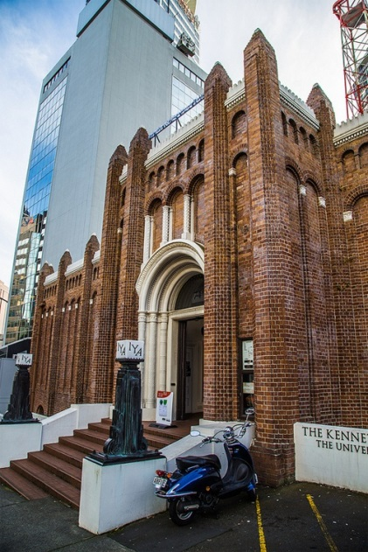

The Television Studio is at street level, accessed through the Art Gallery foyer and left at the top of the stairs (the doorway to the left in the photo below).

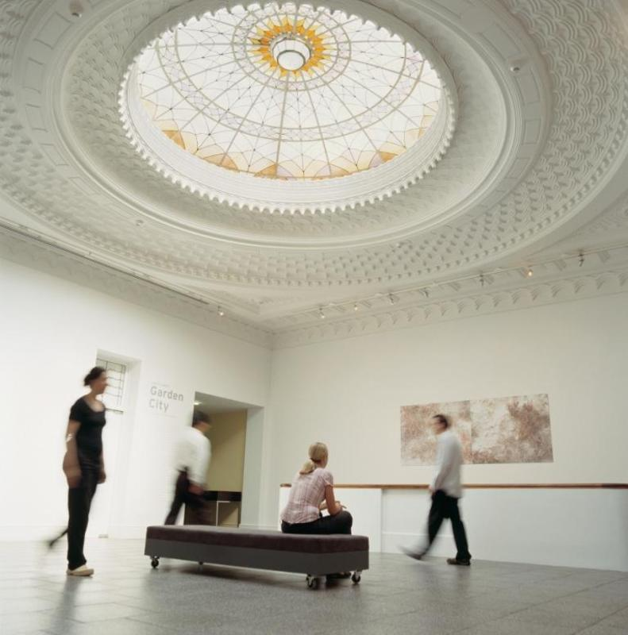

Producing 303’s FULL CREDIT Studio interview programme

Two weeks of the course are held in the TV studio - one week for the rehearsal and then the recording of the ‘Full Credit’ sports interview programme. The interviews are conducted by members of the class and the studio is operated by the students under live recording conditions. These interviews are directly linked into the major research project and the end of semester in- class test.

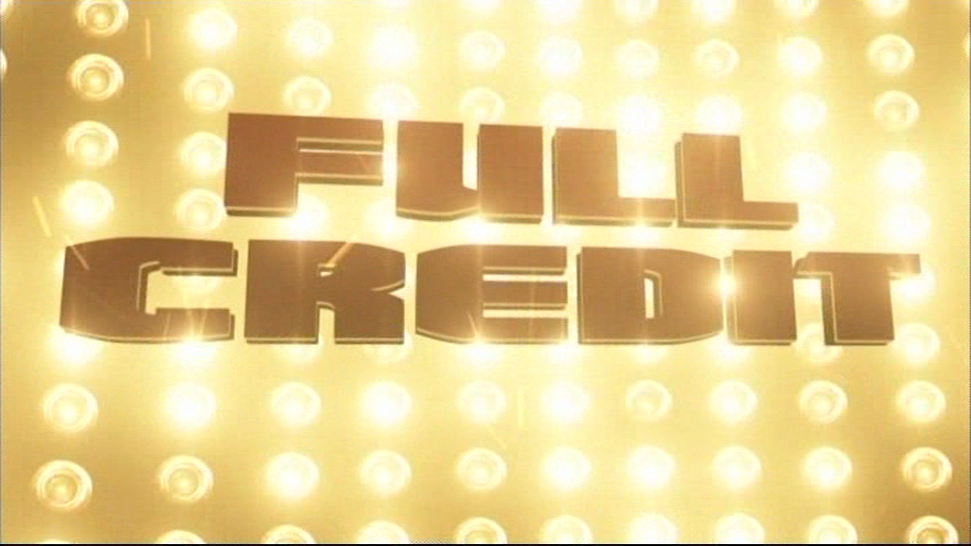

If you are one of the interview team of three, you can use this credit as part of your research component for your second assignment. All students in the class should use the information gained from the guests for their research and will be able to contribute interview questions if they are not on the interview team.

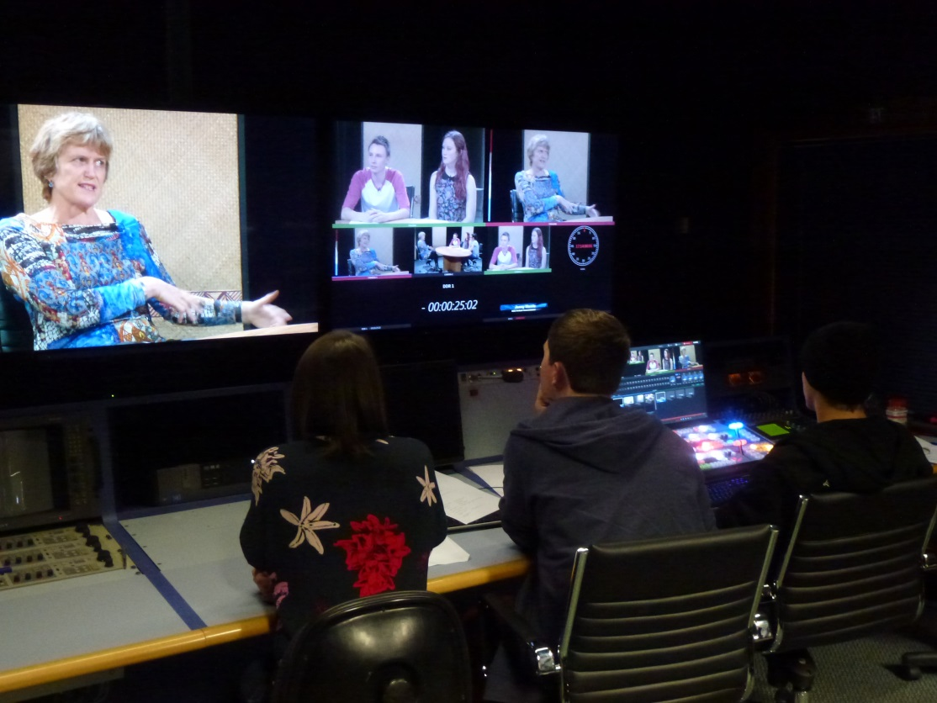

Class members will crew the studio in the following roles which will be taught and practiced the week before in rehearsal:
Studio director
Director’s Assistant
Audio Op
Vision Switcher
Character generator op
Autocue Op
Camera Op x 3
Floor manager
Interviewer x 3 per interview
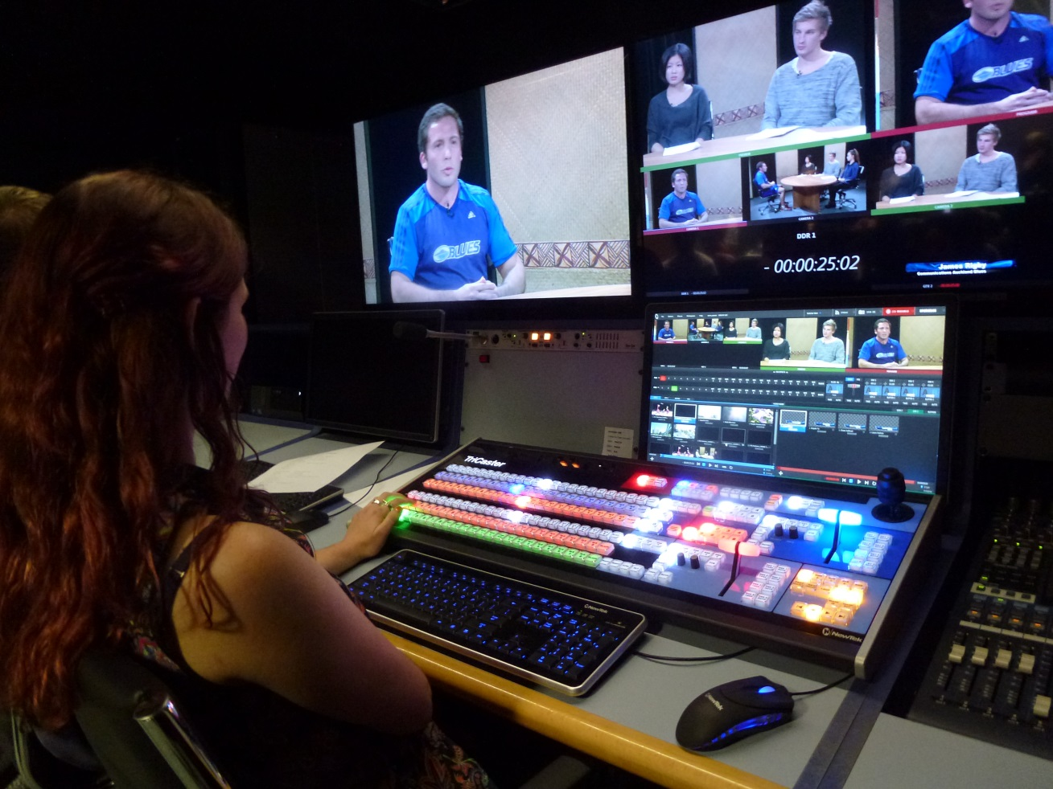

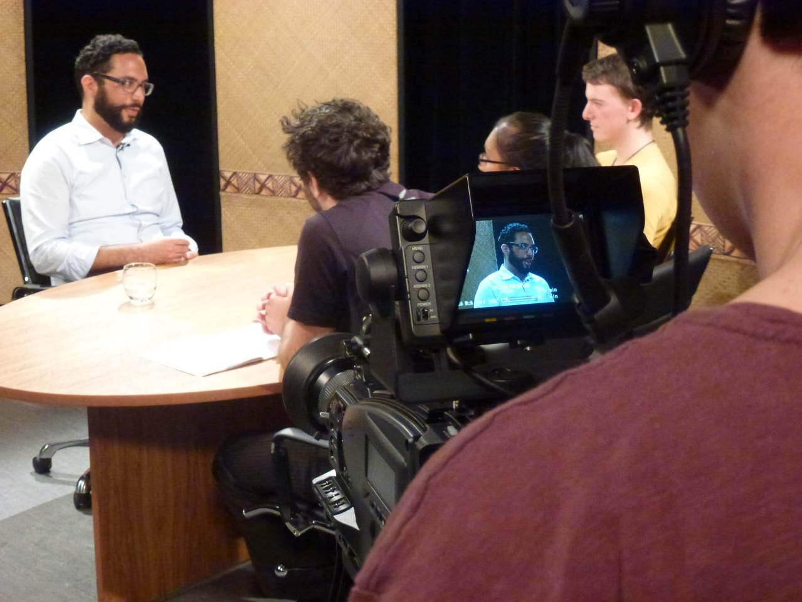

Interview guests Full Credit 2015

