MEDIA 729 Semester 1, 2019

FILM EVIl

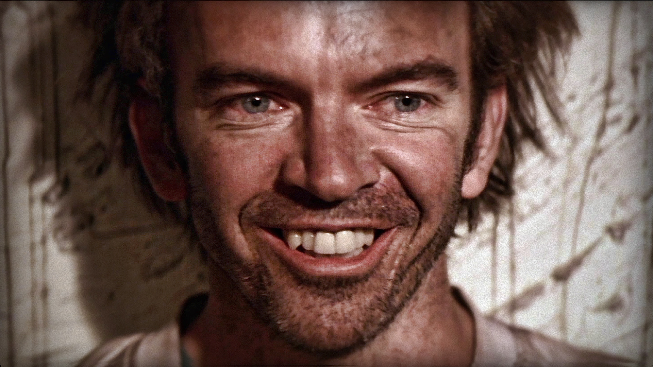
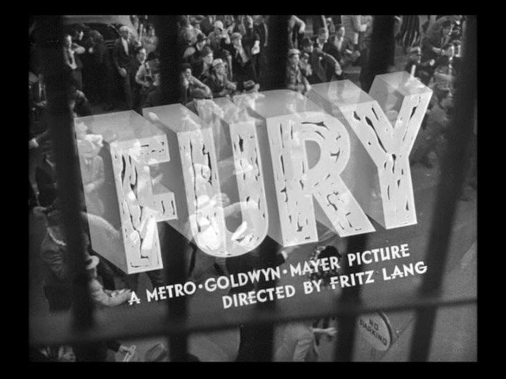

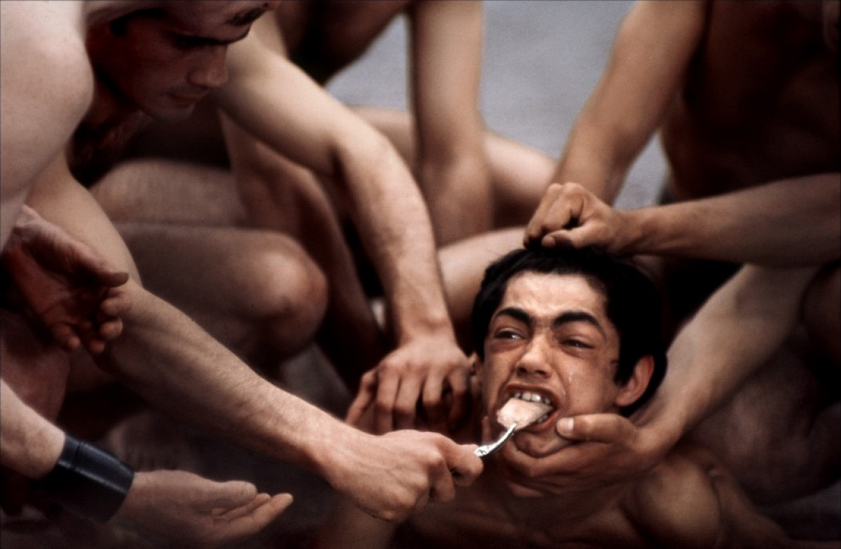

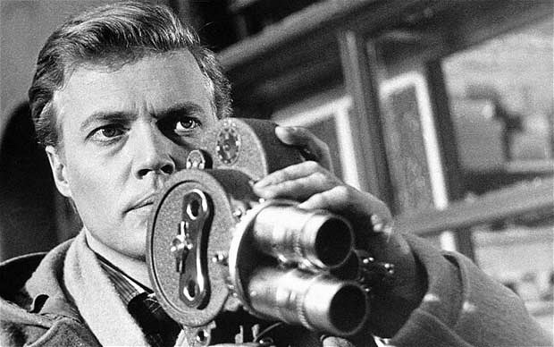

FTVMS 729 Film Evil
(Semester 1, 2019)

Convenor: Laurence Simmons
Office: Rm 515, HSB 2O1E
Extension: 87130
Email: l.simmons@auckland.ac.nz

Office Hours: Email me to make an appointment.

Seminar Time: Tuesday 9-12am
Seminar Room: 810 Rm 336 (1-11 Short Street)

COURSE OVERVIEW

This course looks at theme of evil in the cinema. Why is it that conceptions of evil and its nature and source, distinctions between natural and moral evil, and what belongs to God versus to the human race have formed so much of the subject matter, and undergone so many transformations, in film? What can films teach us about evil? And what about the proposition that some films may themselves be evil? Through a number of theoretical readings that draw on a psychoanalytical understanding of evil — including texts by Immanuel Kant on ‘radical evil’, Hannah Arendt’s interpretation of Auschwitz, Alain Badiou on the self-evidence and necessity of evil, Alenka Zupancic on rethinking the concept of evil, Terry Eagleton on the rarity of pure evil, Jacques Lacan on how the pure ethical attitude is inextricably linked to the pleasure of violence, Slavoj Žižek on ‘loving thy neighbour’ and violence, George Bush and ‘the axis of evil’ and current reflections on looming climatic and nuclear disasters — we will address the working structures of the evil event in the cinema. Films to be studied range from Fritz Lang’s Fury (1936) where an innocent man is lynched by a righteous mob; Ingmar Bergman’s Prison (1949) which proposes that life on earth is governed by the Devil; Rolf de Heer’s Bad Boy Bubby (1994) about a 35-year-old psychopath who has never set foot outside his mother’s apartment; Michael Powell’s Peeping Tom (1959) which provoked such fury in the press that it all but destroyed the career of its director; Pier Paolo Pasolini’s Salò (1975) often cited as the most disturbing film ever made; Lars von Trier’s shocking Antichrist (2009) accused of rampant misogyny, of being “an abomination”, “the sickest film in the history of cinema”; and Gus van Sant’s exploration of high school shootings Elephant (2003).

READINGS

Each week the topic will be set by a theoretical reading which defines the key concept under consideration. These readings will be supported by other articles or chapters, which draw directly on the weekly themes and concepts, and which refer directly to the film in question. Both readings are required readings, meaning that they must be read in advance of each seminar and brought to class in either hard copy or electronic format. Reading response questions for each weeks’ reading material will be posted on Canvas. You are asked to respond in written form to two of the questions on one page and bring your page to class. These will be collected, looked at and commented on by the course convenor and handed back in the following class. Students will be expected to show knowledge of each reading during class discussions, during which time we will extend the key concepts beyond the selected articles, in order to assess their applicability to a range of films that deal with the theme of love. These readings and reading response questions are collected on Canvas in the weekly modules. There is also an extended bibliography for the notion of evil and for evil and the cinema.

SCREENINGS

There will not be any group screenings for this course, but students will be expected to spend two to three hours viewing assigned materials per week, in the AV section of the Main Library or, where possible, at home. The essential films to be viewed are listed in the course programme week by week, and will be placed on desk copy in the AV section of the Main Library for your use (there may also be other online sources for the weekly films). In addition to the films assigned for viewing each week, students are encouraged to watch other cognate films (signalled along with the weekly module readings) and draw on this knowledge during class discussions, and for their research project.

“The problem of evil will be the fundamental problem of post-war intellectual life in Europe — as death became the fundamental problem after the last war.”
- Hannah Arendt, 1945

