Report from the Prime Minister’s Office
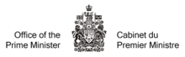

From:

Date:

To: Prime Minister Justin Trudeau

Title

Purpose of the Report

Analysis

Recommendations for future action

Sources

